Final Year Design Project

KIPS COACHING KHARIAN


By
Raima Nasir 2022-fkw-16

Maryam Iftikhar 2022-fkw-14

Kiran Shahzadi 2022-fkw-29

Nayab Zahoor 2022-fkw-15

Under the supervision of Ms. Pakiza Saif
Session: 2022-2026

DEPARTMENT OF INFORMATION TECHNOLOGY
F.G DEGREE COLLEGE FOR WOMEN, KHARIAN CANTT

FACULTY OF COMPUTING &
INFORMATION TECHNOLOGY (FCIT), UNIVERSITY OF THE PUNJAB, LAHORE

KIPS COACHING KHARIAN

A project presented to
University of the Punjab, Lahore

In partial fulfilment of the requirement for the degree of

Session: 2022-2026

By

Raima Nasir 2022-FKW-16

Maryam Iftikhar 2022-FKW-14

Kiran Shahzadi 2022-FKW-29

Nayab Zahoor 2022-FKW-15

DEPARTMENT OF INFORMATION TECHNOLOGY
F.G DEGREE COLLEGE FOR WOMEN, KHARIAN CANTT

FACULTY OF COMPUTING &
INFORMATION TECHNOLOGY (FCIT),
UNIVERSITY OF THE PUNJAB, LAHORE.

DECLARATION

We hereby declare that this App neither whole nor as a part has been copied out from any source. It is further declared that we have developed this App and accompanied report entirely on the basis of our personal efforts. If any part of this project is proved to be copied out from any source or found to be reproduction of some other. We will stand by the consequences. No portion of the work presented has been submitted of any application for any other degree or qualification of this or any other university or institute of learning.

Signature: _______________ Signature: _________________

Raima Nasir [080045] Kiran Shahzadi [080052]

Signature: _______________ Signature: ________________

Maryam Iftikhar [080035] Nayab Zahoor [080039]

CERTIFICATE OF APPROVAL

It is to certify that the final year design project (FYDP) of BSIT “Kips Coaching App Kharian” was developed by RAIMA NASIR (2022-FKW-16), MARYAM IFTIKHAR

(2022-FKW-14), KIRAN SHAHZADI (2022-FKW-29) and NAYAB ZAHOOR (2022FKW-15)
Under the supervision of “Ms. PAKIZA SAIF” in my opinion it is fully adequate, in scope and quality for the degree of Bachelors of Science in INFORMATION TECHNOLOGY.

Signature: _________________________
Supervisor
Miss Pakiza Saif
FG Degree College for Women Kharian Cantt
Dated: _________________________

Signature: __________________________
HOD, Department of Information Technology
Mrs. Sidra Khan
FG Degree College for Women Kharian Cantt
Dated: _________________________

PROOFREADING CERTIFICATE

It is certified that this document does not contain any spelling, punctuation or grammatical mistakes. This document is well organized and also meet the defined objectives.

Student Name Registration Roll no Signature Number
Raima Nasir (2022-fkw-16) 080045 _____________
Maryam Iftikhar (2022-fkw-14) 080035 _____________
Kiran Shahzadi (2022-fkw-29) 080052 _____________
Nayab Zahoor (2022-fkw-15) 080039 _____________

Acknowledgement

We want to express our sincere thanks to everyone who supported us during the development of our project. We are especially grateful to our supervisor Ma’am Pakiza Saif for her kind guidance, motivation and continuous help throughout this work. We would also like to appreciate the tools and technologies that made our project possible. The platforms we used along their helpful online resources played on important role in completing our tasks smoothly. We are also thankful to the team who provided us with valuable information, cooperation and the opportunity to work on this project.
Their support helped us understand the requirements and build a better solution. Finally, we thank all those who helped us directly or indirectly and help us reach this stage.

Signature: --------------------------- Signature: ------------------------

Raima Nasir [080045] Kiran Shahzadi [080052]

Signature: --------------------------- Signature: ------------------------

Maryam Iftikhar [080035] Nayab Zahoor [080039]

Abbreviations

FCIT | Faculty of Computing and Information Technology
JSON | JavaScript Object Notation
UI | User Interface
XML | Extensible Markup Language

Table of Contents

Introduction ................................................................................................................................13
1.Introduction ............................................................................................................................. 14
1.1 Problem Statement ........................................................................................................14
1.2 Problem Solution ..........................................................................................................14
1.3 Objectives of the Proposed System ............................................................................. 14
1.4 Scope ............................................................................................................................ 15
1.5 System Components ..................................................................................................... 15
1.6 Related Systems ........................................................................................................... 18
1.7 Vision Statement............................................................................................................19
1.8 System Limitations and Constraints ............................................................................. 19
1.9 Technologies and Tools ............................................................................................... 20
1.10 Project Deliverables ......................................................................................................20
1.11 Project Planning ............................................................................................................21
1.12 Summary .......................................................................................................................21

Literature Review........................................................................................................................23
- Review.......................................................................................................................................24
  - Literature Survey....................................................................................................... 24
  - Related Work ........................................................................................................... 24
  - Gap Analysis ............................................................................................................ 25
  - Summary .................................................................................................................. 25

Requirements Analysis................................................................................................................26
3.Analysis………….................................................................................................................. 27
3.1 User classes and Characterisics................................................................................. 27
3.2 Requirement Identifying Techniques ....................................................................... 28
3.3 Functional Requirements...........................................................................................57
3.4 Non-Functional Requirements ..................................................................................72
3.5 External Interface Requirements ...............................................................................73
3.6 Summary....................................................................................................................73

Design and Architecture.............................................................................................................74
4.System Design…………........................................................................................................75
4.1 Design Consideration.........................................................................................................75
4.2 Requirement Traceability Matrix.......................................................................................75
4.3 Design Models...................................................................................................................77
4.4 Architectural Design ………….........................................................................................83
4.5 Data Design .......................................................................................................................85
4.6 User Interface Design.........................................................................................................88
4.7 Behavioral Model...............................................................................................................91
4.8 Design Decisions................................................................................................................96
4.9 Summary............................................................................................................................98
4.10Refrerences.......................................................................................................................98

Implementation.........................................................................................................................
5.Impelementation ………….....................................................................................................
5.1Algorithm......................................................................................................................
5.2Enternal APIs / SDKs..................................................................................................
5.3Metrics of the Git Repository............................................................................... 5.4Summary...............................................................................................................
Testing and evaluation
6.Introduction
6.Unit testing.....................................................................................................................
6.2 Functional testing.........................................................................................................
6.3 Performance testing........................................................................................................
6.4 Integration testing...........................................................................................................
6.5 Summary...........................................................................................................

System conversion.............................................................................................................
7. Introduction …………........................................................................................................
7.1 Conversion Method.........................................................................................................
7.2 Deployment.......................................................................................
7.3 Post Deployment Testing.......................................................................................................
7.4 Challenges………….........................................................................................
7.5 Conclusion.......................................................................................................................

Conclusion .............................................................................................................
8. Introduction …………........................................................................................................
8.1 Evaluation.........................................................................................................
8.2 Traceability Matrix.......................................................................................
8.3 Conclusion.......................................................................................................
8.4 Future work………….........................................................................................

References

List of Figures
Figure 1: Gantt Chart .................................................................................................................... 21
Figure 2: Use Case Diagram ......................................................................................................... 28
Figure 3: Story boarding ............................................................................................................... 57
Figure 4: Class Diagram ............................................................................................................... 78
Figure 5: Sequence Diagram (Admin) .......................................................................................... 79
Figure 6: Sequence Diagram (Student) ......................................................................................... 80
Figure 7: Sequence Diagram (Teacher) ........................................................................................ 81
Figure 8: Sequence Diagram (Parent) .......................................................................................... 82
Figure 9: State Transition Diagram............................................................................................... 83
Figure 10: Architecture Diagram .................................................................................................. 84
Figure 11: Component Diagram ................................................................................................... 85
Figure 12: ERD Schema ............................................................................................................... 86
Figure 13: Screen Image................................................................................................................ 88
Figure 14: Screen Image................................................................................................................ 89
Figure 15: Screen Image................................................................................................................ 89
Figure 16: Screen Image ............................................................................................................... 90
Figure17: Sequence Diagram (Admin) ......................................................................................... 92
Figure 18: Sequence Diagram (Student) ....................................................................................... 93
Figure 19: Sequence Diagram (Teacher) ...................................................................................... 94
Figure 20: Sequence Diagram (Parent) ........................................................................................ 95
Figure 21: State Transition Diagram............................................................................................. 96

List of Tables
Table 1: Related Systems .............................................................................................................. 19
Table 2: Technologies and Tools .................................................................................................. 20
Table 3: Related Systems .............................................................................................................. 24
Table 4: User Classes and Characteristics .................................................................................... 27
Table 5 Use Case 1: Register ........................................................................................................ 29
Table 6 Use Case 2: Login ............................................................................................................ 30
Table 7 Use Case 3: Reset Password ............................................................................................ 31
Table 8 Use Case 4: Update Profile ............................................................................................... 32
Table 9 Use Case 5: Approve parent and student registration ...................................................... 33
Table 10 Use Case 6: Add/Delete/update student teacher and parent .......................................... 34
Table 11 Use Case 7: Manage announcements............................................................................. 35
Table 12 Use Case 8: View system reports .................................................................................. 36
Table 13 Use Case 9: Record fee payment ................................................................................... 37
Table 19 Use Case 15: Classes timetable ..................................................................................... 38
Table 20 Use Case 16: View subjects ……….............................................................................. 39
Table 21 Use Case 17: Enroll in subjects ……............................................................................. 39 Table 22 Use Case 18: Fee payment…………............................................................................. 39
Table 23 Use Case 19: Attend online classes ............................................................................... 40
Table 24 Use Case 20: Download study material ......................................................................... 41
Table 25 Use Case 21: View and attempt online quizzes and assignment .................................... 42
Table 26 Use Case 22: View fee history and status .................................................................... 43
Table 21 Use Case 17: Create link for online classes ................................................................... 45
Table 22 Use Case 18: Upload study material............................................................................... 46
Table 23 Use Case 19: Upload and view assignment .................................................................... 47
Table 24 Use Case 20: Create online quizess ............................................................................... 48
Table 25 Use Case 21: Manage student perfomance .................................................................... 49
Table 26 Use Case 22: Communication with parents ................................................................... 50
Table 27 Use Case 23: Link parent to child .................................................................................. 51
Table 28 Use Case 24: View child profile .................................................................................... 52
Table 36 Use Case 32: View progress report................................................................................. 53
Table 30 Use Case 26: Receive announcements ........................................................................... 54
Table 31 Use Case 27: Feedback and review ............................................................................... 55
Table 32 Use Case 28: Logout ...................................................................................................... 56
Table 33: Functional Requirement #1 ........................................................................................... 59
Table 34: Functional Requirement #2 ........................................................................................... 59
Table 35: Functional Requirement #3 ........................................................................................... 60
Table 36: Functional Requirement #4 ........................................................................................... 60
Table 37: Functional Requirement #5 ........................................................................................... 61
Table 38: Functional Requirement #6 ........................................................................................... 61 Table 39: Functional Requirement #7 ........................................................................................... 62
Table 40: Functional Requirement #8 ........................................................................................... 62
Table 41: Functional Requirement #9 ........................................................................................... 63
Table 42: Functional Requirement #10 ......................................................................................... 63
Table 43: Functional Requirement #11 ......................................................................................... 64
Table 44: Functional Requirement #12 ......................................................................................... 64
Table 45: Functional Requirement #13 ......................................................................................... 65
Table 46: Functional Requirement #14 ......................................................................................... 65
Table 54: Functional Requirement #15 ......................................................................................... 66
Table 55: Functional Requirement #16 ......................................................................................... 66
Table 56: Functional Requirement #17 ......................................................................................... 67
Table 57: Functional Requirement #18 ......................................................................................... 67
Table 58: Functional Requirement #19 ......................................................................................... 68
Table 59: Functional Requirement #20 ......................................................................................... 68
Table 60: Functional Requirement #21 ......................................................................................... 69
Table 61: Functional Requirement #22 ......................................................................................... 69
Table 62: Functional Requirement #23 ......................................................................................... 70
Table 56: Functional Requirement #24 ......................................................................................... 70
Table 57: Functional Requirement #25 ......................................................................................... 71
Table 58: Functional Requirement #26 ......................................................................................... 71
Table 59: Functional Requirement #27 ......................................................................................... 72
Table 60: Functional Requirement #28 ......................................................................................... 72
Table 61: Traceability Matrix ....................................................................................................... 75
Table 62: Data Dictionary ............................................................................................................. 87
Table 63: Screen object (Live classes) .......................................................................................... 90
Table 64: Screen object (Notifications and announcements) ....................................................... 91
Table 65: Screen object (Fee payment and confirmation) ............................................................ 91
Table 66: Objects and Attributes .................................................................................................. 97

Chapter 1

Introduction

1.Introduction
This chapter: Introduction contains a thorough overview, including goals, objectives and defined scope of our project. This chapter also represents the technologies and tools that will used in implementation of project, along with Vision Statement. Importance of this chapter is that it fully explains the functionality and scope of proposed project. Achieving project objectives requires a complete understanding of the problem statement. Failure to do so will result in the objectives not being achieved.

1.1 Problem Statement
The existing system of KIPS Coaching Kharian is based on a manual process, which has led to several operational issues. Students face long queues during registration and fee submission due to the absence of an online payment facility. Additionally, there are no online scheduling updates, making the overall process time-consuming and inconvenient for students.
As a result, students are required to visit the coaching center repeatedly to obtain information, which leads to unnecessary time wastage. Teachers also experience difficulties in managing student records, sharing study materials and maintaining effective communication with parents. Furthermore, there is no centralized online platform that connects students, teachers and parents. In certain situations, such as adverse weather conditions like rain, students are unable to attend physical classes. This often results in missing important lectures and tests, further affecting their academic performance.

1.2 Problem Solution
The KIPS Coaching Kharian system is designed to address the challenges faced by students, teachers and administrators in managing academic activities. In the existing system, many tasks such as student registration and fee submission are performed manually, which leads to inefficiency and inconvenience.
This application provides a complete online platform where students can register, attend online classes, download study materials, check class schedules, pay fees and view results from anywhere. Teachers can conduct online classes, share notes and other learning resources and communicate effectively with students and parents. Parents can also register and monitor child performance pay fee and communicate with teacher. The administration can manage student records, monitor academic performance and handle the admission process online.
Overall, the KIPS Coaching Kharian system aims to make the learning process faster, more organized and more convenient for all users. It also supports students in different situations by providing uninterrupted access to educational resources.

1.3 Objectives of Proposed System
- To automate the Online Coaching service of KIPS.
- Live classes will conduct through the Google meet links.
- To provide features like online quizzes, result tracking and notification of class starting.
- To make communication between teachers and parents more effective.
- To ensure that students can access study material anytime and anywhere.
- To provide notifications to keep the students and teacher updated.
- To improve the design and layout for better user experience.
- To provide a better dashboard for monitoring student progress.
- To provide user friendly and accessible app for Android devices.

1.4 Scope

Our “KIPS COACHING KHARIAN” project is designed to modernize and enhance the learning mobile platform for students and teachers. Our project includes the following features:

Project Scope
- Develop a mobile-based digital learning platform for Matric and Intermediate students.
- Enable online enrollment and secure access for students, teachers and parents.
- Provide sharing of study materials in digital formats (PDFs, documents, images).
- Display student performance reports on a parent dashboard.
- Include messaging and notification features for effective communication.
- Students and Parents pay fee online.
- Focus only on digital learning features; no physical or classroom-based setup included.

1.5 System Components

System Components of KIPS COACHING KHARIAN are:

Admin Module:

Login
Admin securely log in to the system
Allow them to manage the whole platform
Reset Password
Admin can reset their password if forgotten
Update Profile
Admin can update their profile.

Manage user registration
Review new register requests
Verify the details and approve or reject the request
Generate a unique ID for Student

Manage users
Manually creates teacher accounts or edit information
Remove users from the system as needed
Assign subjects to teachers
Admin assign subjects or classes to the teachers
Create class timetable
Admin create timetable and share it with teachers and students.

Manage Announcements
Post important updates
Announcements are visible to all users

Manage System Report
Check reports
Help in monitoring and decision making

Manage fee Payment
Update the system when a student pays the fees
Ensure fee status is accurate and visible to the students and parents

Logout
Allow Admin to logout from the system.

Student Module:

Registration and Login Module
Users can create an account (using email, phone number).
Existing users can log in securely.
View and Enroll into subjects
View available subjects and enroll into subjects in the system.
Students can enroll more than one subject.
Reset Password
Password encryption and recovery options.

Update Profile
Students can update their profile.
Attend online Classes
Student take online classes as per schedule.
Classes schedule or time table will be share with students.

Download study material
Students access the study material uploaded by the teacher.
Material can be saved for the offline study.
View and attempt online quizzes and assignments
Students can view and submit assignments.
Students attempt quizzes created by teachers.
Scores may be automatically calculated after submission.

View reports, fee payment and fee history status
Students can view their academic reports.
They also pay fees, check fee status and payment history anytime.

Receive Announcements
Students receive alerts for new quizzes, assignments, announcements or fees.
Helps them stay updated.
Give feedback and rating
Students can provide feedback about classes, teachers and study materials.
Students can also rate their learning experience to help improve the quality of the coaching services.

Logout
Allow students to logout from the system.

Teacher Module:

Login
Teachers securely log in to manage academic tasks.
Login provides access to teacher-specific tools.
Reset Password
Teacher can rest their password
Update Profile
Teacher can update their profile as needed.

Create Classes
Teacher will create class according to schedule and automatically system will send notification to students for class updates.
The system also sends a reminder notification to the teacher.
Take Classes and Upload study material
Teachers will take classes as per schedule and upload notes, slides and resources for students.
Create and check quizzes
Teachers create quizzes and set questions.
Students can attempt them online through the system and AI detection tool checks their answers for copied and AI generated content.

Manage student performance
Teachers view student progress.
They update marks or give feedback accordingly.

View and upload assignments
Teacher upload assignment for students to complete.
They also review submitted student work and update status.
Manage Syllabus
System shall allow the teachers to create, update and view syllabus content for their assigned subject.
Announcements
View Notifications

Response and communication with parents
Teachers can message to parents regarding student performance or concern.
Help to build strong communication.

Logout
Allow Teacher to logout from the system.

Parent Module:

Registration and login
Parents create account and log in.
Login ensure secure access to child-related information.

Reset password and update profile
Parents can also reset password and updates their profiles.
Link parent to child account
Parents connect their account with their child’s profile. This give them visibility to academic and fee details.

View results
Parents can see the child’s marks, performance reports and progress. Help them to track academic improvement.

Receive Notification
Parents receive system notifications such as fee payment alert.

Fee payment
Parents can pay the child’s fee through the system. Payment status update immediately.

Fee history status
Parents check past payment and pending dues.
Provide complete transparency of financial records
Review and Feedback
Parents can also give review and feedback
Logout
Allow Parents to logout from the system.

1.6 Related systems
There are similar applications related to educational management systems that are functioning effectively in the education industry. These include KIPS Virtual App, The Educator Online System and Roots International Learning Platforms. These institutions have successfully implemented digital platforms and achieved notable success in managing academic and administrative operations. But these systems do not provide fully functional system for live classes and not even any dashboard where student and parents can check/view progress report. KIPS Virtual App just provide video lecture. Due to these limitations, our project aims to create a complete online education system where students can attend live classes, access study material and attend classes from home. Additionally, parents will be able to communicate with teachers and monitor their child’s academic performance.
Table 1: Related Systems

App name | Weakness | Proposed Solutions
KIPS Virtual App | The KIPS Virtual System provides limited access for students, as it primarily focuses on student enrollment and recorded video lectures. There is no facility for live online classes which reduces real-time interaction between students and teachers. | An integrated system is proposed that provides live classes, student performance tracking and parents can monitor their child performance and communicate with teachers.
Roots International Learning Platform | High subscription and maintenance cost. | An affordable and scalable solution is proposed for medium-sized academies like KIPS Coaching Academy, reducing costs while supporting future growth.

1.7 Vision Statement
Students at KIPS Coaching Kharian currently face several challenges due to the manual system, including long queues for fee submission, lack of timely updates and the need to physically visit the campus to obtain information. To address these issues, the (App) KIPS Coaching Kharian is being developed to provide a digital solution that offers simple registration, online fee payment, instant updates, notifications and easy access to class schedules and other important information from anywhere. This application aims to create a more efficient, accessible and student-friendly learning environment.

1.8 System Limitations and Constraints

Limitations
The main limitation of our project is that KIPS Coaching Kharian serves only for the Kharian and surrounding. Our app is specifically designed for students of this branch. Another limitation is that the app currently covers only Punjab region data and does not include information for other KIPS branches across Pakistan. The app needs an active internet connection to work properly.

Constraints
The app does not support offline mode, so user must be connected to the internet to access features. The KIPS COACHING KHARIAN is only android app.

1.9 Technologies and Tools

Table 2: Technologies and Tools
Tools, Libraries and Technology | Tools | Version | Rationale
Tools, Libraries and Technology | Android studio | Narwhal | Used for design, code, test and debug
Tools, Libraries and Technology | Libraries | Version | Rationale
Tools, Libraries and Technology | Firebase | 3.x | Cloud-based database management system
Tools, Libraries and Technology | Groq API | llama-3.3-70b-versatile | Cloud-based AI API used for copy text detection and AI generated content analysis
Tools, Libraries and Technology | Technology | Version | Rationale
Tools, Libraries and Technology | Java | 8 | Programming language for building: backend and logic of application
Tools, Libraries and Technology | JSON | N/A | Used for structuring all data sent to and received  from Firebase
Tools, Libraries and Technology | XML | 1.0 | For designing the interface of the app
Tools, Libraries and Technology | Node.js | N/A | For server-side logic, Firebase functions and payments gateway setup

1.10 Project Deliverables

Project Deliverables:
Project Proposal: initial document covering basic detail of the project i.e., scope, objectives and planning.
SRS (Software Requirement Specification): This includes all the functional and nonfunctional requirements that the project will cover.
Design Specification Document: Includes the overall system design and architecture, including User Interfaces and data design as well.
Prototypes: Dummy working project.
Final Project: Fully developed mobile application of our Service.
Admin Panel: A panel/dashboard for the admin to manage and view details.
Testing Reports: Outlining test cases and their results.
Project Report: Complete FYP documentation enlisting all the specifications of our system. Presentation: A final presentation of our application.

1.11 Project Planning
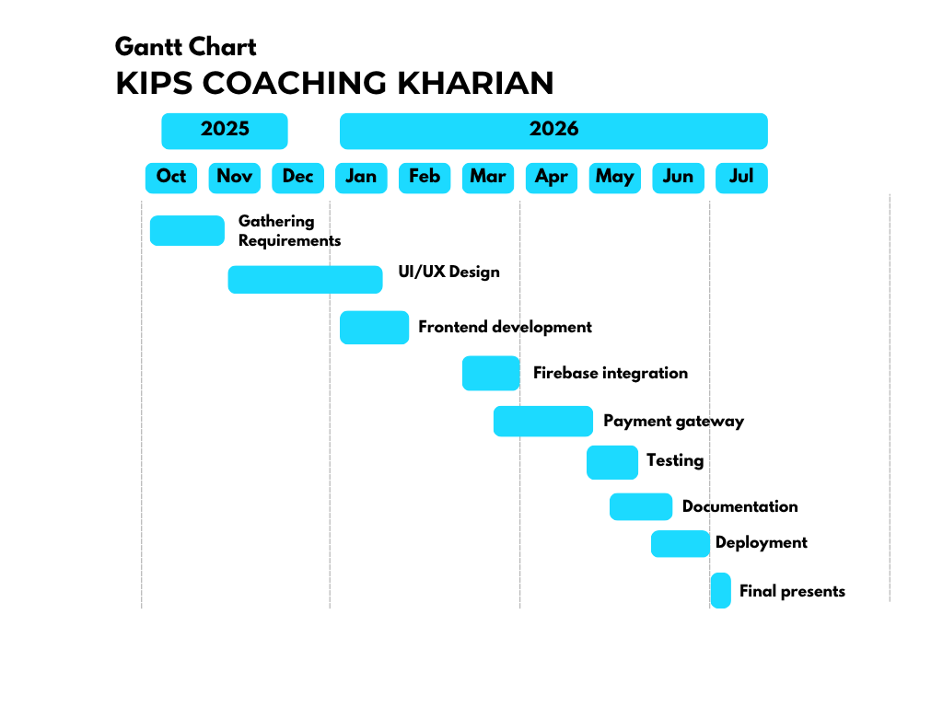

Figure 1: Gantt Chart

1.12 Summary
This chapter introduces the functionalities and core features of our mobile application. First, it states the problem that led to the development of our mobile application followed by the solution which is our app named KIPS Coaching Kharian. This chapter also outlines the goals and objectives of our proposed system, along with the risks, limitations and dependencies in details. The scope of our project is included and the system components are clearly defined. A literature review is provided to analyze related systems. We crafted a vision statement that conveys the long-term purpose, intent and significance of our product. Additionally, this chapter list the limitations and constraints of our system and describe the technologies and tools used in the project's implementation. To represent plans for carrying out project activities and showcasing milestones, a Gantt chart is also displayed.

Chapter 2

Literature Review

2.Review
Literature Review of our project highlights the previous researches, systems and technologies related to our system. This review helps by providing the modern recommendations and upgrade the system.

2.1 Literature Survey
Recent studies on Learning management system (LMS) shows that digital platforms improve learning efficiency by offering online content, quizzes, scheduling and progress tracking. Research highlights that mobile based system are more effective in developing countries because they reduce physical barriers such as distance and weather etc. For such system to succeed features like user authentication, content management and fee deposits are essential. However, challenges such as poor internet access, limited teacher training and lack of integrated systems for students, parents and teachers still affect adoption in many educational institutions.

2.2 Related work
As there is a manual system, there is no online system of KIPS Coaching Kharian. However, there are similar applications related to educational management systems that are functioning effectively in the education industry. These include KIPS Virtual App, The Educators Online System and Roots International Learning Platforms. These institutions have successfully implemented digital platforms and achieved notable success in managing academic and administrative operations.
Table 3: Related Systems

App name | Weakness | Proposed Solutions
KIPS Virtual App | The KIPS Virtual System provides limited access for students, as it primarily focuses on student enrollment and recorded video lectures. There is no facility for live online classes which reduces real-time interaction between students and teachers. | An integrated system is proposed that provides live classes, student performance tracking and parents can monitor their child performance and communicate with teachers.
Roots International Learning Platform | High subscription and maintenance cost. | An affordable and scalable solution is proposed for medium-sized academies like KIPS Coaching Academy, reducing costs while supporting future growth.

2.3 Gap analysis

The comparison of existing system shows several gaps that KIPS COACHING KHARIAN will address:
Lack of integrated Teacher and Parent communication in current systems.
No user friendly branch specific app managing registrations, schedules, study material and fee payments.
Existing systems does not solve problems like online classes, registration or communication with parents about student performance.
Many platforms lack low cost online payment integration, which your system introduce.

2.4 Summary

The literature and related work indicate a strong need for digital academic management systems that are affordable, mobile friendly and suitable for institution. Current portal provides partial digital services but fail to address issues like communication gaps, accessibility and manual work load. Our system provides a digital platform for students, teacher, parent and administrator that supports efficient learning and management.

Chapter 3

Requirements Analysis

3.Analysis
Software requirement specification for our project SRS, which addresses both the functional and non-functional needs of our mobile application, is presented in this chapter. Along with the hardware, software and communication interfaces that will be utilized to carry out this project.
It also outlines the requirements for the user and external interfaces. This chapter acts as a point of reference for the project's progress.

3.1 User Classes and Characteristics

Table 4: User Classes and Characteristics
User Class | User Characteristics
Admin | Secure login, update profile, View and manage all users,  Manage user’s account, unique ID for Student, Create and share class timetable, Assign teacher to specific classes, View all scheduled sessions and enrollments, Enrolled Student report and manage payment of student fee, Send announcements/Notification and logout.
Student | Registration and login, Update Profile, View and enroll into subjects, Attend online classes, Download study material, View and attempt quizzes and assignments, Online fee payment, View progress report, Receive alerts and notifications, Give Review and Feedback and Logout
Teacher | Login and profile update, Create and Join classes and deliver lecture, Upload study material, View enrolled students of their subjects, Create quizzes and assignments, Upload assignment/quizzes marks, Upload student performance, communication with parents, Receive Notification and Logout.
Parent | Registration and login, update profile, Communication with teachers directly, Access Child’s dashboard and monitor child performance, view progress report, Online fee payment, Receive instant alerts, Review and Feedback and logout.

3.2 Requirement Identifying Techniques
This part enlists various techniques that are used to identify the requirements of our project
KIPS COACHING KHARIAN.

Use Case Diagram
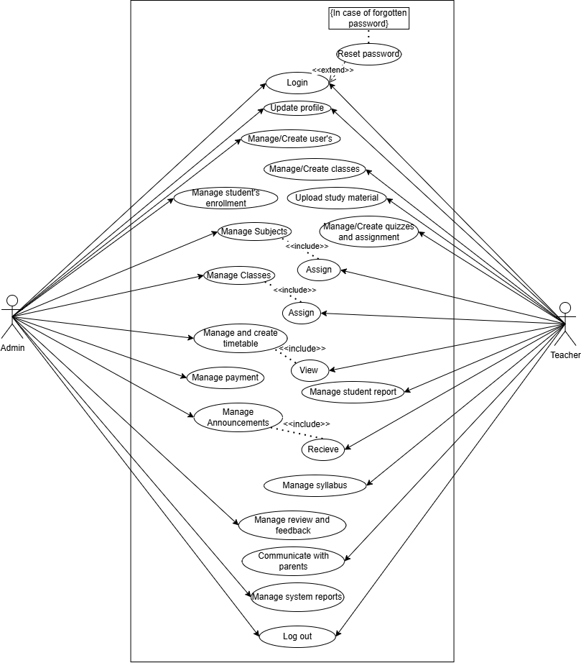
Figure 2: Use case diagram

Use Case Diagram
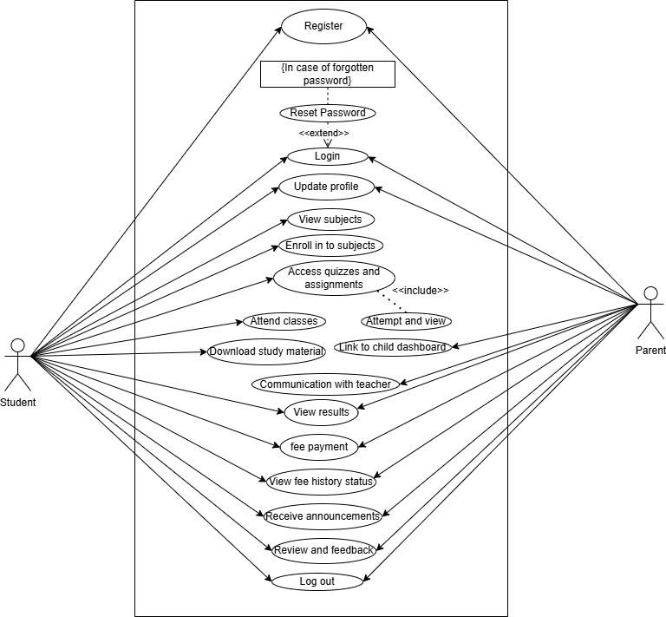
Figure 2: Use case diagram

Table 5 Use Case 1: Register

ID: | UC#1
Title | Register
Description | Allow users (student and parent) to register with the KIPS Coaching Kharian app
Primary Actors | Student, Parent
Preconditions | Students and Parents are not already registered and has valid username /email.
Post conditions | User account is created and stored in the system database.
Main success scenario | Users (student and parent) selects “Register”.  Users (student) enters required details (Full name, Email, username, Password).  For User (parent) enter required details (Full name, Phone number, Email Address, Student-Id, Password)  After validation, system successfully registers the users (student and parent).
Alternate Flow | Already registered Login
Exception | Invalid email format and weak password
Status | Completed
Priority | Very High
Include | Validate user input

Table 6 Use Case 2: Login

ID: | UC#2
Title | Login
Description | Allow an authorized user (admin, students, parents and teachers) to securely log in to the system to access their respective functionalities.
Primary Actors | Admin, Parent, Teacher, Student
Preconditions | The users (Admin, Teachers) have a valid Email Address and password. The users (Students and parents) have valid Email address, Student-Id and password.  The system is operational and the login page is displayed.
Post conditions | The user is successfully authenticated and redirected to the dashboard.  An error message is displayed for invalid credentials and the user remains on the login page.
Main success scenario | User open the app  Users selects the account type  If user is Admin or Teacher then enter email and password  If user is Student or Parent then enter email, student-id and password  System verifies the entered credentials  User is logged in successfully
Alternate Flow | User enter incorrect credentials  System display an error message
Exception | Server error or network failure during login
Status | Draft
Priority | Medium
Include | User authentication Role based access control

Table 7 Use Case 3: Reset Password

ID: | UC#3
Title | Reset Password
Description | Allow User (Admin, Student, Teacher and Parent) to reset their forgotten password for the KIPS COACHING KHARIAN APP.
Primary Actors | Admin, Student, Teacher, Parent
Preconditions | The user (admin, student, teacher and parent) must have a registered account within the system
Post conditions | The user’s password is successfully reset and they can access their account with the new credentials.
Main success scenario | Users select forgotten password or reset password. User enters their registered email or mobile number. After validation the system sends a password reset link or temporary password. User follow the instructions to set a new password. System successfully updates a user password.
Alternate flow | User enters an unregistered email.  Password reset link expires  User requests multiple password resets.
Exception | System failure during password update. Emails delivery failure  Invalid password format.
Status | Proposed
Priority | High
Include | Validate user input

Table 8 Use Case 4: Update Profile

ID: | UC#4
Title | Update Profile
Description | Allow an authorized user (admin, students, parents and teachers) to modify their personal information such as contact details, username etc.
Primary Actors | Admin, Parent, Teacher, Student
Preconditions | The user is successfully logged into the system.  The user is on the “Profile” page.
Post conditions | The user’s information is updated in the database.  A confirmation message “Profile updated successfully” is displayed.
Main success scenario | User selects “Edit Profile”.  User modifies the desired fields.  User clicks the “Update” button. System validates the input data.  System updates the record and displays success message
Alternate Flow | None
Exception | Database connection error, server timeout during update.
Status | Completed
Priority | Medium
Include | Personal details, Contact info

Table 9 Use Case 5: Manage User Registrations

ID | UC#5
Title | Manage User Registrations
Description | Allows an administrator to review and approve registration requests from students and parents
Primary Actors | Admin
Preconditions | Student or parent has submitted a registration
Post conditions | The users (student and parent) registration is approved and their account is activated. to the approved user. The request is remove from the pending list
Main success scenario | Admin log in.  Admin view pending registration.  Admin select a request.  Admin approve the registration.  System activate the account and generate a unique id for Student.
Alternate Flow | Admin reject the registration request. System send rejection notification.
Exception | System error or connection failure during approval process.
Status | Draft
Priority | Medium
Include | User authentication Notification Service

Table 10 Use Case 6: Manage Users

ID: | UC#6
Title | Manage Users
Description | Allow the admin to add new users, update existing users details or delete student, teacher and parent accounts.
Primary Actors | Admin
Preconditions | Admin is logged in and has management privileges.
Post conditions | User records are added, updated or removed from the system database.
Main success scenario | Admin log in  Admin select the manage users.  Admin choose add, update or delete option.  Admin enter or modify user details.  System save changes successfully.
Alternate flow | Admin cancel the operation. No changes are saved.
Exception | Database error or system failure during operation.
Status | Approved
Priority | High
Include | User Authentication Data Validation

Table 11 Use Case 7: Manage classes/sections(Admin)
ID: | UC#7
Title | Manage classes/sections(Admin)
Description | Admin creates, edit, views and deletes class records (e.g. Grade 10th A) within the system.
Primary Actors | Admin
Preconditions | Admin must be logged in and have administrative permissions. Academic years/terms should be defined.
Post conditions | Class information is updated in the database; classes/sections become available for subject assignment and timetabling.
Main success scenario | Admin log in.  Admin open Student card and approve the student requests.  After approving the request, the confirmed mail is sent to the student with the student id and assigned class/section.
Alternate flow | Admin deletes a class/section.  System alerts admin if a class with the same name and section already exists.
Exception | System or database error during saving; data is not updated and an error message is displayed.
Status | Approved
Priority | High
Include | User Authentication

Table 12 Use Case 8: Manage subjects(Admin)
ID: | UC#8
Title | Manage subjects(Admin)
Description | Admin creates, edits and deletes subjects in the system catalog.
Primary Actors | Admin
Preconditions | Admin must be logged in and have administrative permissions to manage the curriculum.
Post conditions | The subject list is updated; changes are reflected across the system.
Main success scenario | Admin log in.  Admin open Subject Management module.  Admin views existing list of subjects.  Admin adds a new subject.  Admin saves changes and confirms the update.
Alternate flow | Admin searches for specific subject by code or name before editing.
Exception | System prevents deletion if a subject is currently assigned to an active timetable or student.
Status | Approved
Priority | High
Include | User Authentication

Table 13 Use Case 9: Assign subjects and classes to teachers(Admin)
ID: | UC#9
Title | Assign subjects and classes to teachers
Description | Admin assigns specific subjects and class sections to teachers for the academic term.
Primary Actors | Admin
Preconditions | Admin must be logged in ; Teachers, subject and classes must already be registered in the system.
Post conditions | The teacher’s profile is updated with their teaching load and the schedule is updated.
Main success scenario | Admin log in.  Admin open teacher card.  Admin fill the form for the teacher.  Admin chooses the subject and the specific class/section.  Admin confirms and saves the assign classes and subjects.  System updates the database and notifies the teacher with the login credentials through the mail.
Alternate flow | System alerts admin if a teacher is assigned a subject they are not qualified or if there is scheduling clash.
Exception | System or database error during saving; data remains unchanged.
Status | Approved
Priority | High
Include | User Authentication, Notification service

Table 14 Use Case 10: View student’s enrollment in subjects(Admin)
ID: | UC#10
Title | View student’s enrollment in subjects(Admin)
Description | Admin views and manage the list of students enrolled in specific subjects.
Primary Actors | Admin
Preconditions | Admin must be logged in; Subjects and Students must already exist in the system.
Post conditions | Admin successfully views the enrollment list; may export or modify records.
Main success scenario | Admin log in.  Admin open Enrollment module.  Admin selects a specific class or subject.  System displays a list of all enrolled students.  Admin filters or searches for specific students as needed.
Alternate flow | Admin selects a student to view their individual subject list.
Exception | No students are currently enrolled in the selected subjects ( system displays “ No records found”).
Status | Approved
Priority | High
Include | User Authentication, Reporting Service

Table 15 Use Case 11: Manage Announcements (Admin)
ID: | UC#11
Title | Manage announcement
Description | Admin can create, edit and delete system announcement for students, teachers and parents.
Primary Actors | Admin
Preconditions | Admin must be logged in and have permissions to manage announcements.
Post conditions | Announcements are updated and relevant users can view them via notifications.
Main success scenario | Admin log in.  Admin open Announcement module.  Admin create or edit an announcement.  Admin publish the announcement.
Alternate flow | Admin deletes an announcement.  System removes it from user view.
Exception | System or database error during announcement management.
Status | Approved
Priority | High
Include | User Authentication Notification Service

Table 16 Use Case 12: Manage system reports(Admin)
ID: | UC#12
Title | Manage system report
Description | Admin can view various system report in the system.
Primary Actors | Admin
Preconditions | Admin must be logged in.
Post conditions | The system displays the requested report.
Main success scenario | Admin log in.  Admin select System Report.  Admin choose the report.  System generate and display the report.
Alternate flow | Admin applies filters.  System update the report view.
Exception | Report generation failure or database error.
Status | Approved
Priority | Medium
Include | User Authentication Reporting Module

Table 17 Use Case 13: Manage Fee Payment(Admin)
ID: | UC#13
Title | Manage fee payment
Description | Admin can save fee payment record from a student in the system.
Primary Actors | Admin
Preconditions | Admin must be logged in and the student record must exist.
Post conditions | The fee payment is recorded in the system and fee paid notification send to student and parents.
Main success scenario | Admin log in.  Admin opens the payment Module.  The system shows two options; Fee management and Fee challan.  Admin searches for the student name.  System displays the student’s fee details and payment status.  Admin searches a student and generates a fee challan.  System checks payment details.  System saves the fee payment record.  System updates the student’s fee status as paid or unpaid.  System sends a fee payment notification to the student and parents.  System displays a confirmation message that the payment record has been saved successfully.
Alternate flow | System displays an existing fee payment record.  Admin modifies the payment amount or payment status.  System validates and saves the updated payment record.  System refreshes and updates the student’s fee status.
Exception | Payment record save failure or database error.
Status | Approved
Priority | High
Include | User Authentication Fee Management Module

Table 18 Use Case14: Manage Class timetable(Admin)
ID: | UC#14
Title | Manage Class timetable(Admin)
Description | Allow an admin to create and modify weekly class schedule within the system and allow the student and teacher to view the classes timetable.
Primary Actors | Admin
Preconditions | The admin must be logged into the application and the admin have appropriate permission to edit scheduled and teacher and student have permission to view timetable.
Post conditions | The new timetable is saved and published to the system visible to the relevant user student and teacher name.
Main success scenario | Admin logs into the system.  Admin opens the timetable management section.  Admin creates or updates the class timetable by selecting classes, subjects, teachers, days and timings.  System validates the timetable details, saves the timetable in the database and publishes it for relevant classes.  Teachers and students receive timetable notifications.  Teachers and students can view the updated timetable in their dashboard
Alternate flow | Admin change day or view weekly timetable.
Exception | Timetable not available or system error
Status | Approved
Priority | Medium
Include | Login

Table 19 Use Case15: View Class timetable (Teacher and Student)
ID: | UC#15
Title | View Class timetable
Description | Allow teacher and student to view the class timetable that has been created and shared by the Admin.
Primary Actors | Teacher, Student
Preconditions | The Admin has created and shared the timetable.  The teacher/student must be logged into the application.
Post conditions | The user has successfully viewed the relevant, up-to-date class timetable.
Main success scenario | User log in to the system.  User open timetable section.  System retrieves timetable data shared by the Admin.  System display class timetable for the user specific group or subject.
Alternate flow | If the Admin changes the timetable, the updated version is instantly visible to teachers and students upon refresh.
Exception | Timetable not yet shared by Admin or system error
Status | Approved
Priority | High
Include | Login

Table 20 Use Case16: View subjects(Student)

ID: | UC#16
Title | View subjects(Student)
Description | Allows students to view the list of available subjects during the registration process.
Primary Actors | Student
Preconditions | Student has opened the registration page.  The subject list is available in the system.
Post conditions | The available subjects are displayed to the student.
Main success scenario | Student opens the registration page.  System displays the list of available subjects.  Student views the subject names.
Alternate flow | If no subjects are available, the system displays "No subjects available."
Exception | Data retrieval failure or system error
Status | Approved
Priority | Medium
Include | Registration, Subject Management Module

Table 21 Use Case17: Enroll into Subjects
ID: | UC#17
Title | Enroll into Subjects
Description | Allows students to enroll in one or more subjects during the registration process.
Primary Actors | Student
Preconditions | Student has viewed the available subjects.  Student is completing the registration process.
Post conditions | The selected subjects are saved with the student's registration request.  After admin approval, the student is enrolled in the selected subjects.
Main success scenario | Student selects one or more subjects.  Student clicks Submit Registration.  System validates the selected subjects.  System saves the enrollment request.  Admin approves the registration.  System enrolls the student in the selected subjects.
Alternate flow | Student changes the selected subjects before submitting the registration.
Exception | Enrollment request cannot be saved due to a system error.
Status | Approved
Priority | High
Include | Registration, User Authentication, Subject Management Module

Table 22 Use Case 18: Fee payment
ID: | UC#18
Title | Fee payment
Description | Allow student to pay their fee or parent to pay their child’s fees through the system.
Primary Actors | Parent, student
Preconditions | Automatically notifies parents or students about fee payments, including due dates and payment status.
Post conditions | Parent or student receives a notification about pending or due fees.
Main success scenario | System checks pending or upcoming fee payments.  System generates a notification.  System sends notification to parent/student via app.  Parent/student receives the notification.  Parent/student views payment details and status.
Alternate flow | Parent/student views history of previous fee notifications.
Exception | Fee record not found for the student.  Notification delivery fails due to network or system error.
Status | Approved
Priority | High
Include | Login, Link parent account to child, view fee history

Table 23 Use Case19: Attend online classes(Student)

ID: | UC#19
Title | Attend online classes
Description | Student joins and attend the scheduled online class using the provided link.
Primary Actors | Student
Preconditions | The student is registered and must be logged into the application.
Post conditions | Student successfully attends the online class.
Main success scenario | Student log in.  Student view online class schedule.  Student joins the class meeting.  System redirects to the online meeting platform.  Student attend the class.
Alternate flow | Student join the class directly from the notification link. Student joins the class late.
Exception | Invalid or expire link shows an error message.  Internet or system issue unable to join the class.
Status | Approved
Priority | High
Include | Authenticate student view class schedule

Table 24 Use Case20: Download Study Material

ID: | UC#20
Title | Download study material
Description | Registered students can download available study materials from the app.
Primary Actors | Student
Preconditions | The student must be logged in and study material must be available.
Post conditions | The selected study material is downloaded to the student's device.
Main success scenario | Student log in.  Student select subject.  Student choose study material.  System downloads the file.
Alternate flow | Student view material online instead of downloading. System displays the content.
Exception | Download failure or network issue.
Status | Proposed
Priority | High
Include | User Authentication File Download

Table 25 Use Case21: View and attempt online quizzes and assignment

ID: | UC#21
Title | View and attempt quizzes and assignment
Description | Allow a student to view an available quiz and assignments within the app.
Primary Actors | Student
Preconditions | The student must be registered and logged into the application.
Post conditions | The student must be logged into the system and a quiz and assignment must be available and assigned to them.
Main success scenario | Student log in.  Student select Quizzes and assignment.  Student select an available quiz and assignment.  Student attempt and submits quiz and assignment
Alternate flow | Student exits quiz and assignment before submission. System auto save or discard attempt.
Exception | Timer expiration or network failure during quiz and assignment.
Status | Proposed
Priority | High
Include | User Authentication Quiz and assignment

Table 26 Use Case 22: View fee history and status

ID: | UC#22
Title | View fee history and status
Description | Allow parent to view the fee history and payment status of a linked child’s account.
Primary Actors | Parent, student
Preconditions | The parent and the child must have an active account, the parent account must be linked with the child’s account and the fee data must exist for the child.
Post conditions | The child’s fee history and status are successfully displayed on the parent’s dashboard.
Main success scenario | Parent/Student logs into the system.  Selects “View Fee History and Status” option.  System displays detailed payment history, including dates, amounts and status (paid/unpaid).  Parent/Student reviews current balance and pending payments.  Optionally, Parent/Student downloads or prints the fee report.
Alternate flow | Parent/Student filters fee history by month or year. Parent/Student receives a summary of total fees paid and pending.
Exception | No fee records found for the student.  System error prevents displaying the fee history.
Status | Approved
Priority | High
Include | Login, Link parent account to child, notification for fee payment

Table 27 Use Case23: Create link for online classes

ID: | UC#23
Title | Create link for online classes
Description | Teacher creates online class link and system will share it with the students.
Primary Actors | Teacher
Preconditions | The teacher must be logged into the application.
Post conditions | Online classes link is created and available to the students and a class reminder is scheduled for the teacher.
Main success scenario | Teacher log in.  Teacher select create online Class.  Teacher enter class detail (subject, date, time).  Teacher enters meeting link.  Teacher click saves/ share.  System saves the link and notifies students.  System schedules a reminder notification for the teacher 15 minutes before class.
Alternate flow | Teacher edit class detail.  Teacher reschedule the class.
Exception | Invalid or missing meeting link error shown. System or internet failure.
Status | Approved
Priority | High
Include | Authenticate teacher notify students

Table 28 Use Case24: Syllabus
ID: | UC#24
Title | Syllabus
Description | Teacher creates or update syllabus for their assigned subject.
Primary Actors | Teacher
Preconditions | The teacher must be logged into the application and have a subject assigned to them.
Post conditions | Syllabus is saved for teachers.
Main success scenario | Teachers log in.  Teacher select syllabus option.  Teacher enters/updates syllabus content.  Teacher click save.  System saves syllabus and mark it pending or covered.
Alternate flow | Teacher edit previously saved syllabus.
Exception | Empty content error shown. System or internet failure.
Status | Approved
Priority | High
Include | Teacher Authentication

Table 29 Use Case25: Upload study material
ID: | UC#25
Title | Upload study material
Description | Allow a teacher to upload study material for students within the app.
Primary Actors | Teacher
Preconditions | The teacher must be logged into the application. The teacher must have a course assigned to them.
Post conditions | Study material must be available for students to view.
Main success scenario | Teachers log in.  Teacher select Study Materials.  Teacher upload file and add details.  System validate and save the material.
Alternate flow | Teacher update or delete existing material. System reflect changes.
Exception | File upload failure or unsupported file format
Status | Approved
Priority | High
Include | User Authentication File Management

Table 30 Use Case26: Upload and view assignments

ID: | UC#26
Title | Upload and view assignments
Description | Teachers upload a PDF assignment and view assignment for their classes.
Primary Actors | Teacher
Preconditions | The teacher must be logged in.
Post conditions | Assignment PDF is uploaded and visible to students or saved as a draft.
Main success scenario | Teacher select subject and grade.  Teacher enters title, total marks, description and due date/time.  Teacher upload PDF file.  Teacher click upload assignment or save as draft.  Teacher open assignment section.  System display uploaded assignments
Alternate flow | Teacher edit, update or reload a draft assignment.
Exception | Invalid file format, upload failure or assignment not found.
Status | Approved
Priority | Medium
Include | Log in

Table 31 Use Case27: Create online quizzes
ID: | UC#27
Title | Create quizzes
Description | Allow a teacher to create quizzes within the system.
Primary Actors | Teacher
Preconditions | The teacher must be logged into the application. The teacher must have a course assigned to them.
Post conditions | Quiz is available for students and their submitted answers can be checked for copied or AI-generated content.
Main success scenario | Teacher log in.  Teacher select Quizzes.  Teacher create quiz questions and settings.  Teacher will set the quiz timer.  Teacher publish the quiz.  Teacher checks submitted answers using AI for copied or AI-generated content.
Alternate flow | Teacher edit or delete a quiz. System update quiz details.
Exception | Quiz save failure or system error.
Status | Approved
Priority | High
Include | User Authentication Quiz Management AI Content Check

Table 32 Use Case 28: Manage student performance
ID: | UC#28
Title | Manage student performance
Description | Allow teacher to give and update marks on a student’s quizzes, assignments and class attended.
Primary Actors | Teacher
Preconditions | The teacher must be logged in and assigned to relevant courses.
Post conditions | Student performance data is recorded and updated in the system.
Main success scenario | Teacher log in to the system.  Teacher select student performance.  Teacher view student performance list.  Teacher enter or update marks/grades.  System save and display updated performance.
Alternate flow | Teacher edit or update previously entered performance data.
Exception | Invalid data entry.  Student record not found or system error.
Status | Approved
Priority | High
Include | Login

Table 33 Use Case29: Communication between Teachers and Parents
ID: | UC#29
Title | Communication with Parents
Description | System allow teachers and parent to exchange real-time messages regarding a student.
Primary Actors | Teacher, Parent
Preconditions | The teacher or parents must be logged in.
Post conditions | Message is delivered and stored in the conversation and a notification is sent to the recipient.
Main success scenario | Teacher logs in to the system.  User opens the communication section.  User selects the other person’s conversation.  User types and sends a message.  System saves and delivers the message in real-time.  System sends a notification for the new message.
Alternate flow | Teacher and Parent edits or resends the message before final submission. Parent and teacher views the message later if not online.
Exception | Teacher/Parent account not found.  Message sending fails due to system error.
Status | Approved
Priority | High
Include | Login

Table 34 Use Case30: Link child account to parent (Parent)
ID: | UC#30
Title | Link child account to parent
Description | Allow parent to link their account to a child existing account using child’s Student-id.
Primary Actors | Parent
Preconditions | The parent and the child must have an active account.
Post conditions | Child account is successfully linked
Main success scenario | Parent logs in to the system and opens the dashboard  Parent selects “Link child account” option.  System retrieves and displays the child’s detail.  System links the child account to parent account successfully.
Alternate flow | Parent requests linking for children.
Exception | Child account not found.  Parent provide incorrect Student ID.  System error prevents linking.
Status | Approved
Priority | High
Include | Login

Table 35 Use Case31: View child academic overview (Parents)
ID: | UC#31
Title | View child academic overview
Description | Allow parent to view the linked child’s academic overview.
Primary Actors | Parent
Preconditions | The parent and the child must have an active account and the parent account must be linked with the child’s account.
Post conditions | The child’s academic overview is successfully displayed to the parent.
Main success scenario | Parent logs into the system.  Parent opens the linked child account.  System displays the child’s academic overview.  System displays academic overview, quiz and assignments report and progress report  Parent reviews the information.
Alternate flow | Parent navigates progress report, quiz section and assignment after viewing the academic Overview
Exception | No child account linked to parent.  System error prevents loading the profile.
Status | Approved
Priority | High
Include | Login, Link child account to parent

Table 36 Use Case 32: View progress report
ID: | UC#32
Title | View progress report
Description | Allow parent and students to view the academic report.
Primary Actors | Parent, Students
Preconditions | The parent and the child must have an active account. The parent account must be linked with the child’s account and the child must have report available in the system.
Post conditions | The child’s academic reports are successfully displayed to the parent and student dashboard.
Main success scenario | Parent/Student logs into the system.  Selects “Progress report” option.  System displays the student’s exam results and grades.  System shows performance, total marks and subject-wise marks.  Parent/Student reviews the report.
Alternate flow | Parent/Student selects a specific class to view report.  System provides graphical representation of performance.
Exception | Report not yet available.  Parent/Student account not linked correctly.  System error prevents loading report.
Status | Approved
Priority | High
Include | Login, Link child account to parent

Table 37 Use Case33: Receive announcements
ID: | UC#33
Title | Receive announcement
Description | Allows users (Student, Teachers, Parents) to view available announcements within the app through notification.
Primary Actors | Student, Teachers, Parents
Preconditions | The user (Student, Teachers, Parents) must be logged into the application.
Post conditions | Announcement must be available and assigned to them.
Main success scenario | User logs in to the system.  User open the announcement section.  System retrieves announcements.  System display announcements to the user.
Alternate flow | User refresh or filter announcement
Exception | No announcement or system error
Status | Approved
Priority | Medium
Include | Login

Table38 Use Case 34: Feedback and Review
Id | UC#34
Title | Feedback and Review
Description | Allows student and parent to give feedback and review about the system
Actor | Parent, student
Preconditions | Parent and student must enter feedback
Post conditions | Parent and student can give feedback and reviews of using app.
Main success scenario | Student and parent give review about system (App).
Alternate Flow | None
Exceptions | Submission Failure
Status | Completed
Priority | Medium
Include | None

Table 39 Use Case 35: Logout
ID: | UC#35
Title | Logout
Description | The user ends their session and logout of the system.
Primary Actors | Admin, Students, Teachers, Parents
Preconditions | The user is currently logged in.
Post conditions | The user is logged out and the system displays the login screen.
Main success scenario | User clicks the “Logout” button.  System terminates the user session.  System redirects the user to the login page.  User confirms they have successfully logged out.
Alternate flow | User session times out automatically due to inactivity, triggering automatic logout.  User cancels logout confirmation (if system asks for confirmation).
Exception | System error prevents logout (rare).  Network interruption during logout may require user to retry.
Status | Approved
Priority | High
Include | Login

Storyboarding
This story board is made using Canva. It depicts our student module in visual form.
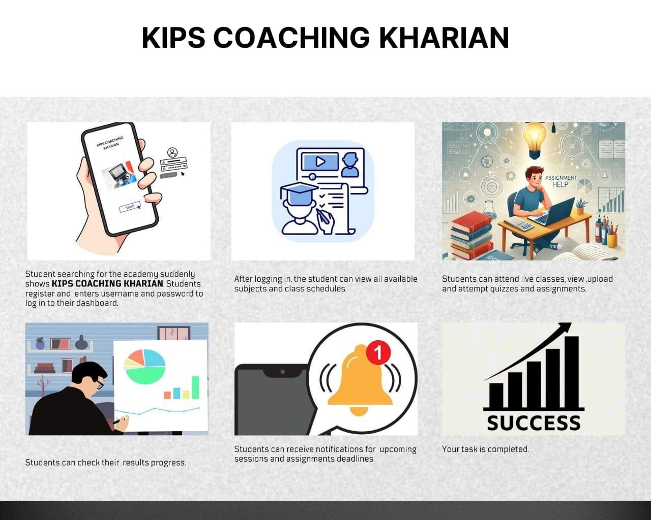

Figure 3: Story boarding

3.3 Functional Requirements

Requirements that must be fulfilled to complete the functionality of our system.
1.User Registration: User (student and parent) shall be able to register themselves by providing credentials.
2.Reset Password: User can reset password in the case of forgot password.
3.User Login: User shall be able to login to the system after registration.
4.Update Profile: Users (Admin, student, teacher and parent) shall update their profiles.
5.Manage users registrations: Admin shall approve the student and parent registration and manually add the teacher.
6.Manage users: Admin shall add, update and delete users (student, teacher and parents).
7.Manage Classes/Sections: Admin shall create, edit, view and delete class/section records within the system.
8.Manage Subjects: Admin shall add, update and delete subjects in the system subject catalog.
9.Assign Subjects and Classes to Teachers: Admin shall assign specific subjects and class sections to teachers.
10.View Student Enrollment in subjects: Admin shall view the list of students enrolled in specific subjects or classes.
11.Manage announcements: Admin shall manage the announcements for the students, teachers and parents.
12.View System Report: Admin shall view the system report.
13.Record fee payment: Admin shall record fee payment in the system.
14.Manage Class Timetable: Admin shall create, edit and publish the class timetable for teachers and students.
15.View Class Timetable: Teacher and students shall view the class timetable shared by the admin
16.View subjects: Student shall view the subjects.
17.Enroll into Subjects: Student shall select and enroll into their desired subjects for the class.
18.Fee Payment: Students shall pay their own fee or parent shall pay their child’s fees through the system.
19.Attend online classes: Students shall attend online classes.
20.Download study material: Students shall download the study material.
21.View and attempt quizzes and assignment:
Students shall view and attempt quizzes and assignments.
22.Upload Study material: Teacher shall upload the study material.
23. Manage Syllabus: Teacher shall manage syllabus for their assigned subject.
24.Create quizzes: Teacher shall create quizzes for the students and check their answers using AI for copied or AI-generated content.
25.Upload and view assignments: Teacher shall upload and view assignments.
26.Create link for online classes: Teacher shall create a link for online class and system shall send a reminder notification before class starts.
27. Receive Announcements: Users (students, teachers and parents) shall receive announcements.
28.Manage student performance: Teacher shall manage the student performance.
29.Communication with parents: Teacher shall communicate with the parents through the email.
30.LinkChild to Parent: The parent account shall link with the child.
31. View child profile: Parents shall view the profile information of the linked child’s account.
32.View progress report: The students and parents shall view the reports.
33.View fee history and status: The parent shall view the fee history and payment status of linked child’s account.
34. Feedback and Review: Students and Parents give the review about the app performance.
35.Logout: The user ends their session and logout of the system.

3.3.1 Functional Requirements

Table 40 Functional Requirement#1
Identifier | Functional Requirement#1
Title | Register
Requirement | User can register for an account using personal details.
Source | KIPS management
Rationale | To allow users to access the system and its features.
Business rule (if required) | User must have a Credentials.
Dependencies | None
Priority | High

Table 41 Functional Requirement#2
Identifier | Functional Requirement#2
Title | Log in
Requirement | System allows users to securely login into the system
Source | System requirement
Rationale | To provide secure access for system users.
Business Rule (if required) | User must be an admin, student, teacher or parent and login with valid credentials
Dependencies | User login system user authentication
Priority | High

Table 42 Functional Requirement#3
Identifier | Functional Requirement#3
Title | Reset password
Requirement | System allows users to securely reset their forgotten password.
Source | System requirement
Rationale | To allow users to regain access to the system if they forget their credentials.
Business Rule (if required) | User must provide a valid email address or username to receive a reset link or code. The reset token should expire within a short period and be single use.
Dependencies | User authentication system, email service.
Priority | High

Table 43 Functional Requirement#4
Identifier | Functional Requirement#4
Title | Update profile
Requirement | User shall be able to view and update their personal information like name, email and password.
Source | User, Security standards
Rationale | Allow user to keep their account information accurate and secure.
Business Rule (if required) | User must be registered.  Password must meet requirements
Dependencies | FR-2
Priority | Medium

Table 44 Functional Requirement#5
Identifier | Functional Requirement#5
Title | Manage registrations
Requirement | System must verify the student and parent identity during the registration process to ensure authenticity and prevent fraud
Source | System design specification legal compliance
Rationale | To maintain data integrity security and comply with regulations
Business Rule (if required) | User must provide a valid email address and a unique identification document
Dependencies | E-mail system, ID verification services or database, user database
Priority | High

Table 45 Functional Requirement#6
Identifier | Functional Requirement#6
Title | Add, update and delete users
Requirement | Allows an admin to securely add a new users account to the system
Source | kips requirements and parent feedback
Rationale | To efficiently enroll new users and manage records
Business Rule (if required) | User must be logged in and have appropriate permissions and requirement fields must be completed
Dependencies | User login, user database, account creation system
Priority | High

Table 46 Functional Requirement#7
Identifier | Functional Requirement#7
Title | Manage classes/Section (Admin)
Requirement | System allows admin to create, edit, view and delete class records.
Source | kips management and system requirement
Rationale | To organize students and teachers into structured class units for effective academic management.
Business Rule (if required) | Admin must be logged in with management privileges.  Class names must be unique per academic year and section.
Dependencies | Admin login, class management
Priority | High

Table 47 Functional Requirement#8
Identifier | Functional Requirement#8
Title | Manage Subjects (Admin)
Requirement | Allows admin to create, edit and delete subjects in the system.
Source | kips management
Rationale | To maintain an up-to-date subject catalog that can be assigned to classes and teachers.
Business Rule (if required) | Admin must be logged in.  Subjects currently assigned to active timetables or students cannot be deleted.
Dependencies | Admin login, class management
Priority | High

Table 48 Functional Requirement#9
Identifier | Functional Requirement#9
Title | Assign Subjects and Classes to Teachers
Requirement | System allows admin to assign specific subjects and class sections to designated teachers.
Source | kips requirements
Rationale | To ensure every class has a qualified teacher assigned for each subject.
Business Rule (if required) | Admin must be logged in.  Teachers, Subjects and classes must already be registered.  A teacher cannot be double assigned to the same time slot.
Dependencies | Admin login, teacher management, subject management, class management
Priority | High

Table 49 Functional Requirement#10
Identifier | Functional Requirement#10
Title | View Student Enrollment in Subjects (Admin)
Requirement | Allows admin to view and manage the list of students enrolled in specific subjects and classes.
Source | kips requirements
Rationale | To give admin visibility over students enrollment for reporting and record management.
Business Rule (if required) | Admin must be logged in and students and subjects must exit in the system.
Dependencies | Admin login, student management, subject management
Priority | High

Table 50 Functional Requirement#11
Identifier | Functional Requirement#11
Title | Manage announcement
Requirement | The system shall allow administrators to create, update and delete announcements.
Source | System user
Rationale | To communicate important information to users effectively and maintain current announcements.
Business Rule (if required) | Only administrators can manage announcements.
Dependencies | Database connection
Priority | High

Table 51 Functional Requirement#12
Identifier | Functional Requirement#12
Title | Manage system reports
Requirement | The system shall allow administrators to view system reports.
Source | System user
Rationale | To monitor system performance and usage.
Business rule (if required) | Only administrator can view the report.
Dependencies | Database connection, reporting modules.
Priority | High

Table 52 Functional Requirement#13
Identifier | Functional Requirement#13
Title | Manage fee payment
Requirement | The system shall allow authorized users to record and manage student fee payments.
Source | Only the Administrator can record the payment
Rationale | To maintain Accurate and current financial records.
Business Rule (if required) | Only the administrator can record a payment.
Dependencies | Database connection
Priority | High

Table 53 Functional Requirement#14
Identifier | Functional Requirement#14
Title | Manage Class Timetable (Admin)
Requirement | Allows admin to create, edit and publish the class timetable for each teachers and students.
Source | kips requirements
Rationale | To provide a structured weekly schedule for all classes.
Business Rule (if required) | Admin must be logged in with scheduling permissions. Classes, subjects and teachers must exit.
Dependencies | Admin login, class management, subject management
Priority | High

Table 54 Functional Requirement#15
Identifier | Functional Requirement#15
Title | View Class Timetable
Requirement | Allows teachers and students to view the class timetable shared by the admin.
Source | kips requirements
Rationale | To allow teachers and students to stay informed about their scheduled classes and plan their lessons accordingly.
Business Rule (if required) | Teacher and Student must be logged in and admin must have published the timetable.
Dependencies | Teacher login, timetable management
Priority | High

Table 55 Functional Requirement#16
Identifier | Functional Requirement#16
Title | View Subjects (Students)
Requirement | The system allow students to view the list of available subjects during the registration process.
Source | KIPS management
Rationale | To allow students to track their academic progress and access subject-specific content.
Business Rule (if required) | Students can only view the subjects; they cannot modify or create them.
Dependencies | FR#1(Student Registration)
Priority | High

Table 56 Functional Requirement#17
Identifier | Functional Requirement#17
Title | Enroll into Subjects
Requirement | Allows students to select and enroll in their desired subjects for the class.
Source | KIPS management
Rationale | To allow students to select and enroll in their desired subjects during registration so that the system can assign the selected subjects after admin approval.
Business Rule (if required) | Students can enroll only in available subjects and enrollment is confirmed after admin approval.
Dependencies | Student registration, subject management
Priority | High

Table 57 Functional Requirement#18
Identifier | Functional Requirement#18
Title | Fee Payment
Requirement | System allows student/parent to pay fees through the system.
Source | kips requirements, Parent and Student Feedback
Rationale | To provide transparent online fee payment mechanism for parents and students, reducing manual handling.
Business Rule (if required) | Parent must be logged in and linked to the student’s account. Student must have an active account. Payment must be made within the due date.
Dependencies | User login, fee record management, notification system
Priority | High

Table 58 Functional Requirement#19
Identifier | Functional Requirement#19
Title | Attend online classes
Requirement | The system shall allow students to view the scheduled online and join the class using the provided meeting link at the scheduled time.
Source | KIPS requirement, student feedback
Rationale | Student need a reliable way to attend online classes.
Business Rule (if required) | Student must be registered in the class. Meeting link is accessible only during class time. Stable internet connection is required.
Dependencies | FR#1
Priority | High

Table 59 Functional Requirement#20
Identifier | Functional Requirement#20
Title | Download Study Material
Requirement | Students logs in and downloads study material in PDF format.
Source | KIPS requirement, Student Feedback
Rationale | To provide students with offline access to educational content.
Business Rule (if required) | Student must be registered and login.
Dependencies | FR#5(View Quizzes/Tests)
Priority | High

Table 60 Functional Requirement#21
Identifier | Functional Requirement#21
Title | View and attempt Quizzes and assignments
Requirement | Students accesses and attempts interactive quizzes and assignments within the system.
Source | KIPS requirement, App Features
Rationale | To allow students to test their understanding and self-access effectively
Business Rule (if required) | Student must be registered and login.
Dependencies | FR#9(view enrolled subjects)
Priority | High

Table 61 Functional Requirement#22
Identifier | Functional Requirement#22
Title | View fee history and status
Requirement | System allows parents to securely view their child’s payment history and current status.
Source | KIPS requirement, parent Feedback, Student feedback
Rationale | To ensure transparency in financial matters and allow parents to track payments
Business Rule (if required) | Parent must be logged in and linked to a student account
Dependencies | Parent login, student account, fee payment system
Priority | High

Table 62 Functional Requirement#23
Identifier | Functional Requirement#23
Title | Receive Announcements
Requirement | System sends announcements to students about classes, quizzes and result.
Source | KIPS requirement, Student Feedback
Rationale | To keep students informed and engaged with their academic progress.
Business Rule (if required) | Student must be enrolled in a course.
Dependencies | FR#7(View Fee Status)
Priority | High

Table 63 Functional Requirement#23
Identifier | Functional Requirement#23
Title | Create link for online class
Requirement | System shall allow the teacher to create an online class by entering class detail and adding a link and share it with students. System send a reminder notification to the teacher before the class starts.
Source | KIPS requirement
Rationale | Teacher need an easy way to schedule and conduct online classes.
Business Rule (if required) | Meeting link must be valid. Class date and time cannot be in the past. Only assigned can create links for their classes. Reminder is sent 15 minutes before class time.
Dependencies | FR#1
Priority | High

Table 64 Functional Requirement#24
Identifier | Functional Requirement#24
Title | Manage Syllabus
Requirement | System shall allow the teacher to create, updated and view syllabus content for their assigned subject.
Source | KIPS requirement
Rationale | To give teachers a clear, organized view of course content and topics to be covered.
Business Rule (if required) | Only the assigned teacher can add/update syllabus for their subject.
Dependencies | FR#9 (Assign Subjects and Classes to Teachers)
Priority | Medium

Table 65 Functional Requirement#25
Identifier | Functional Requirement#25
Title | Upload Study Material
Requirement | Upload study material in pdf form to a specific course or class.
Source | KIPS requirement, teachers feedback
Rationale | Teachers need a mechanism to share resources with students efficiently.
Business Rule (if required) | Only teachers can access the upload functionality.
Dependencies | FR#2 (Class Timetable
Priority | High

Table 66 Functional Requirements#26
Identifier | Functional Requirement#26
Title | Upload and view Assignments
Requirement | Upload a PDF assignment for students and view previous assignments.
Source | KIPS requirement, teacher feedback
Rationale | Mechanism to distribute assignments to students and manage them within the system.
Business Rule (if required) | Maximum file size is 50MB and only PDF file format.
Dependencies | FR#6 (Communication with Parents)
Priority | High

Table 67 Functional Requirement#27
Identifier | Functional Requirement#27
Title | Create Quizzes
Requirement | Create new quizzes, add questions, set time limits, upload them to specific class and check submitted answers using AI for copied and AI-generated text.
Source | KIPS requirement
Rationale | Teachers need a tool to assess student knowledge efficiently and detect answers that are copied between students or generated using AI tools (e.g., ChatGPT).
Business Rule (if required) | At least 1 question required. AI-based check applies only to text-based quiz answers and flags both student to student similarity and AI-generated content.
Dependencies | FR#3 (Upload Study Material)
Priority | High

Table 68 Functional Requirement#28
Identifier | Functional Requirement#28
Title | Manage Student Performance
Requirement | Record student performance data (grades, comments) for specific assignment.
Source | KIPS requirement, teacher feedback.
Rationale | To track student progress and provide feedback.
Business Rule (if required) | Data entry must be validated against defined grade scales.
Dependencies | FR#4 (Create Online Quizzes)
Priority | High

Table 69 Functional Requirement#29
Identifier | Functional Requirement#29
Title | Communication between Teacher and Parent
Requirement | Teacher and parent can send and receive real-time chat messages regarding a student.
Source | KIPS requirement, parent feedback
Rationale | Timely communication between teachers and parents regarding progress, behavior and announcements.
Business Rule (if required) | Messages must be logged and stored in the database.  Parent is notified when a new message is received.
Dependencies | FR#5 (Manage Student Performance)
Priority | High

Table 70 Functional Requirement#30
Identifier | Functional Requirement#30
Title | Link Child to Parent
Requirement | System allows parents to securely link their account to a child’s account.
Source | KIPS requirement, parent Feedback
Rationale | To ensure proper account management and parental oversight.
Business Rule (if required) | Parent and child must both have valid accounts
Dependencies | Parent and child account registration requirements
Priority | High

Table 71 Functional Requirement#32
Identifier | Functional Requirement#32
Title | View progress report
Requirement | System allows parents and students to securely view their academic reports.
Source | KIPS requirement, parent Feedback
Rationale | To provide parents with timely updates on their child’s academic progress.
Business Rule (if required) | Parent must be logged in and have a child associated with their account.
Dependencies | Payroll login requirement, student resport data availability
Priority | High

Table73 Functional Requirement #34
Identifier | Functional Requirement #34
Title | Give Feedback and Review
Requirement | Student and parent shall provide feedback and reviews about their experience.
Source | Student, parent
Rationale | Improve System quality
Business Rule | Inappropriate review must be removed
Dependencies | None
Priorities | Medium

Table 74 Functional Requirement#35
Identifier | Functional Requirement#35
Title | Log out
Requirement | System allows users to securely log out from this session
Source | KIPS requirement, Users Feedback
Rationale | To ensure account security/privacy and manage system access
Business Rule (if required) | None
Dependencies | User login requirements
Priority | High

3.4. Non-functional requirements

The non-functional requirements of KIPS COACHING KHARIAN are followed below:

3.4.1. Reliability requirements
The system must ensure minimum downtime and available to the users during operational hours. Users need easy access to the platform for all coaching activities. A reliable system ensures continuity of service during all scheduled operational hours.

3.4.2. Usability requirements
The interface must be simple, easy to navigate and used on mobile devices. Clear error message will guide users that is human readable message (e.g. username you entered is not recognized. Please check your spelling).

3.4.3. Performance requirements
The system will load quickly and response in 4 or 5 second if the user has good internet connection. It supports the users to perform their tasks.

3.4.4. Security requirements
All the user’s data including personal information, academic records and personal information must be stored securely. The system should have clear access controls defining which action each type of user can perform.

3.5. External interface requirements
The external interface requirements of our system are given below:

3.5.1. User interface requirements

The application is developed for the android mobile platform using Android Studio and Java. The UI is designed to be responsive across various android device screen size and resolutions. User interactions like data submission to Firebase. Error message is displayed for invalid inputs.

3.5.2. System interface requirements
The system integrates with Firebase authentication to manage user login, registrations and session management. The system will facilitate joining classes through a teacher shared link.

3.5.3. Hardware interface requirements
The system run on Android smartphones. The system may require access to standard mobile hardware components such as touch screen for user input and network connectivity for database connectivity.

3.6. Summary
Requirement Analysis provided an insightful overview of project. We analyzed the requirements that are required by our project by using several requirement identifying techniques i.e. use case diagram, story board etc. We also provided a detailed overview of our use cases, which clearly describe each use case along with its activities. After describing the use cases, we also explained the FRs of our system that must be fulfilled to complete system’s functionality. By describing these requirements in a structured format, we are confident that no ambiguity is left in the requirement analysis of our project and of course, we cannot forget the NFRs of any project, so we have described them as well, along with the external interface requirements. The project is an Android application developed using java within Android Studio. The Firebase is used as the backend as a service for its real time database and authentication. The non-functional requirements focus on reliability, usability and security. The external interface is the android user interface, the Firebase APIs for data management and standard mobile hardware component.

Chapter 4

Design and Architecture

4.System Design

4.1 Design Considerations

Assumptions

Students, teachers, admins and parents will have a stable internet connection to access the app and manage information. It will provide accurate and up-to-date course schedules, student records and announcements. The application will be used primarily on Android devices and will expand in the future for iOS devices. The payment gateways for fee submission will be functional and available all the time.

Dependencies

Android Studio and other libraries for the development of apps. Third-party payment gateways will be used for transactions (fee submission). The app's backend system uses a database to keep all its information organized (student grades, teacher schedules, etc.). Google Maps to provide location information for the physical campus/branches.

Limitations

The primary limitation is that Kips Coaching Kharian is a Kharian-based service and physical classes are conducted only in Kharian City. The app requires an active internet connection to work properly. Payment failures may arise due to issues with third-party payment gateways.

Risks

There is a risk, if the project does not satisfy the requirements of the management team at Kips Coaching Kharian. Users (students, parents, teachers, admin) can cause errors by entering incorrect data or selecting the wrong options. If a user cancels a subject or requests a refund at a time that is against the terms and conditions, it can cause conflicts. The project might face resistance from traditional administrative staff who do not want to upgrade to the online system.

4.2 Requirement Traceability Matrix:

Traceability Matrix:

Table 75 Traceability matrix

Requirement ID | Requirement Description | Design specification | Code
R1 | Admin Login | Login component | AdminLoginActivity.java
R2 | Reset Password | Rest password component | ResetPassword.java
R3 | Manage and create users | Manage user | ManageUserActivity.java

R4 | Manage users registration | Manage student and parent registration | Manage student and parent requests Activity.java
R5 | Manage announcements | Announcement manager | ManageAnnouncementsActivity.java
R6 | Manage system report | System report viewer | SystemReportActivity.java
R7 | Manage fee payment | Fee payment manager | FeePaymentActivity.java
R8 | Student Register | Register component | StudenLoginActivity.java
R9 | Student Login | Login component | StudentLoginActivity.java
R10 | View enrolled subjects | Enrolled subjects viewer | SubjectActivity.java
R11 | Attend online class | Online classes component | ClassScheduleActivity.java
R12 | Download study material | Study material downloader | StudyMaterialActivity.java
R13 | View quizzes and assignments | Quizzes and assignment viewer | QuizActivity.java  AssignmentActivity.java
R14 | View Progress Report | Report viewer | ProgressActivity.java
R15 | Fee Report | Fee challan and fee history | FeeActivity.java
R16 | Receive announcements | Notification server | AnnouncementsActivity.java
R17 | Feedback and Review | Feedback and review component | FeedbackActivity.java
R18 | Update Profile(Student) | Profile update component | ProfileActivity.java
R19 | Upload study material | Study material Upload | TeacherStudyMaterialActivity.java
R19 | Create quizzes | Quizzes handler | TeacherQuizzesActivity.java
R20 | Create and share link for online classes | Online classes manager | TeacherCreateClassActivity.java
R21 | Manage student performance | Student performance manager | StudentProgressActivity.java
R22 | View and upload assignment | Assignment viewer | TeacherAssignmentActivity.  java
R23 | Receive announcement/ notifications | Notification server | AnnouncementActivity.java
R24 | Communication with parents | Communication with parent manager | CommunicationActivity.java
R25 | Parent registration | Registration component | ParentregisterActivity.java
R26 | Parent login | Login component | ParentloginActivity.java
R27 | Link to child account | Child account manager | LinktochildActivity.java
R28 | View child account | Child account viewer | Childaccountviewer.java
R29 | View child result | Result viewer | Resultviewer.java
R30 | Fee payment and history | Fee History manager | Feehistoryviewer.java
R31 | Give review and feedback | Feedback module | FeedbackActivity.java
R32 | View announcements | Announcement manager | Announcementviewer.java
R33 | Logout | Logout manager | LogoutActivity.java

4.3 Design Models

1.Design Class Diagram (DCD)
The class diagram represents the core structure of the system, defining essential classes such as Students, Teachers, Parents, Classes, Admin along with their attributes and methods. These classes interact with each other to handle class schedule, fee payment, reports etc.

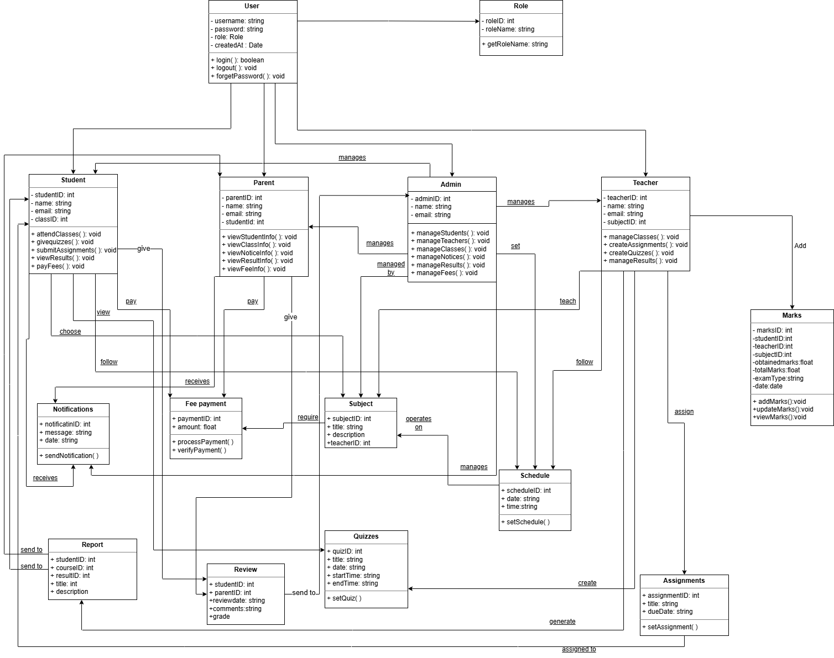

Figure 4: Class Diagram

2.Sequence Diagram

The sequence diagram for KIPS Coaching Kharian describes the flow of interactions between users (like students, parents, teachers, admin) and the KIPS Coaching system components. It covers different scenarios crucial to classes schedule such as searching for subjects, selecting subjects, registration, fee payment, manage quizzes and assignments for students, maintaining schedule, generate reports and admin functionalities like manage fee payment process and sends new updates through notifications. The diagram outlines the step-by-step communication between system components (like the student interface, teacher interface, parent interface, database and payment gateway) to execute these specific actions.

Admin Sequence diagram

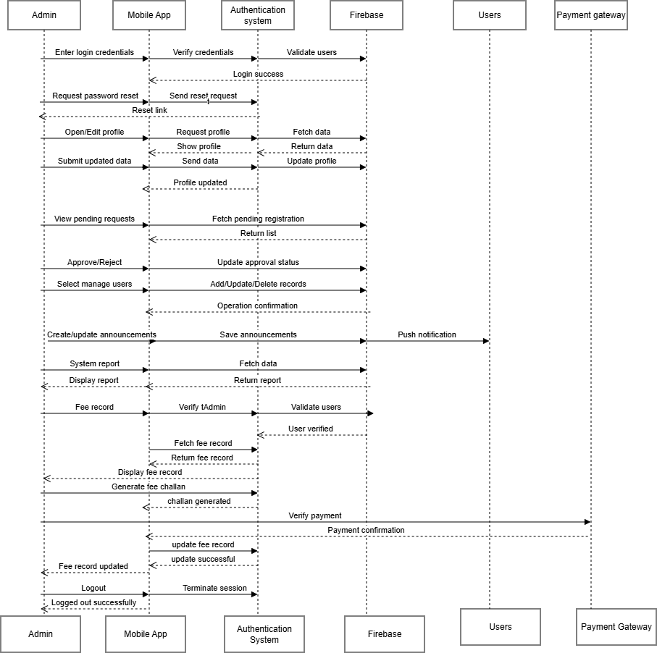
Figure 5: Sequence Diagram (Admin)

Student Sequence diagram

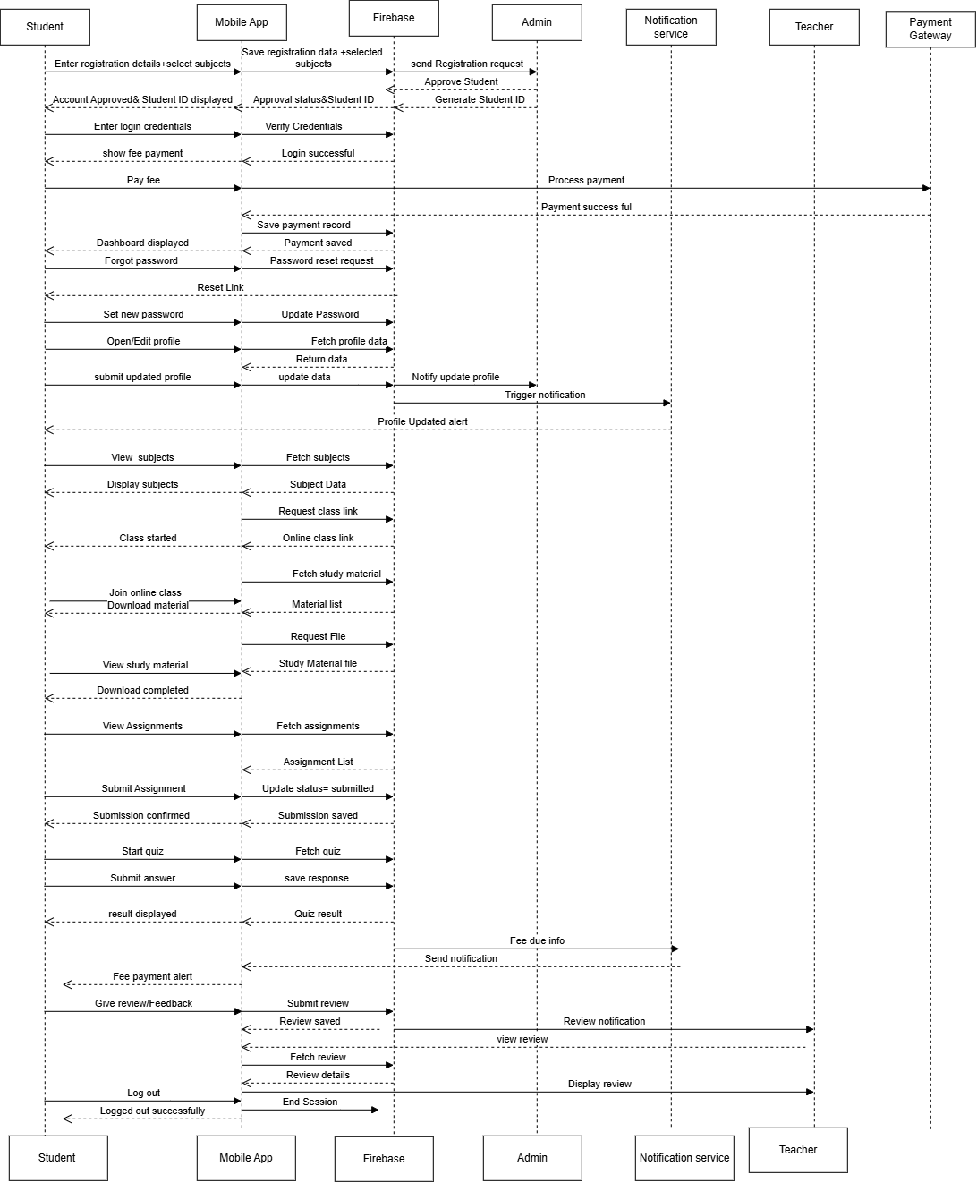
Figure 6: Sequence Diagram (Student)

Teacher Sequence diagram

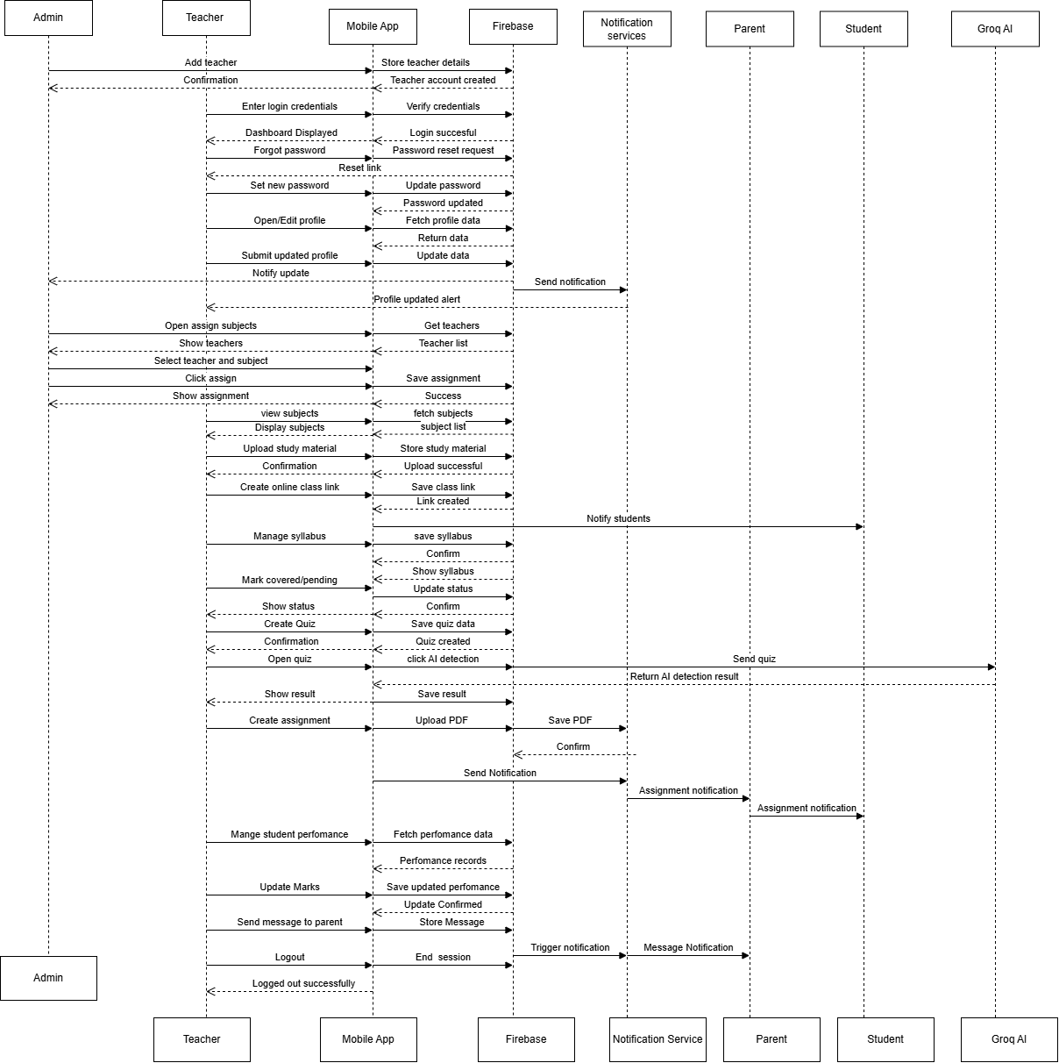
Figure 7: Sequence Diagram (Teacher)

Parent Sequence Diagram

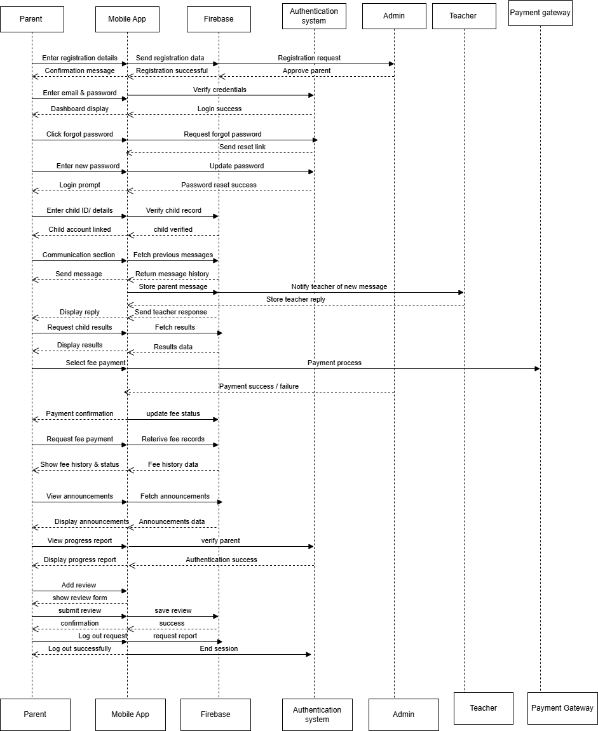
Figure 8: Sequence Diagram (Parents)

3.State Transition Diagram
This diagram shows the different states of the KIPS coaching app and the transitions between them. It covers all the student’s login from initially opening the app and to register an account, fees payment, timetable checking, view assignments, quizzes and successfully logout from the app.

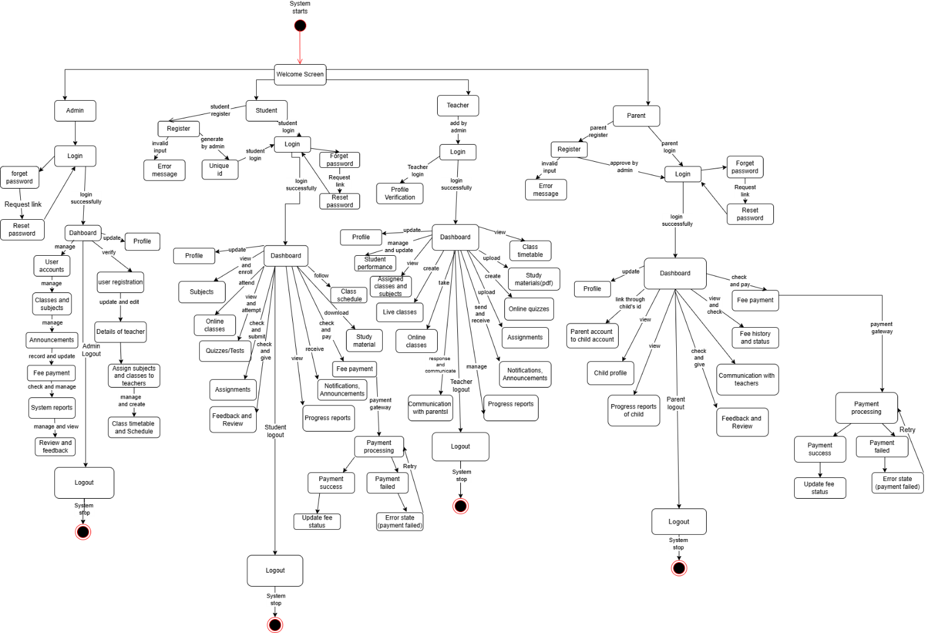

Figure 9: State Diagram

4.4 Architectural Diagram

The KIPS Coaching App is built using a 3-tier structure that includes the User Interface (Frontend), Business Logic (Backend) and Database Layer. The frontend is the mobile app that students interact with.
It allows students to login, register, view schedules, access study materials, view assignments, view quizzes, check results, check fee status and notifications. Enables teachers to manage class schedules, access study materials, upload assignments and quizzes, student progress and send announcements. Provide admins with tools for user management (students, teachers, parents), course management, fee tracking and announcements. Allows parents to monitor their child progress, grades, fees and communication with teachers.
When a user does something in the app, the backend takes care of the main work, like checking login details, fees handling, assignments and quizzes. This backend then talks to the database, which is built using firebase. The database saves important data. The backend also connects other services like fee payment (such as payfast) to send messages and complete payments safely. This keeps everything clean and organized.

1.Tier Architecture Diagram

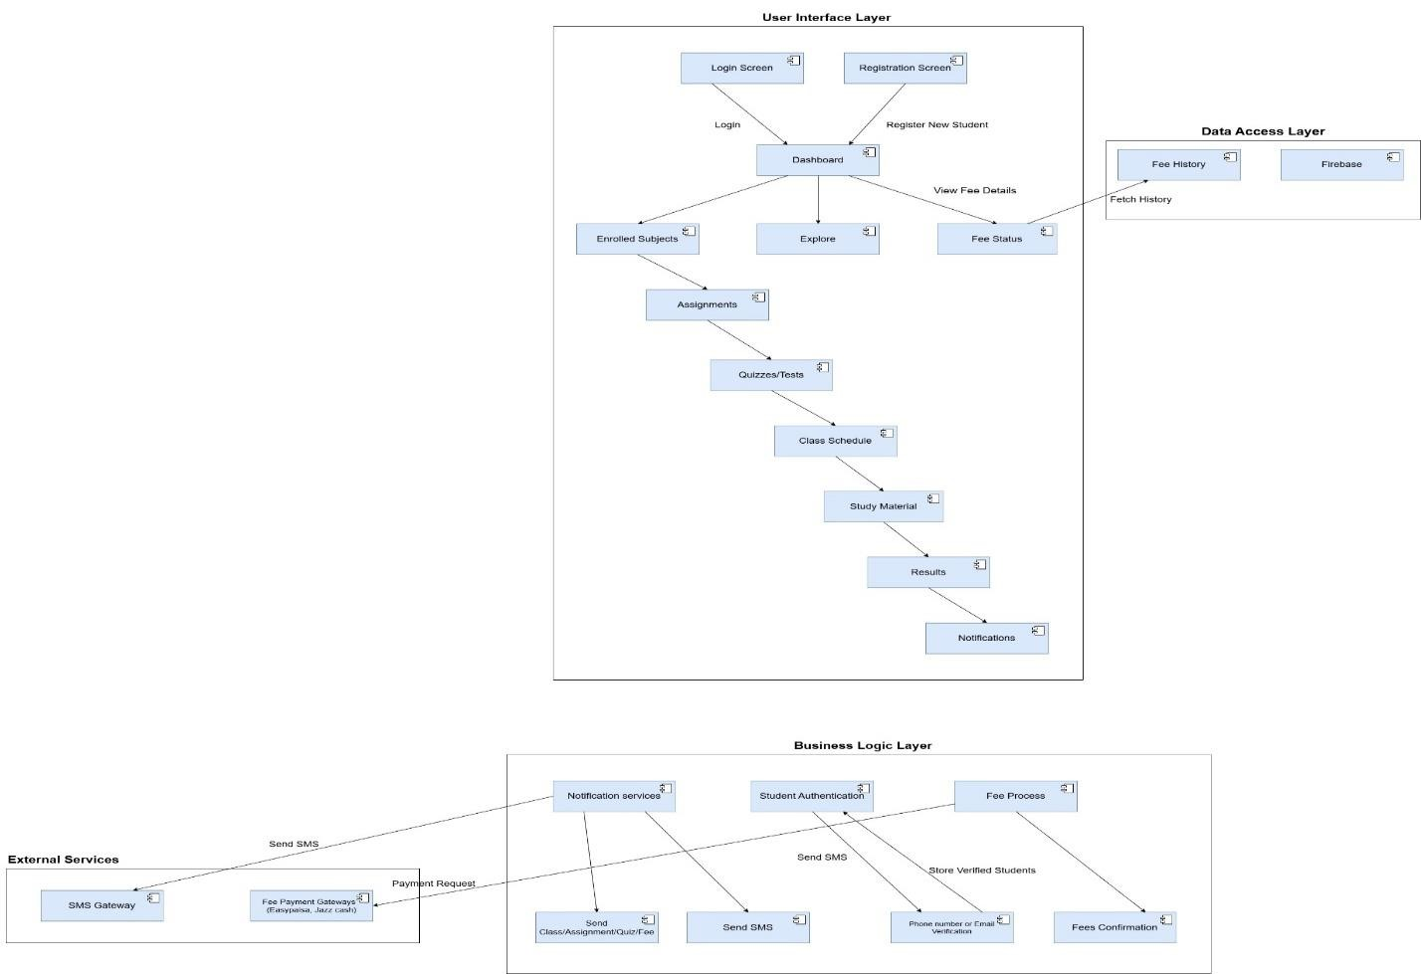

Figure 10: Architecture Diagram

2.UML component diagram:

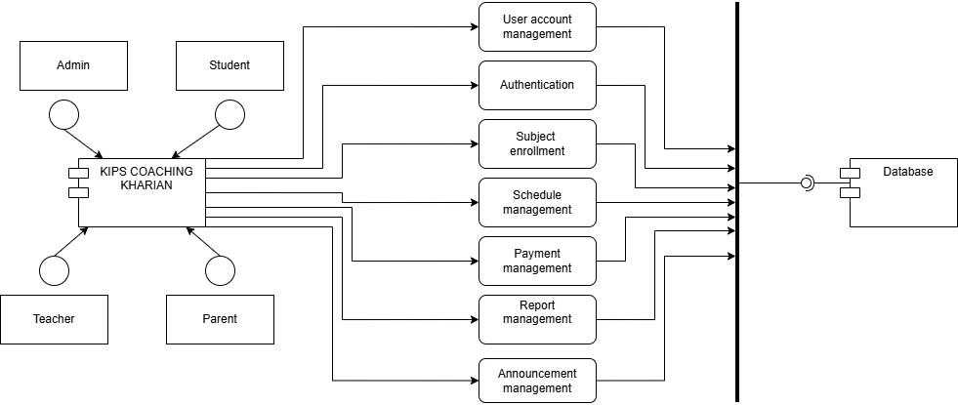

Figure 11: UML component diagram

4.5 Data design
Data design shows how the information in the KIPS COACHING KHARIAN is stored, organized and managed. It uses firebase to store and organize data.
Erd Schema:

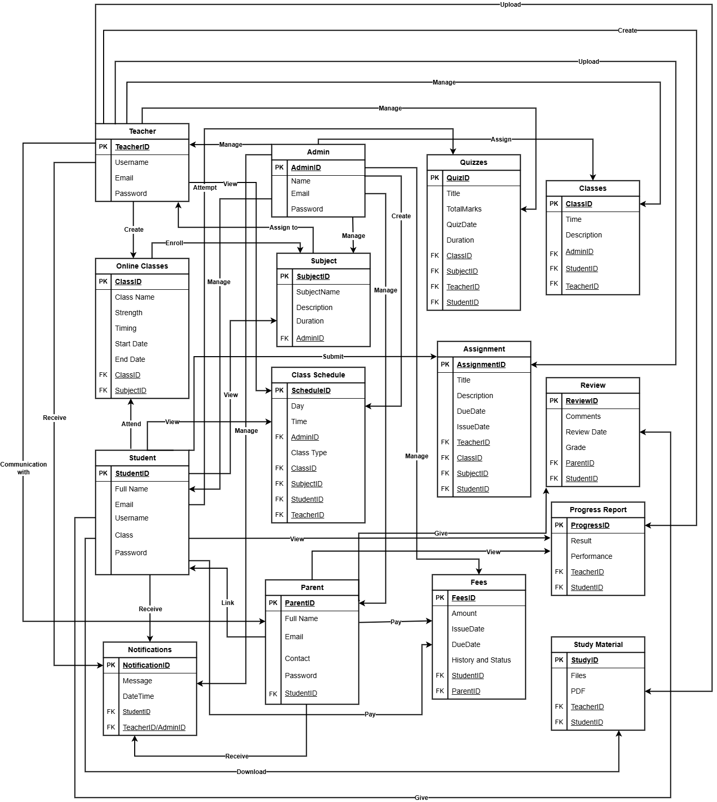

Figure 12: ERD Schema

2.Data dictionary

This table contains the alphabetical list of system entities with their type and descriptions for KIPS COACHING KHARIAN APP.

Table 76: Data Dictionary

Terminology | Data type | Description
Amount | Decimal (10,2) | Fee amount
Announcement_description | Text | Announcement details
Announcement_id | Int | Announcement unique ID
Announcement_title | Varchar (150) | Announcement title
Assignment_id | Int | Assignment unique ID
Assignment_marks | Int | Assignment obtained marks
Assignment_status | Varchar (20) | Pending / Submitted
Syllabus_id | Int | Syllabus unique ID
Syllabus_content | Text | Syllabus topics/content for a subject
Class | Varchar (50) | Student class
Created_at | Datetime | Account creation date
Due_date | Date | Assignment deadline
Email | Varchar (150) | User login email
Fee_id | Int | Fee record ID
File_url | Varchar (255) | Study material or assignment file
Last_login | Datetime | Last login timestamp
Login_id | Int | Login record ID
Material_id | Int | Study material ID
Message_id | Int | Communication message ID
Name | Varchar (100) | Name of  Admin/Teacher/Student/Parent
Notification_id | Int | Notification ID
Notification_message | Text | Notification content
Password | Varchar (255) | Encrypted password
Payment_date | Date | Fee payment date
Payment_method | Varchar (50) | Cash / Online
Phone | Varchar (15) | Contact number
Quiz_id | Int | Quiz ID
Quiz_marks | Int | Obtained quiz marks
Remarks | Varchar (255) | Teacher remarks
Register_id | Int | Registration ID
Role | Varchar (50) | Admin / Teacher / Student /  Parent role
Status | Varchar (20) | Paid / Unpaid
Student_id | Int | Student unique ID
Subject | Varchar (100) | Teaching subject
Teacher_id | Int | Teacher ID
Title | Varchar (150) | Quiz / Assignment / Material title
Total_marks | Int | Quiz total marks
Upload_date | Datetime | Material upload date
User_id | Int | General user ID
User_name | Varchar (100) | Registered user name
User_type | Varchar (20) | Admin / Teacher / Student / Parent

4.6 User interfaces design 4.6.1 Screen Images
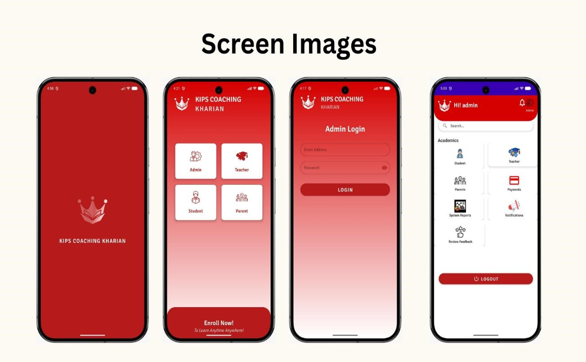
Figure 13: Screen image
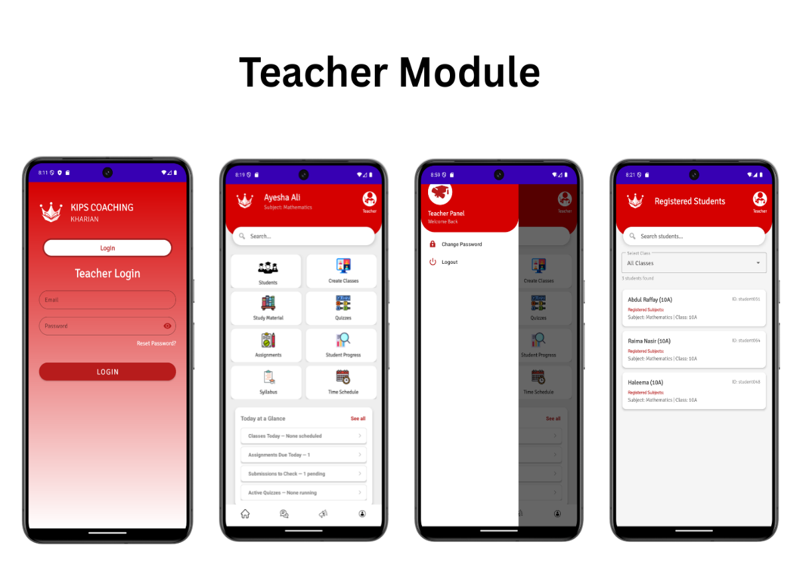
Figure 14: Screen image
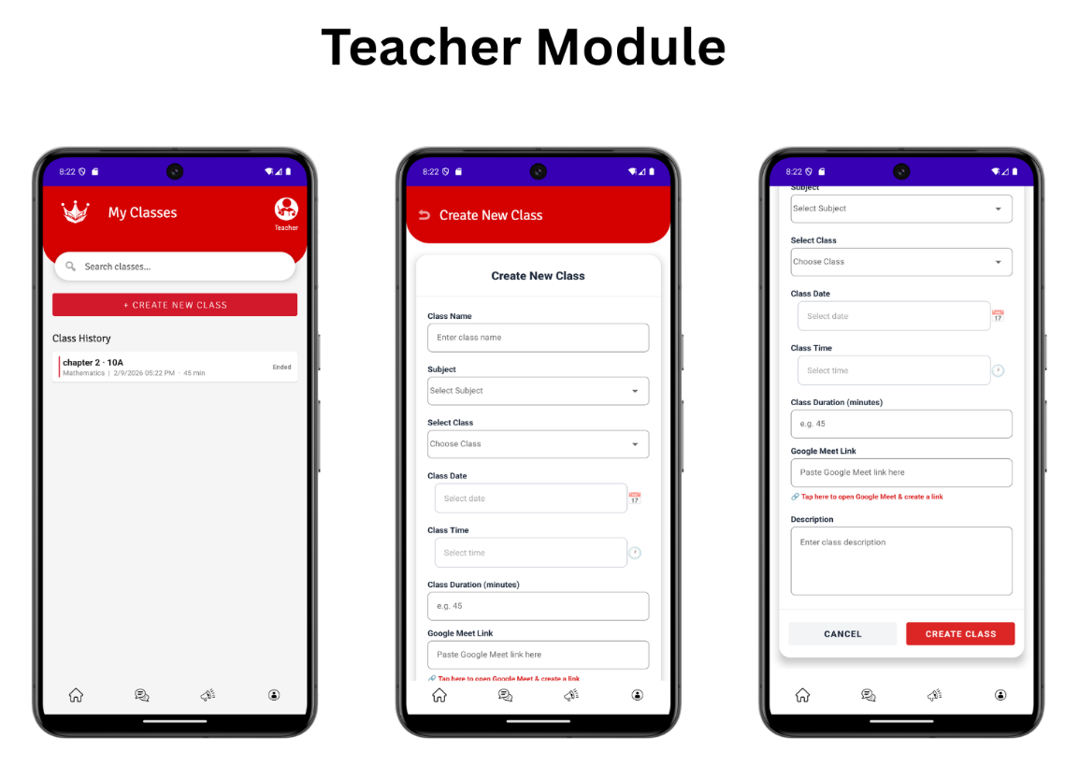
Figure15: Screen image
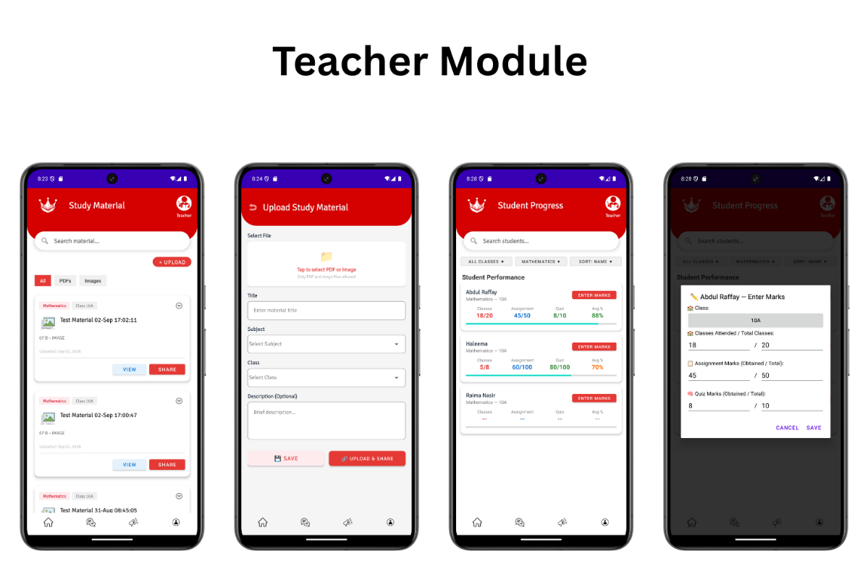
Figure16: Screen image
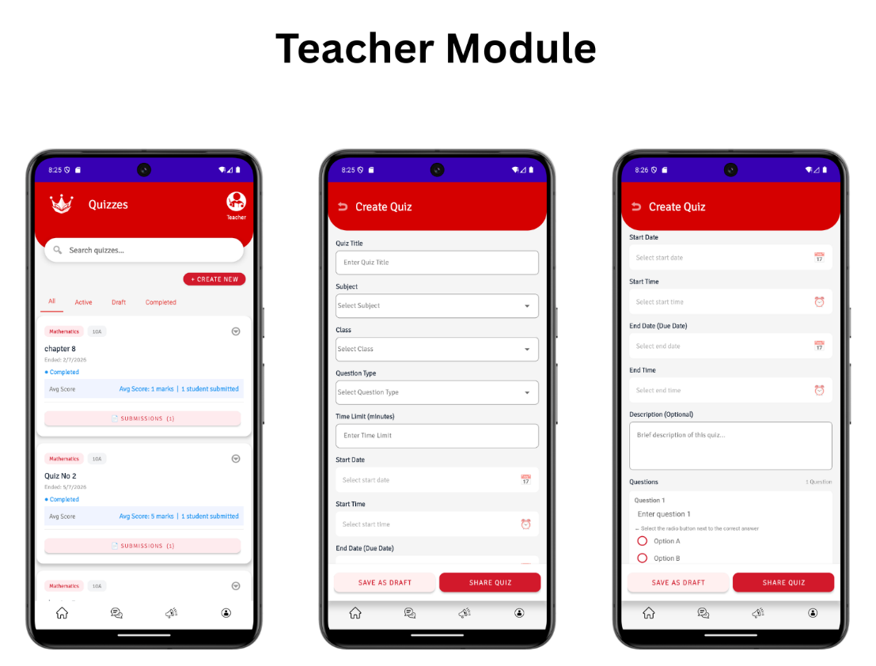
Figure17: Screen image
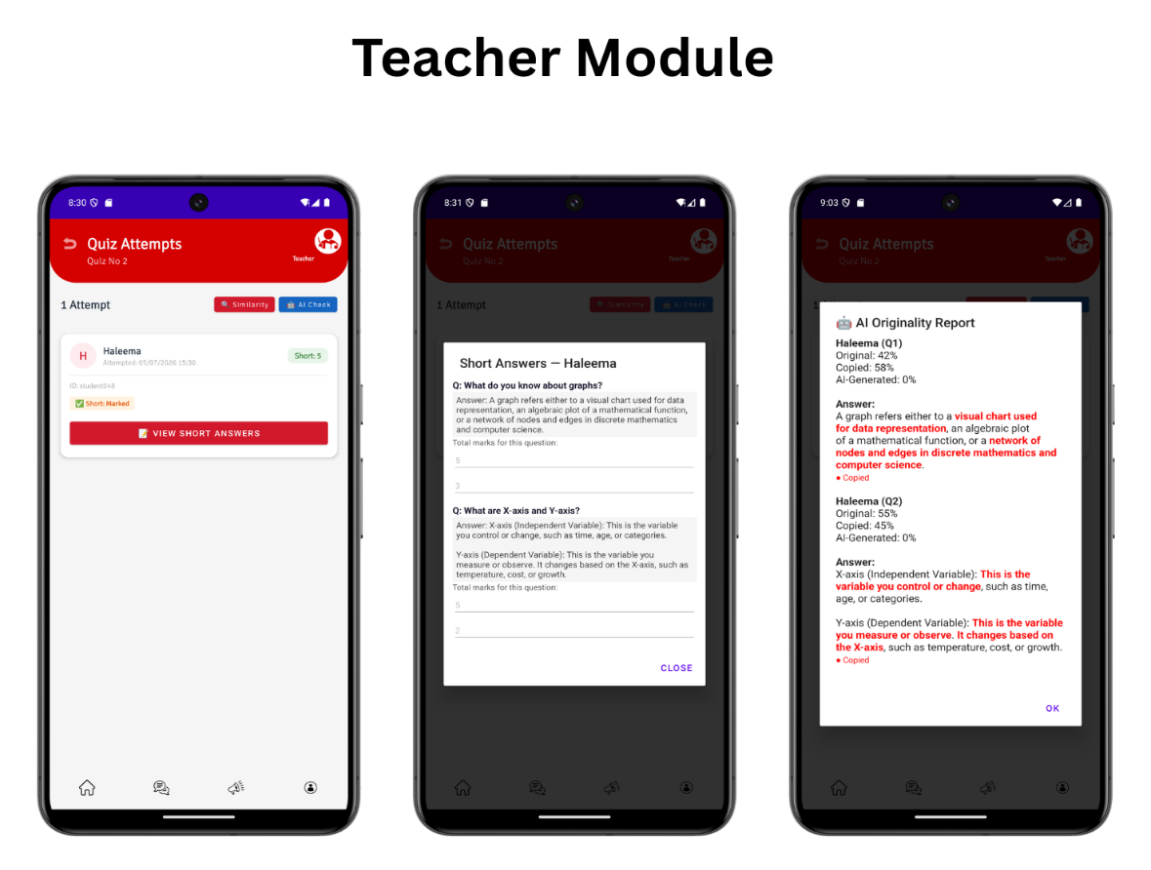
Figure 18: Screen image
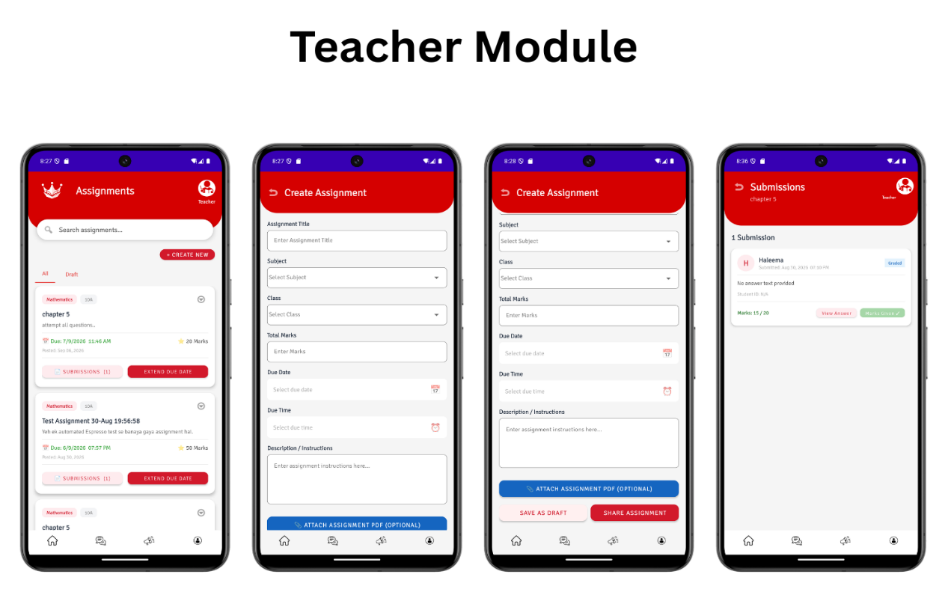
Figure 19: Screen image
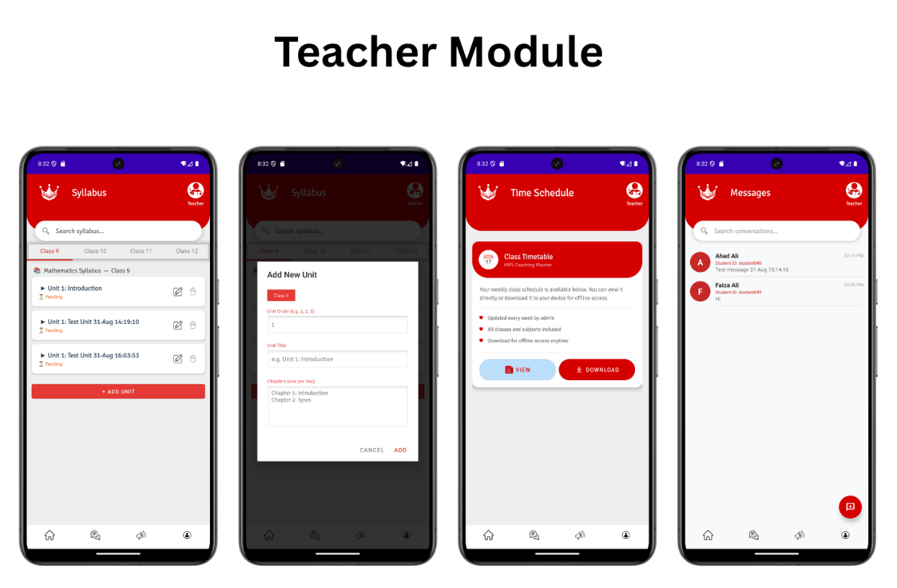
Figure 20: Screen image
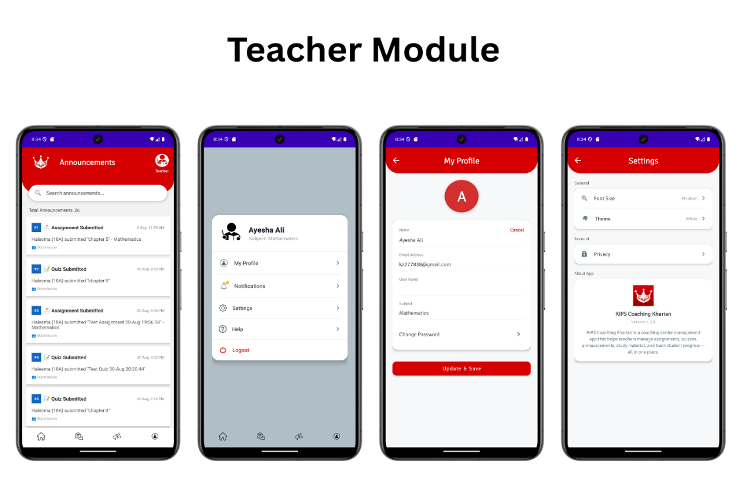
Figure 21: Screen image
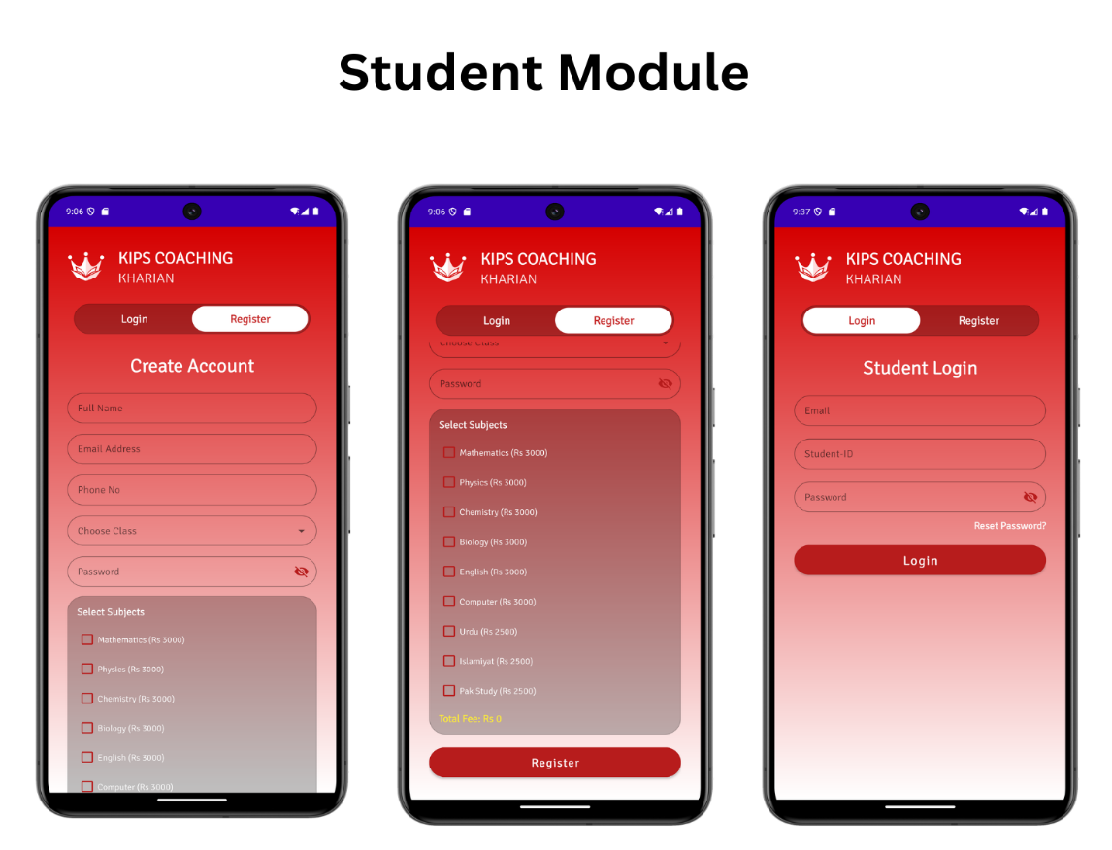
Figure 22: Screen image
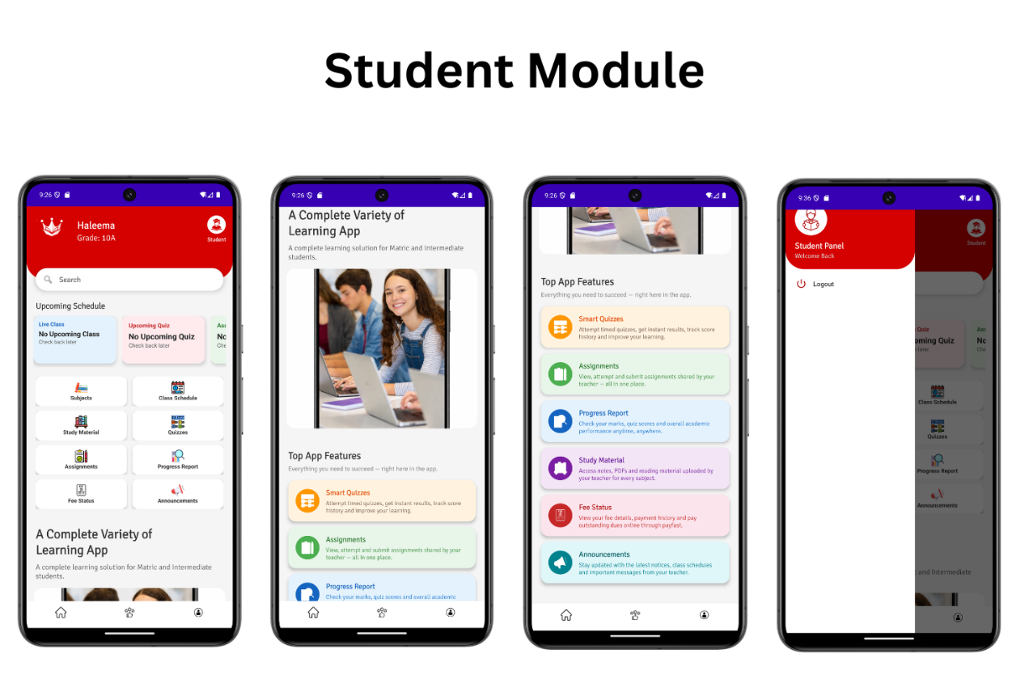
Figure 23: Screen image
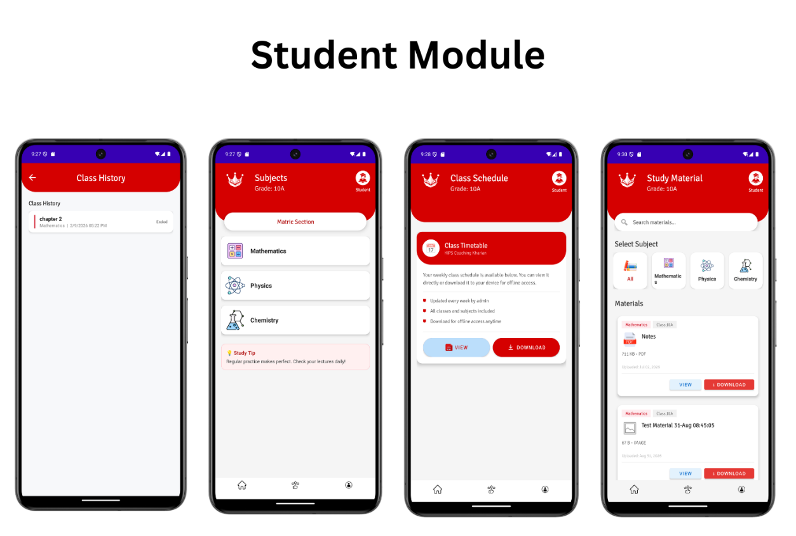
Figure 24: Screen image
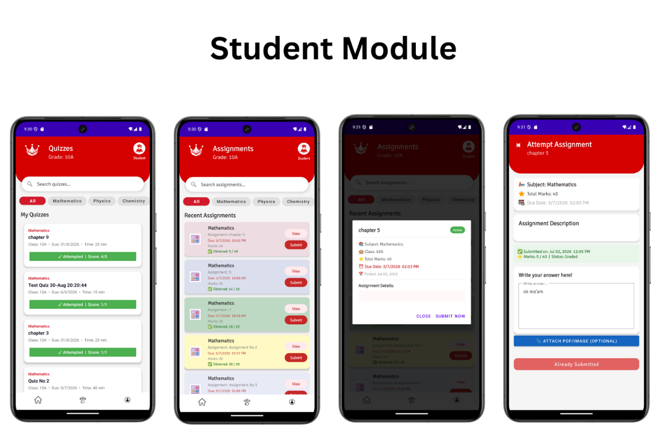
Figure 25: Screen image
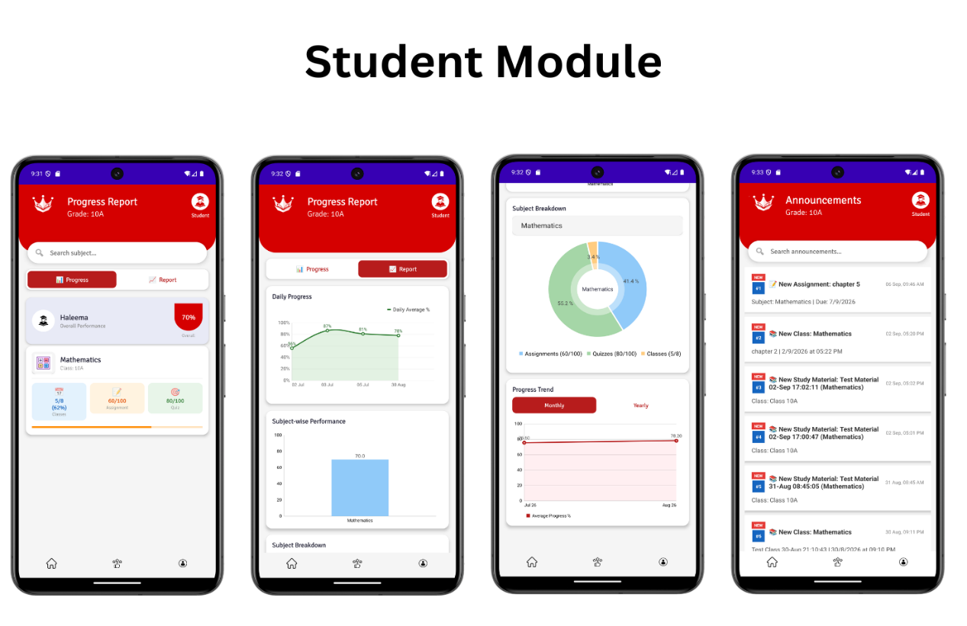
Figure 26: Screen image
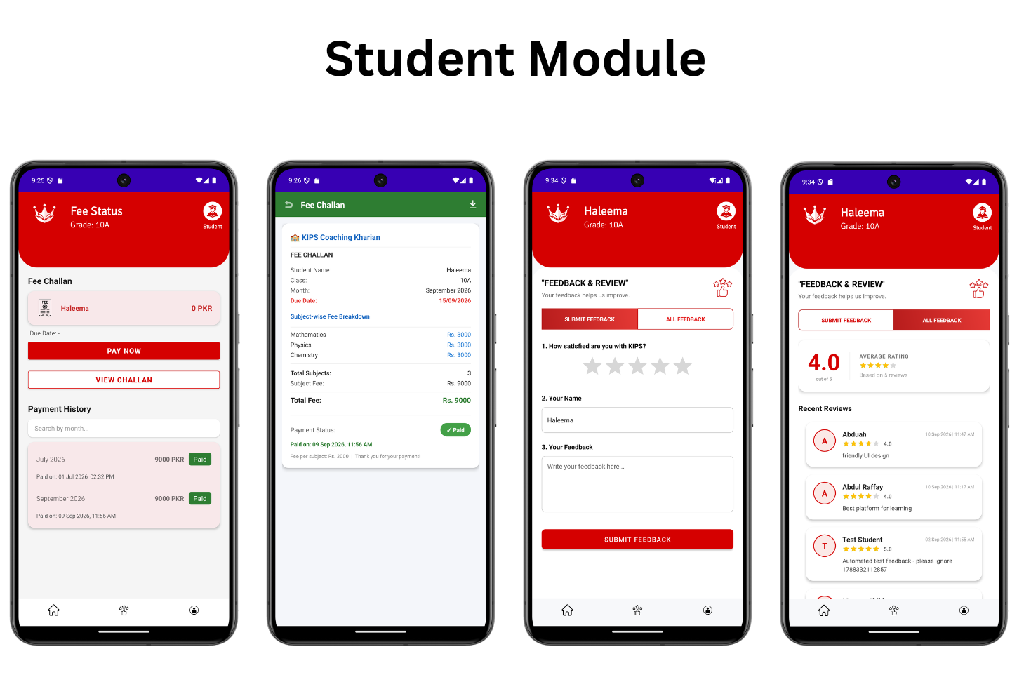
Figure 27: Screen image
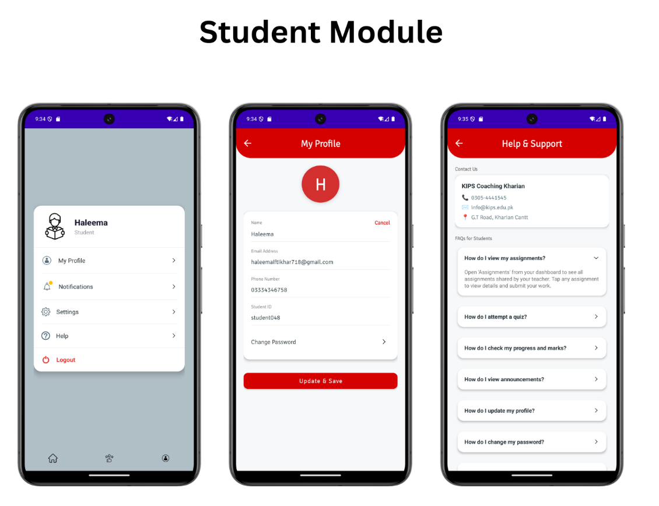
Figure 28: Screen image

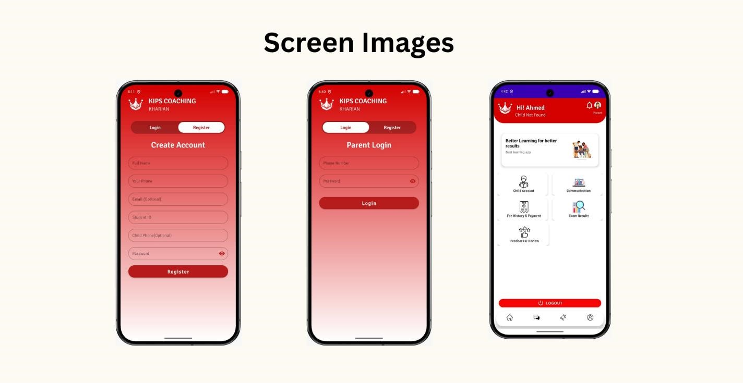
Figure 16: Screen image

4.6.2 Screen Objects and Actions:

This section details the screen components and the functions they perform for use cases:

Table 77: Screen object (Live classes)
Screen Object | Action
Teacher dashboard | Create account and access teacher dashboard then manage live classes section
Create live class | Teacher creates live class
Start/end live class | Teacher starts the live class and end it after completion
Student dashboard | Student logs in and view scheduled live class
Attend live class | Student attend live class and exits when the class end

Table 78: Screen object (Notifications and announcements)
Screen Object | Action
Admin dashboard | Access and manage notifications and announcement
Create announcement | Admin create notifications and announcements
Send notifications | Send notifications to student, teacher and parent
View/receive Announcements | View/receive notifications and announcements

Table 79: Screen object (Fee payment and confirmation)
Screen Object | Action
Student/parent dashboard | Access the fee payment section
Fee details | Students and Parents view fee amount, due date and payment status
Enter payment details | Provide necessary information
Pay button | Complete the fee payment transaction
Payment confirmation alert | In app confirmation payment notification sent

4.7 Behavioral Model

1.Sequence Diagram
The sequence diagram helped visualize how different parts of the system, like the app, database and payment gateways are work together for booking of guider and hotels.

Admin Sequence diagram
Figure 17: Sequence Diagram (Admin)

Student Sequence diagram

Figure 18: Sequence Diagram (Student)

Teacher Sequence diagram

Figure 19: Sequence Diagram (Teacher)

Parent Sequence diagram

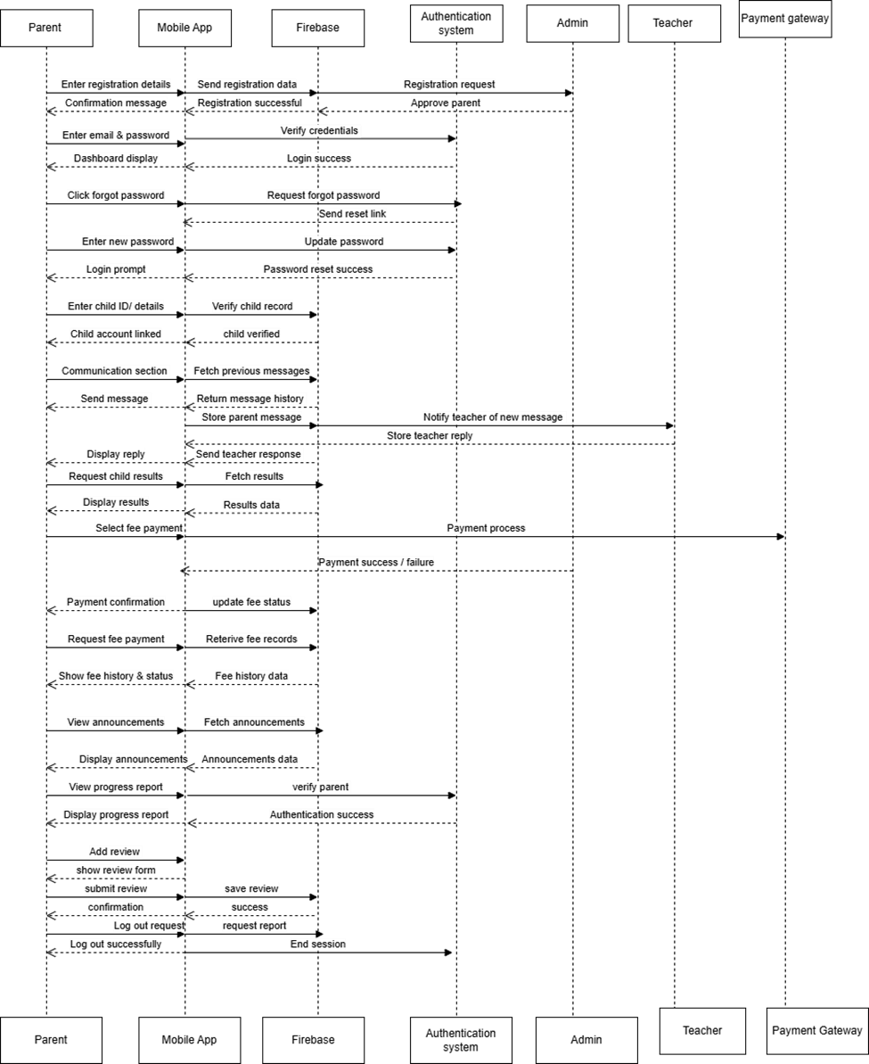
Figure 20: Sequence Diagram (Parents)

2.State Transition Diagram
Shows state transitions within the software, especially useful for systems with complex workflows or lifecycle states.

Figure 21: State Diagram

4.8 Design Decisions

We made key design decisions to ensure our system easy to use:

1. Object Oriented Design (OOD)

We use Object- Oriented Programming (OOP) to organize the system in modular and maintainable way. This makes the system easy to upgrade, scale and manage. The KIPS COACHING management system is build using an object – oriented approach, where each object represents real –world entities within the coaching environment, such as Students, Teachers, Subjects, Assignments and notifications. Each object contains relevant attributes and methods, making the system organized and efficient for future enhancements.

Table 80: Object and attributes

Object Name | Description | Attributes
Admin | Manage overall system including students, teachers, parents, subjects and fees | name, email, password
Student | Represent a students enrolled in KIPS Coaching Kharian | student_id, name, class, parent_contact
Teacher | Represents a teacher or faculty member | teacher_id, name, password, email
Parent | Represent a parents | Parent_id, name, password, email
Subjects | Represents subjects offered by the coaching center | subject_id, name, teacher_assigned_id
Live class | Represents live classes conducted by the teachers | class_id, subject_id,  teacher_id, date, time, meeting link, platform, duration
Quiz | Represents quizzes created by the teacher | quiz_id, subject_id, teacher_id, duration, total marks, topics
Assignment | Represents assignments for students | assignment_id, subject_id, teacher_id, student_id, due_date, submission_date, marks_obtained
Notification | System generated  notifications for the students,  teacher and parent | notification_id, recipient_type, recipient_id, message
Fee | Track student fee payment | fee_id, student_id, amount, due_date, payment_date, payment_method, status
Timetable | Represents daily or weekly class schedules | timetable_id, class_id, day, start_time, end_time

2.Model-View-Controller (MVC) Architecture
We followed the MVC pattern to separate data, business logic and the user interface. This approach keeps the system organized, easy to maintain and user friendly for students, teachers and admins.

3.Database Design and Normalization
We use firebase as the backend database to ensure fast, reliable data storage. The data is normalized to avoid duplication, ensure quick searches and maintain consistency for student records, study materials and fee transactions.

Conclusion
By using OOP, MVC and an optimized database, our KIPS Coaching Kharian provides a smooth and user friendly interface.
Students can easily view subjects, attend online classes, view assignments and fee payments. Teacher can efficiently manage study materials, assignments, quizzes and student performance. Over all the system ensures efficiency, reliability and ease of use for everyone involved.

4.9 Summary
This chapter explain how the KIPS COACHING KHARIAN App provides a smooth and automated academic management system. The system follows an object- oriented approach, making it well- structures and easy to manage. Using an object oriented approach, the app efficiently manages student records, class schedules, assignments, notifications and fee details. The sequence and state diagram showed how the student, teacher, parent and admin modules interact and how task moves through different stages. Key improvements such as fee alerts, parent monitoring and teacher tools for the uploading quizzes and assignments make the app easy to use, efficient and reliable.

4.10 References
- KIPS Education System
KIPS Virtual Learning Platform.
https://kips.edu.pk
Related system reference (Student enrolments and recorded lectures).
- The Educators School System Online Academic Management System.
https://educators.edu.pk
Example of integrated digital education platform.
- Roots International Schools Roots Learning Management System.
https://rootsinternational.edu.pk
Reference for paid and large-scale LMS platforms.
- KIPS Preparations Kharian Campus KIPS Learning Management System.
https://kipsprep.com/
Reference for coaching and preparatory education platform.

Chapter 5

Implementation

5. Implementation
The implementation of KIPS Coaching Kharian application includes the key logic used to perform the main functions of the system, such as user authentication, fee management, class scheduling, quiz creation, study material handling and performance tracking. The important parts of the logic are described in pseudocode format.
Our project consists primarily of the frontend, which is the mobile application that users (Admin, Students, Teacher and Parent) interact with and the backend, which handles data storage and logic. The mobile application was constructed using Android Studio. The backend was built using Firebase for real-time data storage and user authentication.

5.1 Algorithm
For our app, no specific algorithm was used, but to explain the core functionality of some features, a few pseudocode examples are given below.

Table 81 Pseudocode 1: Student / Parent Registration
Pseudocode 1: Student / Parent Registration
Input: full_name, email, username, password, contact
Output: Registration successful / Error message
Step Instructions
- START
- Receive all input (full name, email, username, password, contact)
- IF all inputs are valid and password = Confirm Password THEN
- Hash the Password
- Insert user data into database
- Request send to admin – waiting for the approval
- ELSE
- Show message “Invalid Credentials”
- ENDIF
- END

Table 82 Pseudocode 2: User Login (Admin, Student, Teacher, Parent)
Pseudocode 2: User Login (Admin, Student, Teacher, Parent)
Input: username, password
Output: login successful / Error message
Step Instructions
- START
- Receive input (username, password)
- Fetch user record form database
- IF Entered Password = Strong Hashed Password THEN
- Create User Session
- Redirect to respective Dashboard
- ELSE
- Show message “Incorrect Password”
- Provide Option “Reset Password”
- ENDIF
- ELSE
- Shoe Message “Username not Found”
- ENDIF
- END

Table 83 Pseudocode 3: Reset Password
Pseudocode 3: Reset Password
Input: user_email, new_password, confirm_password
Output: login successful / Error message
Step Instructions
- START
- Receive input (Email)
- IF User_email exists in Database THEN
- Send Reset Verification To Email
- Receive new_password, confirm_new_password
- IF new_password = confirm_new_password THEN
- Hash new_password
- Update Password in Database
- Show Meassage “Password Changed Successfully”
- ELSE
- Shoe Message “Passwords Do Not Match”
- ENDIF
- ELSE
- Show Message “Email Not Found”
- ENDIF
- END

Table 84 Pseudocode 4: Update Profile
Pseudocode 4: Update Profile
Input: user_id, name, email, contact, Profile_image
Output: Profile updated successfully
Step Instructions
- START
- Receive input (User ID, Update Fields)
- Valid all inputs
- IF input are valid THEN
- Update User Record in Database
- Show Message “Profile Updated Successfully”
- ELSE
- Shoe Message “Invalid Input Data”
- ENDIF
- END

Table 85 Pseudocode 5: Manage Registration(Admin)
Pseudocode 5: Manage Registration
Input: admin_id, pending_user_id
Output: Account activated, unique Student ID generated, notification sent
Step Instructions
- START
- Admin logs in
- Admin views Pending Registration list
- Admin selects a pending request
- IF request is valid THEN
- Activate User Account
- Generate Unique Student ID (if student)
- Send Notification to Approved User
- Remove request from Pending list
- Show Message “Registration Approved”
- ELSE
- Reject Request
- Shoe Message “Registration Rejected”
- ENDIF
- END

Table 86 Pseudocode 6: Manage Users (Admin)
Pseudocode 6: Manage Users (Admin)
Input: admin_id, user_type, user_details
Output: User added, updated or deleted successfully
Step Instructions
- START
- Admin logs in
- Admin selects User Management option
- Admin selects user type (Students / Teacher / Parent)
- Admin chooses action: Add, Update or Delete
- IF Add THEN
- Receive user details
- Insert record into Database
- Show Message “User Added Successfully”
- ELSE IF Delete THEN
- Receive updated details
- Update record in Database
- Show Message “User Updated Successfully”
- ELSE IF Delete THEN
- Remove record from Database
- Shoe Message “User Deleted Successfully”
- ENDIF
- END

Table 88 Pseudocode 8: Manage Subjects (Admin)
Pseudocode 8: Manage Subjects (Admin)
Input: subject_name, subject_code, credit_hours
Output: Subject created/updated/deleted successfully / Error message
Step Instructions
- START
- Admin logs in
- Admin Subject Management option
- IF Add New Subject THEN
- Admin enters class details (name, code, credit hours)
- IF subject code does NOT already exist THEN
- Save new subject record to database
- Show Message “Subject Added Successfully”
- ELSE
- Show Message “Subject code already exists”
- ENDIF
- ELSE IF Edit THEN
- Admin modifies subject details and save update record to database
- Show Message “Subject Updated Successfully”
- ELSE IF Delete THEN
- Remove Subject from Database
- Shoe Message “Subject Deleted Successfully”
- ELSE
- Show Message “Cannot delete subject currently in use”
- ENDIF
- END

Table 89 Pseudocode 9: Assign Subjects and Classes to Teachers(Admin)
Pseudocode 9: Assign Subjects and Classes to Teachers (Admin)
Input: teacher_id, subject_id, class_id
Output: Assigned saved successfully / Error message
Step Instructions
- START
- Admin logs in
- Admin opens assign option
- Admin selects a teacher from the list and assign subject and class
- IF teacher is qualified for subject AND no scheduling class exists THEN
- Save to database and send notification to teacher
- Show Message “Saved Successfully”
- ELSE IF teacher is not qualified THEN
- Admin modifies class details and save update record to database
- Show Message “Teacher not qualified for this subject”
- ENDIF
- END

Table 90 Pseudocode 10: Manage Announcements (Admin)
Pseudocode 10: Manage Announcements (Admin)
Input:
Output: Announcement published and notification sent to users
Step Instructions
- START
- Admin logs in
- Admin opens Announcement option
- Admin creates or edits an announcement
- Admin selects target audience (Students / Teachers / Parents / All)
- Admin clicks Publish
- System saves announcement in Database
- System sends notifications to target users
- Show Message “Announcement Published Successfully”
- END

Table 92 Pseudocode 12: Record Fee Payment (Admin)
Pseudocode 12: Record Fee Payment (Admin)
Input: admin_id, student_id, amount, payment_date, payment_method
Output: Fee record saved, notification sent to student and parent
Step Instructions
- START
- Admin logs in
- Admin selects Fee Management option
- Admin Searches student record
- Admin enters payment details (Amount, Date, Method)
- System validates input
- IF valid THEN
- Save Fee Record in Database
- Update fee status to Paid
- Send notification to Student and Parent
- Show Message “Fee Recorded Successfully”
- ELSE
- Show Message “Invalid Payment Details”
- ENDIF
- END

Table 93 Pseudocode 13: Manage Class Timetable (Admin)
Pseudocode 13: Manage Class Timetable (Admin)
Input: class_id, subject_id, day, time
Output: Timetable saved and published / Error message
Step Instructions
- START
- Admin logs in
- Admin opens Timetable option and select a class
- IF Create Timetable THEN
- Admin assign subjects, teachers and time slots for each day
- IF no teacher or class in double booked THEN
- Save timetable to database
- Admin click “Publish” and notify teachers and students
- Show Message “Timetable Published Successfully”
- ELSE
- Show Message “Scheduling conflict detected”
- ENDIF
- ELSE IF Edit timetable THEN
- Admin modifies existing slots and save changes
- ELSE IF Delete timetable THEN
- Remove timetable from Database
- ENDIF
- END

Table 94 Pseudocode 15: View Timetable
Pseudocode 15: View Timetable
Input: user_id, user_role
Output: Timetable displayed on screen
Step Instructions
- START
- User logs in
- User opens class schedule section
- System fetches latest timetable PDF\entry from firebase
- IF timetable data exists THEN
- Display class timetable to user
- Allow users to view or download the timetable pdf
- ELSE
- Show Message “Timetable Not Available”
- ENDIF
- END

Table 95 Pseudocode 16: View Subjects (Student)
Pseudocode 15: View Subjects (Student)
Input: student_id, class
Output: Available subjects list displayed
Step Instructions
- START
- Student opens the registration page
- Student retrieves the list of available subjects from the Database
- IF subjects are available THEN
- Display available subjects list to Student
- Student views the subject names
- ELSE
- Show Message “No Subjects Enrolled”
- ENDIF
- END

Table 96 Pseudocode 17: Enroll into Subjects (Student)
Pseudocode 16: Enroll into Subjects (Student)
Input: student_id, selected_subject_id
Output: Subject enrollment request submitted successfully
Step Instructions
- START
- Student views the available subjects
- Student selects one or more subjects(at least one)
- Student clicks “Register”
- System validates the selected subjects
- IF selected subjects are valid THEN
- Save the enrollment request with the student's registration
- Send the registration request for Admin approval
- ELSE
- Display message "Network error"
- ENDIF
- END

Table 97 Pseudocode 18: Attend Online Classes (Student)
Pseudocode 12: Attend Online Classes (Student)
Input: student_id, class_id, meeting_link
Output: Students join the online class
Step Instructions
- START
- Student logs in
- Student opens Online Class Schedule
- System send notification of class meeting link
- Students click on the class meeting link
- IF link is valid AND class is active THEN
- System redirects students to online meeting platform
- Students joins and attend the class
- ELSE
- Show Message “Invalid or Expired Link”
- ENDIF
- END

Table 98 Pseudocode 19: Download Study Material (Student)
Pseudocode 18: Download Study Material (Student)
Input: student_id, subject_id, material_id
Output: Study material downloaded to student device
Step Instructions
- START
- Student logs in
- Student selects Subject
- Student opens Study Materials section
- Students chooses material to download
- IF file is available THEN
- System downloads file to device
- Show Message “Download Successful”
- ELSE
- Show Message “File Not Available”
- ENDIF
- END

Table 9 Pseudocode 20: View and Attempt Quizzes/Assignments(Student)
Pseudocode 19: View and Attempt Quizzes / Assignments(Student)
Input: student_id, quiz_id, assignment_id, answers
Output: Quiz/Assignment submitted successfully
Step Instructions
- START
- Student logs in
- Student selects Quizzes and Assignments option
- System fetches available quizzes/assignments for student’s class
- Student selects an available quiz or assignment
- IF current time is within the due/ deadline THEN
- Student attempts and submits quiz/assignment
- System saves submission in Database
- Show Message “Submitted Successfully”
- ELSE
- Show Message “Deadline Expired”
- ENDIF
- END

Table 100 Pseudocode 20: View Fee History and Status (Student/Parent)

Pseudocode 20: View Fee History and Status (Student/parent)
Input: student_id or parent_id
Output: Fee history and status displayed
Step Instructions
- START
- Student/Parent logs in
- Selects View Fee History and Status option
- System retrieves fee records from Database
- IF fee record exit THEN
- Display detailed payment history (dates, amounts, status)
- Display current balance and pending payments
- ELSE
- Show Message “No Fee Records Found”
- ENDIF
- END

Table 109 Pseudocode 29: View Progress Report (Student)
Pseudocode 29: View Progress Report (Student)
Input: student_id
Output: Academic results displayed
Step Instructions
- START
- Student logs in
- Student opens progress report option
- System retrieves quiz/assignment/classes report from Database
- IF results available THEN
- Display total marks, subject-wise marks and grades
- Display performance trends
- ELSE
- Show Message “Results Not Yet Available”
- ENDIF
- END

Table 101 Pseudocode 21: Create Link for Online Classes (Teacher)
Pseudocode 21: Create Link for Online Classes (Teacher)
Input: teacher_id, subject_id, class_name, grade, class_date, class_time, class_link, class_duration, description
Output: Class link saved, students notified and reminder scheduled
Step Instructions
- START
- Teacher logs in
- Teacher selects Create online Class option
- Teacher enters class details( Class Name, Subject, Class Link, Grade, Date, Time, Duration, Description)
- Teacher clicks Generate Meet Link
- IF all details are valid THEN
- System opens Google Meet link back into the app
- Teacher clicks Save/Share button
- IF all details are valid THEN
- System saves class link and schedule in Database
- System sends notification to enrolled Students
- System schedules a reminder for the teacher before class time
- Show Message “Class Created Successfully”
- ELSE
- Show Message “Invalid or Missing Class Link”
- ENDIF
- END

Table 101 Pseudocode 22: Manage Syllabus (Teacher)
Pseudocode 21: Manage Syllabus (Teacher)
Input: teacher_id, subject_id, syllabus_id
Output: syllabus saved for teachers
Step Instructions
- START
- Teacher logs in
- Teacher selects syllabus option for subject
- Teacher enters/updates syllabus content
- System valid inputs
- IF valid THEN
- Save syllabus in database
- Show message “Syllabus Updated Successfully”
- ELSE
- Show Message “Update Failed”
- ENDIF
- END

Table 102 Pseudocode 22: Upload Study Material (Teacher)
Pseudocode 22: Upload Study Material (Teacher)
Input: teacher_id, subject_id, grade, title, file, description
Output: Study material uploaded and available to students
Step Instructions
- START
- Teacher logs in
- Teacher selects Study Material option
- Teacher selects subjects and grade, enters title and description, uploads file
- System validate file format (PDF or image only)
- IF valid THEN
- Upload file and save material in Database
- Make material available toenrolled Students
- Show Message “Study Material Uploaded Successfully”
- ELSE
- Show Message “Upload Failed – Unsupported Format”
- ENDIF
- END

Table 103 Pseudocode 23: Upload and View Assignment (Teacher)
Pseudocode 23: Upload and View Assignment (Teacher)
Input: teacher_id, subject_id, grade, title, total_marks, description, assignment_file, due_date, due_time
Output: Assignment uploaded/saved and displayed to students
Step Instructions
- START
- Teacher logs in
- Teacher selects subject and grade
- Teacher enters title, total marks, description, due date/time and upload PDF
- System validates file format and required fields
- IF valid THEN
- Teacher clicks Create Assignment (or save as draft)
- System saves the assignment
- Teacher opens Assignment section to view uploaded assignments
- System displays assignment list
- Show Message “Assignment Uploaded Successfully”
- END

Table 104 Pseudocode 24: Create Online Quizzes (Teacher)
Pseudocode 24: Upload Study Material (Teacher)
Input: teacher_id, subject_id, grade, title, description, questions, time_limit, start_date, end _date, start_time, end_time, total_marks
Output: Quiz published, available to students and answers checked by AI
Step Instructions
- START
- Teacher logs in
- Teacher selects Quizzes option
- Teacher enter quiz title, description, subject, grade, time limit
- Teacher adds questions (minimum 1 question) with marks for each
- Teacher sets start/end date and time window
- Teacher publishes the quiz or saves as draft
- IF quiz saved successfully THEN
- System makes quiz available to enrolled Students within the set window
- Show Message “Quiz Created Successfully”
- (After student submit) Teacher opens quiz submissions
- Teacher click AI button
- System sends system answers to Groq AI API
- IF copied or AI-generated content found THEN
- Mark submissions as “copied” or “AI-generated”
- ELSE
- Mark submissions “Original”
- ENDIF
- ELSE
- Show Message “Quiz Save Failed”
- ENDIF
- END

Table 105 Pseudocode 25: Manage Student Performance (Teacher)
Pseudocode 25: Manage Student Performance (Teacher)
Input: teacher_id, submission_id, obtained_marks
Output: Marks recorded for that submission
Step Instructions
- START
- Teacher logs in
- Teacher selects student performance option
- Teacher clicks “Give marks” on a student’s name
- Teacher enters obtained marks in the popup
- System validates inpute data
- IF valid THEN
- System saves updated performance in Database
- Show Message “Marks given Successfully”
- ELSE
- Show Message “Invalid Marks Entry”
- ENDIF
- END

Table 106 Pseudocode 26: Communication with Parents (Teacher)
Pseudocode 26: Communication with Parents (Teacher)
Input: teacher_id, parent_id, message_text
Output: Massage delivered to parent in real-time chat
Step Instructions
- START
- Teacher logs in
- Teacher opens communication section
- Teacher selects a parent from the conversation list (or start a new chat)
- Teacher types message and click send
- System save massage in database under the conversation
- System delivers message to parent in real-time
- System sends a notification to the parent for the new message
- Show updated conversation to teacher
- IF message send THEN
- Show Message “Message Sent Successfully”
- ELSE
- Show Message “Parent Account Not Found”
- ENDIF
- END

Table 108 Pseudocode 28: View Child Profile (Parent)
Pseudocode 28: View Child Profile (Parent)
Input: parent_id, linked_child _id
Output: Child profile displayed to parent
Step Instructions
- START
- Parent logs in
- Parent selects View Child profile option
- System verifies parent-child linkage
- IF linked verified THEN
- System retrieves child personal details and academic information
- Display child profile and performance metrics
- ELSE
- Show Message “No Child Account Linked”
- ENDIF
- END

Table 110 Pseudocode 30: Receive Announcements
Pseudocode 30: Receive Announcements (Student/Teacher/Parent)
Input: user_id or user_role
Output: Announcements displayed to user
Step Instructions
- START
- User logs in
- User open Announcement section
- System retrieves announcements from Database
- IF announcement available THEN
- System displays announcements to user
- ELSE
- Show Message “No Announcement Available”
- ENDIF
- END

Table 111 Pseudocode 31: Feedback and Review (Parent/Student)
Pseudocode 31: Feedback and Review (Parent/Student)
Input: parent_id or student_id, feedback_text, rating
Output: Feedback submitted successfully
Step Instructions
- START
- Parent/Student logs in
- Selects Feedback and Review option
- Student/Parent enters feedback text and rating
- IF feedback is valid AND not duplicate THEN
- System saves feedback in Database
- Show Message “Feedback Submitted Successfully”
- ELSE
- Show Message “Invalid Feedback”
- ENDIF
- END

Table 112 Pseudocode 32: Logout
Pseudocode 32: Logout
Input: user_session
Output: User logged out, redirected to login screen
Step Instructions
- START
- User clicks the Logout Button
- IF User is logged in THEN
- System terminates user session
- Clear all session data
- Redirect User to Login page
- Show Message “Logged Out Successfully”
- ENDIF
- END

5.2 External APIs / SDKs

In the “KIPS Coaching Kharian” project, several external services, APIs and SDKs were used primarily Firebase, Google Services and a third-party payment gateway to build the application features. The following table summarizes the key external components:

Table 113 APIs used in the project

Name of API/SDK and versions | Description of API/SDK | Purpose of usage | List of API endpoint/ function/Class Example
Firebase Authentication SDK (Android) | Handles user registration, login and session management securely for all user types (Admin, Student, Teacher, Parent). | Used for user registration, login validation and session persistence. | FirebaseAuth.getInstance(), createUserWithEmailAndPassword(), signInWithEmailAndPassword(),  signOut()
Firebase Real-time Database SDK | Facilitates real-time data updates and cloud-based storage for all applications data. | Used for storing students profiles, class schedules, assignments, quizzes, fee records and announcements. | FirebaseDatabase.getInstance().getReference(),  DatabaseReference.setValue(), DatabaseReference.addValueEventListener(), DatabaseReference.updateChildren()
Firebase Cloud Messaging (FCM) SDK | Push notifications service to deliver in app and push notifications to users accounts. | Used to send fee payment alerts, class start notification, assignment deadlines and announcements to students, parents and teachers. | FirebaseMessaging.getInstance(), FirebaseMessaging.getToken(), onMessagingReceived(), (FirebaseMessagingService), RemoteMessage.getNotification()
PayFast Mobile SDK | Manual integration using a WebView to redirect users to PayFast secure payment page for free transactions. | Used to process student fee payments securely via the PayFast gateway. | WebView.postUrl(): To send payment data. StartActivityForResult(): To launch the payment screen.  MD5 Signature Generation: To secure transaction data.  OnActivityResult(): To listen for payment success/failure.
Google Meet API/Linked-Based Integration | Integration allowing teachers to generate and share Google Meet links for live online classes. | Used to conduct live online classes; teachers share meeting links which students join directly from the app. | Intent.ACTION_VIEW: To open the Google Meet link.  Uri.parse(): To parse the class meeting URL.  OnActivityResult(): To handle return from meeting.
Google Maps SDK for Android | Provides map and location services to display the physical campus and branch locations. | Used to show the KIPS Coaching Kharian campus/branch location on an interactive map for students and parents. | MapFragment / SupportMapFragment, GoogleMap.addMarker(), LatLan(), CameraUpdateFactory.newLatLngZoom()
Android SDK (Core Framework) | The core software development kit for building Android applications; provides UI components, activity lifecycle and resource management. | Provides foundational classes for UI view, layouts, activities, fragments, intents and all core app functionality. | AppCampatActivity, Intent, RecycleView, TextView, ImageView, ContextCompat.getDrawable(), SharedPreference, Bundle

5.3 Code Repository

To keep all KIPS Coaching Kharian project files safe and organized, we are using GitHub as our version control system. GitHub helps us manage our code and other files in one place. We have uploaded the current version of the code to the GitHub repository. This makes it easier for the collaborate, track changes and always access the latest version of the project.

GitHub Repository Link:
The repository for the KIPS Coaching Kharian project can be accessed using the following link:

5.3.1 Metrics of the Git Repository

The following metrics will be monitored to ensure effective use of the Git repository:
Commits: Regular commits have been made to track every development change in the system. This helps maintain stable progress, save every change in detail and easily review what changes have been made to the codebase.
Branches: We have one main branch for our code. This keeps the work organized and ensures new features are carefully reviewed before being merged into the main codebase.
Pull Requests: All commits have been pushed directly from GitHub Desktop to the main branch. No pull requests are currently open.
Issues: Currently, no issues have been raised in this repository.
Contributors: This project has been developed and maintained by four contributes: Raima Nasir, Kiran Shahzadi, Maryam Iftikhar and Nayab Zahoor.
Code Reviews: No formal code reviews were conducted for this project, as all changes were directly committed to the main branch.

5.4 Summary

This chapter explains the technical foundation of the KIPS Coaching Kharian project and how it supports the overall system objectives. We explain the main features of the system through pseudocode tables aligned with each use case and how they were implemented using simple logic. It also mentions the use of external tools and lastly explains how we used Git and GitHub to manage our code, work together as a team and track progress.
This chapter shows how we turned our app plan and ideas into a real working system using the right tools and methods.

Chapter 6

Testing and Evaluation

6.Introduction
This part of our project was all about testing. After completing the system, we wanted to make sure that every feature is working the way it should. We did different types of testing like unit testing, functional testing, integration testing and performance testing. Each type helped us to understand how our system behaves and if anything needs to be fixed. It also gave us a chance to experience the system just like a real user.

6.1 Unit Testing (UT)
The unit testing was done to make sure each part of the system works correctly before combining everything together. We tested the main features separately using manual inputs and actions. Each test helped to confirm that the modules were working as expected and giving the right results. Unit testing of our system are as follows:

- Valid Login

Table 114 Unit testing 1
TEST CASE ID | UT1
TITLE | Valid login
Description | In this test case verifies that multiple user’s can successfully log using valid credentials
Objective | To ensure the login module allows authorized users to access the system
Precondition | User account is already registered
Test steps | - Open the application  - Navigate to login page  - Enter valid email and password  - Click the Login button
Input | Valid email and password
Expected result | Users should log in successfully and the dashboard should be displayed
Actual Result | User logged in successfully and dashboard opened correctly
Remarks | Valid testcase was passed successful

10.Enroll in subjects

Table 115 Unit testing 10
TEST CASE ID | UT10
TITLE | Enroll in subjects
Description | This test case verifies that a student can submit a subject enrollment request from the dashboard and the admin can approve the request successfully.
Objective | To ensure that the subject enrollment request is submitted, approved by the admin and the student is enrolled successfully.
Precondition | 1.Registration page is available.  2.Subjects are available in the system.  3.Admin account is active.
Test steps | 1.Student opens the Registration page.  2.Student enters the required registration details.  3.Student views the list of available subjects.  4.Student selects one or more subjects.  5.Student clicks Register.  6.System validates the registration details and selected subjects.  7.System saves the registration request and sends it to the Admin for approval.  8.Admin opens the Registration Requests page.  9.Admin reviews the student's registration request.  10.Admin approves the registration request.  11.System creates the student account.  12.System enrolls the student in the selected subject(s).  13.System displays "Registration Approved Successfully".
Input | Enter valid credentials
Expected result | Enrollment requests should be submitted by the student and approved successfully by the admin
Actual Result | Student enrolment request submitted and approved successfully
Remarks | Test case passed

11.Attend online classes

Table 115 Unit testing 11
TEST CASE ID | UT11
TITLE | Attend online classes
Description | This test case verifies that a student can successfully join and attend an online class through the provided meeting link.
Objective | To ensure that the student can access and attend the scheduled online class successfully.
Precondition | 1. Student account is registered and active.  2. Student is logged into the system.  3. An online class is scheduled.  4. A valid meeting link is available.
Test steps
  1. Student logs into the system.
  2. Student opens the Live Class card.
  3. System displays the list of scheduled classes.
  4. Student selects the desired class.
  5. Student clicks the Join Class button.
  6. System validates the meeting link.
  7. System redirects the student to the online meeting platform.
  8. Student joins and attends the online class successfully.
Input | Valid student login credentials and a valid online class link.
Expected result | The student should successfully join and attend the scheduled online class without any errors.
Actual Result | Student successfully joined and attended the online class.
Remarks | Test case passed

12.Download Study Material

Table 115 Unit testing 12
TEST CASE ID | UT12
TITLE | Download Study Material
Description | This test case verifies that a student can successfully view and download the study material uploaded by the teacher.
Objective | To ensure that the student can access and download the required study material successfully.
Precondition | 1. Student account is registered and active.  2. Student is logged into the system.  3. Student is enrolled in the subject.  4. Study material has been uploaded by the teacher.
Test steps
  1. Student logs into the system.
  2. Student opens the Study Material page.
  3. System displays the list of available study materials.
  4. Student selects the required study material.
  5. Student clicks the Download button.
  6. System validates the download request.
  7. System downloads the selected study material.
  8. Student opens the downloaded file successfully.
Input | Valid student login credentials and available study material.
Expected result | The selected study material should be downloaded successfully and be accessible to the student.
Actual Result | Study material downloaded successfully and opened without errors.
Remarks | Test case passed

13.View and attempt Quizzes and Assignments

Table 115 Unit testing 13
TEST CASE ID | UT13
TITLE | View and attempt Quizzes and Assignments
Description | This test case verifies that a student can view available quizzes and assignments, attempt the quiz, submit the assignment and receive confirmation successfully.
Objective | To ensure that the student can access quizzes and assignments, attempt the quiz, submit the assignment and complete both activities successfully.
Precondition | 1. Student account is registered and active.  2. Student is logged into the system.  3. Student is enrolled in the subject.  4. Quizzes and assignments are available for the selected subject.
Test steps
  1. Student logs into the system.
  2. Student opens the Quizzes and Assignments page.
  3. System displays the list of available quizzes and assignments.
  4. Student selects a quiz and attempts all questions.
  5. Student clicks the Submit Quiz button.
  6. System validates and saves the quiz submission.
  7. Student selects an assignment.
  8. Student uploads the required assignment file.
  9. Student clicks the Submit Assignment button.
  10. System validates and saves the assignment submission.
  11. System displays the message "Quiz and Assignment Submitted Successfully."
Input | Valid student login credentials, quiz answers and a valid assignment file.
Expected result | The student should successfully attempt the quiz, submit the assignment and receive a successful confirmation message.
Actual Result
  Quiz attempted successfully, assignment submitted successfully and confirmation message displayed.
Remarks | Test case passed

14.View Progress Report

Table 115 Unit testing 14
TEST CASE ID | UT14
TITLE | View Progress Report
Description | This test case verifies that a student can view their progress report, including quiz marks, assignment scores and overall performance.
Objective | To ensure that the student can access and view the progress report successfully.
Precondition | 1. Student account is registered and active.  2. Student is logged into the system.  3. Student is enrolled in at least one subject.  4. Quiz, assignment and overall records are available in the system.
Test steps
  1. Student logs into the system.
  2. Student opens the Progress Report page.
  3. System retrieves the student's academic records.
  4. System displays quiz marks, assignment scores, weekly and monthly reports and overall progress.
  5. Student views the progress report.
Input | Valid student login credentials.
Expected result | The student's progress report should be displayed correctly with updated quiz marks, assignment scores and overall performance.
Actual Result
  Progress report displayed successfully with accurate student performance details.
Remarks | Test case passed

15.Fee Report

Table 115 Unit testing 15
TEST CASE | UT15
TITLE | Fee Report
Description | This test case verifies that a student can view the generated fee report successfully.
Objective | To ensure that the student can access the fee report correctly.
Precondition | 1. Student account is registered and active.  2. Student is logged into the system.  3. A fee challan has been generated for the student.
Test steps
  1. Student logs into the system.
  2. Student opens the Fee Report page.
  3. System displays the generated fee challan.
  4. Student reviews the challan details.
  5. Student clicks the Pay button.
  6. Student pay their fee successfully.
Input | Valid student login credentials.
Expected result | The fee challan should be displayed correctly.
Actual Result
  Fee challan displayed successfully.
Remarks | Test case passed

16.Create Online Class

Table 115 Unit testing 16
TEST CASE ID | UT16
TITLE | Create Online Class
Description | This test case verifies that a teacher can create on online class, generate link and notify students.
Objective | To ensure the class is created successfully and enrolled students receive a notification.
Precondition | - Teacher account is active and logged in.  - Teacher has a subject/class assigned.
Test steps | - Teacher opens create class page.  - Teacher enters class name, subject, grade, date, time and duration.  - Teacher clicks Generate Meet Link.  - System opens Google Meet to create a meeting.  - Teacher copies the generated link into the app.  - Teacher clicks create class button.  - System validates the class details.  - System saves the class and sends notification to enrolled students.  - System displays “ Class Created successfully”.
Input | Valid class name, subject, grade, date, time and meeting link
Expected result | Class should be created, saved and students receive a notification.
Actual Result | Class created and notification sent to students successfully.
Remarks | Test case passed

17.Manage Syllabus

Table 115 Unit testing 17
TEST CASE ID | UT17
TITLE | Manage Syllabus
Description | This test case verifies that a teacher can add or update syllabus for their assigned subject.
Objective | To ensure the syllabus is saved correctly and marked as pending or covered.
Precondition | - Teacher is logged in.  - Teacher has a assigned subject.
Test steps | - Teacher opens syllabus page.  - Teacher selects class and enters/updates syllabus content.  - Teacher clicks save.  - Teacher mark syllabus covered or pending.  - System validates that the content is not empty.  - system saves the syllabus.  - System displays “Syllabus Updated Successfully”.
Input | Valid syllabus text
Expected result | Syllabus should be saved and marked as covered or pending.
Actual Result | Syllabus saved and marked as covered or pending.
Remarks | Test case passed

18.Upload Study Material

Table 115 Unit testing 18
TEST CASE ID | UT18
TITLE | Upload Study Material
Description | This test case verifies that a teacher can upload study material for a specific subject and class.
Objective | To ensure uploaded study material is saved and visible to the correct students only.
Precondition | 1. Teacher is logged in.  2. Teacher has a assigned subject.
- Teacher opens Study Material page.
- Teacher selects subject and class.
- Teacher enters title and description.
- Teacher selects a PDF or image file.
- Teacher click upload and share button.
- System validates the file format.
- System uploads the file and saves the material.
- System displays “Study Material Uploaded Successfully”.
Input | Valid PDF/image file, title, subject, class and description.
Expected result | Study material should upload and be visible only to students of the selected subject and class.
Actual Result | Study material uploaded and visible to correct students
Remarks | Test case passed

19.Upload Assignment

Table 115 Unit testing 19
TEST CASE ID | UT19
TITLE | Upload Assignment
Description | This test case verifies that a teacher can upload a PDF assignment with a due date for students.
Objective | To ensure the assignment is uploaded correctly and PDF file is attached.
Precondition | 1. Teacher logged in.  2. Teacher has an assigned subject/class.
Test steps | - Teacher opens Assignment page.  - Teacher selects subject and class.  - Teacher enters title, total marks, due date/time and description.  - Teacher upload a PDF file.  - Teacher clicks Share Assignment button.  - System validates that the file is a PDF and fields are filled.  - System saves the assignment.  - System displays “Assignment Uploaded Successfully”.
Input | Valid title, total marks, due date/time and PDF file.
Expected result | Assignment should upload successfully with enrolled students.
Actual Result | Assignment uploaded successfully with enrolled students.
Remarks | Test case passed

20.Create Quiz

Table 115 Unit testing 20
TEST CASE ID | UT20
TITLE | Create Quiz
Description | This test case verifies that a teacher can create a quiz with questions(MCQS and questions) and a time window for students to attempt.
Objective | To ensure the quiz is created with at least one question and is available to students during the set window.
Precondition | - Teacher is logged in.  - Teacher has an assigned subject/class.
Test steps | - Teachers opens Quizzes Page.  - Teacher enters quiz title, subject, class, time limit, start/end date and time.  - Teacher selects question type (MCQS and questions).  - Teacher clicks add questions with marks.  - teacher clicks Share Quiz button.  - System validates that at least one question exists.  - System saves and publish the quiz.  - System displays “Quiz Created Successfully”.
Input | Valid quiz title, at least 1 question, start/end date and time.
Expected result | Quiz should publish successfully and be visible to students within the set time window.
Actual Result | Quiz published and visible to students during the set window.
Remarks | Test case passed

21.AI-based checking on quiz submissions

Table 115 Unit testing 21
TEST CASE ID | UT21
TITLE | AI-based checking on quiz submissions
Description | This test case verifies that the system correctly flags copied or AI-generated answers in quiz submissions.
Objective | To ensure the Groq AI check correctly identifies copied and AI- generated answers among student submissions.
Precondition | - Teacher is logged in.  - At least one student have submitted the quiz.
Test steps | - Teacher opens Quiz Submissions page.  - Teacher click AI Check button.  - System sends students answers to Groq AI API.  - System checks answers for copied and AI- generated content.  - System marks each submissions as “Original”, “Copied” or “AI-generated”.
Input | One or more submitted quiz answers.
Expected result | Copied, AI-generated or Original answers should be marked.
Actual Result | Copied, AI-generated or Original answers correctly marked.
Remarks | Test case passed

22.Manage student performance

Table 115 Unit testing 22
TEST CASE ID | UT22
TITLE | Manage student performance
Description | This test case verifies that a teacher can enter marks for a student’s assignments, quizzes and classes attended.
Objective | To ensure entered marks do not exceed the total marks and are saved correctly.
Precondition | - Teacher is logged in.  - Teacher has an assigned subject/class.
Test steps | - Teacher opens Student Progress page.  - List of enrolled students appears.  - Teacher click on enter marks button.  - Teacher enter classes attended, assignment and quiz marks.  - Teacher clicks on save button.  - System validates that marks and percentage of marks shows.  - System saves the marks and share with students.
Input | Marks value greater than the total marks (invalid case).
Expected result | System should reject marks greater than total marks.
Actual Result | System rejected invalid marks and displayed an error message.
Remarks | Test case passed

23.Communication with parents

Table 115 Unit testing 23
TEST CASE ID | UT23
TITLE | Communication with parents
Description | This test case verifies that a teacher can send and receive real-time chat messages with a parent.
Objective | To ensure messages are delivered in real-time and the parent is notified.
Precondition | - Teacher and parent accounts are active.  - A conversation exits between them.
Test steps | - Teacher opens communication section.  - Teacher selects a parent’s conversation.  - Teacher types a message or image/PDF file and clicks Send.  - System saves the message in the database.  - System delivers the message to the parent in real-time.  - System sends a notification to the parent.
Input | Valid text message, image/PDF file.
Expected result | Messages should be delivered instantly and parent should receive a notification.
Actual Result | Message delivered in real-time and notification received.
Remarks | Test case passed

3.View Announcement

Table 116 Unit testing 3
TEST CASE ID | UT 3
TITLE | View announcements
Description | This test case verifies that user’s Can successfully view important announcements posted by administration
Objective | To ensure the announce accurately displays real time data to authorized users
Precondition | - User account is already registered  - admin has posted announcements
Test steps | - Open the application  - Log in with valid credentials  - Navigate to the announcements  - Scroll through the list of updates
Input | Click on Announcements
Expected result | Latest announcement should be visible
Actual Result | User successfully viewed announcement and data fetch correctly
Remarks | Valid test case was passed

5.Bottom navigation bar functionality

Table 118 Unit testing 5
TEST CASE ID | UT5
TITLE | Bottom navigation bar functionality
Description | This test case verifies that user can successfully navigate between the main sections of app using the bottom navigation icons
Objective | To ensure the navigation correctly redirect user to the appropriate screen (home, profile and more)
Precondition | - Application is open  - User is logged into the dashboard
Test steps | - Observe the bottom navigation bar on the dashboard  - Tap on different icons
Input | User tab input on navigation icons
Expected result | Each icon should highlight when pressed and the corresponding screen should load instantly without errors
Actual Result | User navigate successfully and correct screens were displayed
Remarks | Valid test case was passed

6.Load user data

Table 119 Unit testing 6
TEST CASE ID | UT6
TITLE | Load user data
Description | This test case verifies that application successfully fetches and display correct user information from the database upon log in
Objective | To ensure the user specific data (name, subject and more) is loaded accurately into the dashboard
Precondition | User is successfully logged into the application
Test steps | - Login with valid credentials  - Wait for the dashboard to initialize  - Observe the profile section for user details  - Cross verifies display data database records
Input | Valid user credentials
Expected result | User specific profile data should be fetched from firebase and displayed correctly in the UI without error
Actual Result | User data first success and displayed in the appropriate field
Remarks | Valid test case passed

6.2 Functional testing
Functional testing checks if each feature of the app work as expected and we test the features of the app such as:
Registration, Login, enroll in subjects and update notification toggle etc.

- Register

Table 120 Functional testing 1
TEST CASE ID | FT1
TITLE | User registrations
Description | Verify that a new user can successfully registered
Objective | To ensure the registration from captures data correctly and creates a new account
Precondition | The user is on the app registration page with a stable Internet connection
Test steps | Navigate to the registration page. Fill the fields according to the requirements and click the registration button.
Input | User name, Email etc.
Expected result | System displays a registration successful message
Actual Result | Account created successfully
Remarks | Valid test passed

Login

Table 121 functional Testing 2
TEST CASE ID | FT2
TITLE | Login
Description | Verify that registered user can successfully logged in.
Objective | To ensure that the authentication system grant access to authorized user and redirects them to the dashboard
Precondition | The user must have a registered account and the application is open and the login page is loaded.
Test steps | Navigate to the login screen. Enter the valid registration email user. Enter the correct password and click the login button.
Input | Username, Email and password
Expected result | The user should be successfully authenticated and redirect to the related dashboard
Actual Result | Successfully redirect the dashboard
Remarks | Passed

3.Forgot Password

Table 122 functional Testing 3

TEST CASE ID | FT3
TITLE | Forgot Password
Description | Verify that Admin can request a password reset link from the login screen.
Objective | To ensure that the forgot password flow is accessible and sends a reset request correctly.
Precondition | The application is open and the Admin login page is loaded.
Test steps | Tap “Forgot Password”. Enter a registered email address. Tap “Send Reset Link”.
Input | Email
Expected result | The system should send a password reset email and display a confirmation message.
Actual Result | Confirmation message displayed and reset email sent successfully.
Remarks | Passed

- Card Navigation

Table 123 functional Testing 4

TEST CASE ID | FT4
TITLE | Card Navigation
Description | Verify that every management card on the Admin Dashboard opens is correct destination screen.
Objective | To ensure all navigation entry points on the dashboard is displayed.
Precondition | The Admin is successfully logged in and the dashboard is displayed.
Test steps | Tap each dashboard card one at a time.
Input | Tap action on each of the 12 dashboard cards.
Expected result | Each card should open its corresponding management screen without error.
Actual Result | All cards opened their correct respective screens.
Remarks | Passed
- Navigation Drawer

Table 124 functional Testing 5

TEST CASE ID | FT5
TITLE | Navigation Drawer
Description | Verify that navigation drawer opens, closes and its menu items function correctly.
Objective | To ensure the hamburger menu and drawer items behave as expected.
Precondition | The Admin is successfully logged in and the dashboard is displayed.
Test steps | Tap the hamburger icon to open the drawer. Tap profile in the drawer. Return to the dashboard and tap the hamburger icon, the tap Home.
Input | Tap action on menu icon and drawer items.
Expected result | The drawer should open/close correctly. Profile should open the Admin Profile screen, Home should close the drawer and remain on Dashboard.
Actual Result | Drawer opened and closed correctly and navigation behaved as expected.
Remarks | Passed
5.Mandatory Field Validation

Table 125 functional Testing 6

TEST CASE ID | FT6
TITLE | Mandatory Field Validation
Description | Verify that add teacher from validates all required fields before allowing account creation.
Objective | To ensure incomplete teacher records cannot be submitted.
Precondition | The Admin is successfully logged in and has navigated to the Add Teacher screen.
Test steps | Leave the name field empty. Fill remaining fields. Tap create Account.
Input | Name, Phone number, Email, password
Expected result | The system should display Name required and prevent submission.
Actual Result | Error displayed and account creation blocked as expected.
Remarks | Passed
- Restricted Email Domain

Table 126 functional Testing 7

TEST CASE ID | FT7
TITLE | Restricted Email Domain
Description | Verify that the system rejects the teacher email address from non approved providers.
Objective | To ensure only recognized email providers are accepted for teacher accounts.
Precondition | The Admin is successfully logged in and navigated to the Add teacher screen.
Test steps | Fill all the fields. Enter an email from non-approved domain. Tap Create Account.
Input | Email
Expected result | The system should display Please use a real email provider and block submission.
Actual Result | Error displayed and account creation blocked as expected.
Remarks | Passed
- Manage student requests- Filter switching

Table 127 functional Testing 8

TEST CASE ID | FT8
TITLE | Mange student requests –Filter switching
Description | Verify that the tapping the summary cards correctly filters the visible student list.
Objective | To ensure the request filtering mechanism displays the correct subset of records.
Precondition | The Admin is successfully logged in and the manage student Requests screen is displayed .
Test steps | Tap the approved summary card. Observe the header and list. Tap the rejected summary card. Observe the header and list.
Input | Tap actions on summary filter cards.
Expected result | The header and displayed records should update to reflect the selected filter.
Actual Result | Header and list updated correctly for each selected filter.
Remarks | Passed
- Manage parent requests- Filter switching

Table 128 functional Testing 9

TEST CASE ID | FT9
TITLE | Mange parent requests –Filter switching
Description | Verify that the tapping the summary cards correctly filters the visible parent list.
Objective | To ensure the request filtering mechanism displays the correct subset of records.
Precondition | The Admin is successfully logged in and the manage parent Requests screen is displayed .
Test steps | Tap the approved summary card. Observe the header and list. Tap the rejected summary card. Observe the header and list.
Input | Tap actions on summary filter cards.
Expected result | The application should reload and display the correct subset of parent records without crashing.
Actual Result | List refreshed correctly for each filter with no crash.
Remarks | Passed
- Fee management- Navigation

Table 123 functional Testing 4

TEST CASE ID | FT3
TITLE | Fee Management- Navigation
Description | Verify that the fee management screen correctly routes to fee management and fee challan modules.
Objective | To ensure both fee related sub modules are reachable from the main fee Management screen.
Precondition | The Admin is successfully logged in and fee management screen is displayed.
Test steps | Tap the fee management card. Return. Tap the fee challan card.
Input | Tap actions on two navigation cards.
Expected result | Each card should open its respective screen correctly.
Actual Result | Both cards navigated to their correct respective screens.
Remarks | Passed
- Share/ update Confirmation Dialog

Table 123 functional Testing 10

TEST CASE ID | FT10
TITLE | Share/ update confirmation dialog
Description | Verify that timetable share action presents the correct audience- selection dialog before processing.
Objective | To ensure the admin can select an audience before the timetable is published.
Precondition | The Admin is successfully logged in and the timetable screen is displayed .
Test steps | Tap the share icon. Observe the confirmation dialog and its option. Tap cancel.
Input | Tap actions on share icon; selecting among students/teachers/both.
Expected result | A confirmation dialog listing Students, teachers, both and process and upload/ cancel buttons should appear; Cancel should dismiss without publishing.
Actual Result | Dialog displayed correctly with all options; Cancel dismissed without processing.
Remarks | Passed
- Manage announcements- Mandatory field Validation

Table 123 functional Testing 11

TEST CASE ID | FT11
TITLE | Mange announcements- Mandatory field Validation
Description | Verify that a new announcement creation enforces mandatory field validation.
Objective | To ensure announcement creation enforces mandatory field validation.
Precondition | The Admin is successfully logged in and the manage Announcement screen is displayed .
Test steps | Tap New Announcement. Leave title and message empty. Tap post.
Input | Title, Message
Expected result | The system should display Title our message compulsory and the announcements should not posted.
Actual Result | Warning message displayed and posting blocked as expected.
Remarks | Passed
- Report Rendering

Table 123 functional Testing 12

TEST CASE ID | FT12
TITLE | Report Rendering
Description | Verify the system reports screen correctly renders all statistical sections after data loads.
Objective | To ensure all report sections render without errors.
Precondition | The Admin is successfully logged in and the system report screen is displayed. .
Test steps | Open the system reports screen and wait for data to load. Scroll through all sections.
Input | None(data loaded automatically from the database)
Expected result | All sections headers and their metrics/charts should be displayed correctly without crashing.
Actual Result | All sections rendered correctly with accurate metrics and charts.
Remarks | Passed
12.Manage subjects- Add new subjects

Table 123 functional Testing 13

TEST CASE ID | FT13
TITLE | Manage subjects - Add new subjects
Description | Verify that the admin can add new subjects and that it appears correctly in the subject list.
Objective | To ensure the subject creation work flow correctly writes and reflect new records.
Precondition | The Admin is successfully logged in and the manage subjects screen is displayed .
Test steps | Tap the Add New subject. Enter a unique subject name. Tap Add. Observe the subject list.
Input | Subject name
Expected result | The system should display a success confirmation and the new subject should appear in the list.
Actual Result | Subject added successfully and displayed in the list as expected.
Remarks | Passed
13.Manage Users- category Navigation

Table 123 functional Testing 13

TEST CASE ID | FT13
TITLE | Manage Users –Category Navigation
Description | Verify that the admin can add new subjects and that it appears correctly in the subject list.
Objective | To ensure the subject creation work flow correctly writes and reflect new records.
Precondition | The Admin is successfully logged in and the manage subjects screen is displayed .
Test steps | Tap the Add New subject. Enter a unique subject name. Tap Add. Observe the subject list.
Input | Subject name
Expected result | The system should display a success confirmation and the new subject should appear in the list.
Actual Result | Subject added successfully and displayed in the list as expected.
Remarks | Passed

6.Attempt Quiz with timer

Table 122 functional Testing 3
TEST CASE ID | FT3
TITLE | Attempt Quiz with timer
Description | Verify that a student can attempt a quiz within the given time limit and the quiz is automatically submitted when the timer expires.
Objective | To ensure the quiz timer works correctly and students can attempt the quiz within the allocated time.
Precondition | Student is logged in. Teacher has created and published a quiz with a valid timer.
Test steps | 1. Log in as a student.  2. Open the Quizzes section.  3. Select the available quiz.  4. Click Start Quiz.  5. Verify the timer starts immediately.  6. Answer the quiz questions before the timer ends.  7. Click Submit before time expires.  8. Repeat the test and let the timer expire without clicking Submit.
Input | Valid student account, published quiz with a timer (e.g., 15 minutes), valid answers.
Expected result | The timer starts when the quiz begins. Student can answer questions while the timer is running. If the student submits before time ends, the quiz is submitted successfully. If the timer reaches zero, the quiz is automatically submitted and no further answers can be changed.
Actual Result | Timer started correctly. Quiz was submitted successfully before time expired. On the second attempt, the quiz was automatically submitted when the timer reached zero.
Remarks | Passed

- Submit Assignment before and after due date

Table 122 functional Testing 4
TEST CASE ID | FT4
TITLE | Submit Assignment before and after due date
Description | Verify that a student can submit an assignment(PDF) before the deadline and cannot submit it after the deadline has passed.
Objective | To ensure the assignment submission feature accepts PDF files or in app assignment before the due date and blocks submissions after the deadline.
Precondition | Student is logged in. Teacher has created and published an assignment with a due date and time.
Test steps | 1. Log in as a student.  2. Open the Assignments section.  3. Select an active assignment.  4. Upload a valid PDF file before the deadline.  5. Click Submit and verify successful submission.  6. Wait until the assignment deadline passes (or use an expired assignment).  7. Try uploading the same or another PDF file after the deadline.  8. Click Submit again.
Input | Valid student account, valid PDF file (e.g., assignment.pdf), assignment with a due date and time.
Expected result | Before the deadline, the PDF is uploaded and the assignment is submitted successfully. After the deadline, the Submit button is disabled and the student cannot submit the assignment.
Actual Result | Before the deadline, the assignment was submitted successfully. After the deadline, the Submit button was disabled and no submission was allowed.
Remarks | Passed

- Join Online class from schedule

Table 122 functional Testing 5
TEST CASE ID | FT5
TITLE | Join Online class from schedule
Description | Verify that a student can join an online class from the class schedule using the Google Meet link.
Objective | To ensure students can access and join scheduled online classes through the provided Google Meet link.
Precondition | Student is logged in. Teacher has scheduled an online class and added a valid Google Meet link. The class time has started or is active.
Test steps | 1. Log in as a student.  2. Open the Class Schedule section.  3. Locate the scheduled online class.  4. Verify the Google Meet link is displayed.  5. Click the Join Class .  6. Verify that Google Meet opens in the browser or app.  7. Join the meeting.
Input | Valid student account, scheduled class, valid Google Meet link.
Expected result | The student is redirected to Google Meet after clicking the Join Class link and can successfully join the scheduled online class.
Actual Result | The Google Meet link opened successfully, redirected the student to Google Meet and the student joined the online class without any issues.
Remarks | Passed

- Create and Publish Quiz

Table 120 Functional testing 6
TEST CASE ID | FT6
TITLE | Create and publish quiz
Description | Verify that a teacher can create a quiz and I appears correctly for students to attempt within the set time limit.
Objective | To ensure the quiz creation flow works end-to-end from teacher creation to student attempt.
Precondition | Teacher logged in and has a assigned subject/class.
Test steps | - Navigates to create quiz page.  - Enter title, subject, class, time limit and question type.  - Set start/end date and time.  - Click share quiz.  - Log in as a student in the same class and open the quizzes section.
Input | Valid quiz title, at least 1 question, valid time limit.
Expected result | Quiz should appear in the student’s quiz list and be attemptable within the set time limit.
Actual Result | Quiz appears correctly and was attempted successfully by the student.
Remarks | Passed

- Real-time chat between teacher and parent

Table 120 Functional testing 7
TEST CASE ID | FT7
TITLE | Real-time chat between teacher and parent
Description | Verify that a message sent by a teacher is received instantly by the parent along with a notification.
Objective | To ensure real-time delivery of chat messages and notifications works correctly.
Precondition | Teacher and parent accounts are active with an existing conversation.
Test steps | - Teacher opens communication section.  - Teacher selects a parent and send a message or image/PDF file.  - Check the parent’s device for message and notification.
Input | Valid text message, image/PDF file
Expected result | Message should appear instantly in the parent’s chat and trigger a notification.
Actual Result | Message and notification received in real-time in the parent’s device.
Remarks | Passed

4.Update announcements

Table 123 functional testing 4
TEST CASE ID | FT4
TITLE | Update announcements
Description | Verify the user receive real time notification when admin ouncement
Objective | To ensure the update announcement system correctly triggers and deliver to the intended user
Precondition | User must be logged an admin have permissions to update announcements
Test steps | Navigate to admin dashboard than select an existing announcement or create new one modify the content of announcement and click the update button .Check the announcement on the user device.
Input | Updated Announcement: New class schedule for Monday
Expected result | A push announcement peers on the user device
Actual Result | Notification appears on the user site
Remarks | Notification should trigger when updated

6.Make payments

Table 125 functional Testing 6
Test case id | FT6
Title | Make payments
Description | Verify that a user can successfully process a payment using Firebase integrated payment system
Objective | To ensure the payment gateway correctly communicate with the firebase and update the transaction status upon completion
Precondition | User is logged into the app and the package is selected
Test steps | Navigate to the pay. Select the preferred payment method. Enter valid payment credentials. Click the Confirm Payment button.
Input | Valid payment details, enter payment amount
Expected result | Payment is Processed successfully
Actual Result | Payment is processed successfully and confirmation message is displayed and Firebase tech
Remarks | Passed

6.3 Performance testing

Performance testing checks if the app can handle lots of user and still be fast.

1.Student Login

Table 127 Performance Testing 1

Test Case id | PT1
Title | Student Login
Description | Measures the response time of the system when students log in and an authentication token is generated.
Objective | To ensure that the student login process performs efficiently under multiple concurrent requests.
Precondition | The student account exists and valid login credentials are available.
Test steps | 1. Configure concurrent users in Apache JMeter.  2. Send login requests.  3. Generate the ID token.  4. Measure the response time and error rate.
Input | Valid student login credentials.
Expected result | The login request should be processed successfully with a low response time and no errors.
Actual Result | 30 requests were processed successfully. Average response time was 473 ms and the error rate was 0%.
Remarks
  The login functionality performed successfully under the applied load.

2.Fee Data

Table 127 Performance Testing 2

Test Case id | PT2
Title | Fetch Fee Data
Description | Measures the time taken by the system to retrieve student fee information.
Objective | To ensure that fee data can be retrieved efficiently when multiple students access the system.
Precondition | The student is authenticated and fee data exists in the database.
Test steps | 1. Configure concurrent users in Apache JMeter.  2. Send requests to retrieve fee data.  3. Measure response time and error rate.
Input | Student fee data request
Expected result | The fee information should be retrieved successfully within an acceptable response time.
Actual Result | 30 requests were processed successfully. Average response time was 496 ms and the error rate was 0%.
Remarks | The system successfully retrieved fee information without any errors.

3.Study Material

Table 127 Performance Testing 3

Test Case id | PT3
Title | Fetch Study Material
Description | Measures the time taken by the system to retrieve study material for students.
Objective | To ensure that study material is loaded quickly and efficiently under concurrent user requests.
Precondition | The student is logged into the application and study material is available in the database.
Test steps | 1. Configure concurrent users in Apache JMeter.  2. Send requests to retrieve study material.  3. Record response time and error rate.
Input | Study material request.
Expected result | The study material should be retrieved successfully without delays or errors.
Actual Result | 30 requests were processed successfully. Average response time was 293 ms and the error rate was 0%.
Remarks | This feature showed good performance and had the fastest average response time among the tested features.

4.Student Announcements

Table 127 Performance Testing 4

Test Case id | PT4
Title | Fetch Announcements
Description | Measures the time taken by the system to retrieve announcements for students.
Objective | To ensure that students can access announcements efficiently when multiple users make requests simultaneously.
Precondition | The student is logged into the application and announcements are available in the database.
Test steps | 1. Configure concurrent users in Apache JMeter.  2. Send requests to retrieve announcements.  3. Measure the response time and error rate.
Input
  Announcement retrieval request.
Expected result | Announcements should be retrieved successfully within an acceptable response time.
Actual Result | 30 requests were processed successfully. Average response time was 437 ms and the error rate was 0%.
Remarks | The announcement retrieval feature performed successfully without errors.

5.Progress Report

Table 127 Performance Testing 5

Test Case id | PT5
Title | Fetch Progress Report
Description | Measures the time taken by the system to retrieve the student's academic progress information.
Objective | To ensure that the progress report is loaded quickly and efficiently under concurrent user requests.
Precondition | The student is logged into the application and progress data is available in the database.
Test steps | 1. Configure concurrent users in Apache JMeter.  2. Send requests to retrieve progress data.  3. Measure response time and error rate.
Input | Student progress report request
Expected result | The progress report should be retrieved successfully within an acceptable response time.
Actual Result | 30 requests were processed successfully. Average response time was 317 ms and the error rate was 0%.
Remarks | The system successfully retrieved progress information with good performance and no errors.

6.Teacher Login

Table 127 Performance Testing 6

Test Case id | PT6
Title | Teacher Login
Description | Measures the response time of the system when teachers log in and an authentication token is generated.
Objective | To ensure that the teacher login process performs efficiently under multiple concurrent requests.
Precondition | The teacher account exists and valid login credentials are available.
Test steps | - Configure concurrent users in Apache JMeter.  - Send login requests.  - Generate the ID token.  - Measure the response time and error rate.
Input | Valid teacher login credentials.
Expected result | The login request should be processed successfully with a low response time and no errors.
Actual Result | 20 requests were processed successfully. Average response time was 579ms and the error rate was 0%.
Remarks | The login functionality performed successfully under the applied load.

7.Create Quiz

Table 127 Performance Testing 7

Test Case id | PT7
Title | Create Quiz
Description | Measures the response time of the system when a teacher creates a new quiz.
Objective | To ensure the quiz creation process performs efficiently under concurrent requests.
Precondition | The teacher is authenticated and had a valid ID token.
Test steps | - Configure concurrent users in Apache JMeter.  - Send request to create a quiz.  - Measure response time and error rate.
Input | Quiz creation request with sample quiz data.
Expected result | The quiz should be created successfully within a acceptable response time.
Actual Result | 20 requests were processed successfully. Average response time was 882ms and the error rate was 0%.
Remarks | Quiz creation performed successfully with no errors, though it was the slowest operation among the tested features.

8.Create Assignment

Table 127 Performance Testing 8

Test Case id | PT8
Title | Create Assignment
Description | Measures the response time of the system when a teacher creates a new assignment for students.
Objective | To ensure assignment creation performs efficiently under concurrent requests.
Precondition | The teacher is authenticated and has a valid ID token.
Test steps | - Configure concurrent users in Apache JMeter.  - Send request to create an assignment.  - Measure response time and error rate.
Input | Assignment creation request with sample assignment data.
Expected result | The assignment should be created successfully without delays or errors.
Actual Result | 20 requests were processed successfully. Average response time was 311ms and the error rate was 0%.
Remarks | The assignment creation feature performed well under load.

9.Create Class

Table 127 Performance Testing 9

Test Case id | PT9
Title | Create Class
Description | Measures the response time of the system when a teacher creates a new class.
Objective | To ensure class creation performs efficiently under concurrent requests.
Precondition | The teacher is authenticated and has a valid ID token.
Test steps | - Configure concurrent users in Apache JMeter.  - Send request a create a class.  - Measure response time and error rate.
Input | Class creation request with sample class data.
Expected result | The class should be created successfully within an acceptable response time.
Actual Result | 20 requests were processed successfully. Average response time was 320ms and the error rate was 0%.
Remarks | Class creation performed consistently with a fast response time and no errors.

10.Upload Study Material

Table 127 Performance Testing 10

Test Case id | PT10
Title | Upload Study Material
Description | Measures the response time of the system when a teacher uploads study material for students.
Objective | To ensure study material upload performs efficiently under concurrent requests.
Precondition | The teacher is authenticated and has a valid ID token.
Test steps | - Configure concurrent users in Apache JMeter.  - Send request to upload study material.  - Measure response time and error rate.
Input | Study material upload requests with sample file/date.
Expected result | The study material should be uploaded successfully without delays or errors.
Actual Result | 20 requests were processed successfully. Average response time was 328ms and the error rate was 0%.
Remarks | Upload functionality performed successfully with fast, consistent response time.

11.Quiz Grading

Table 127 Performance Testing 11

Test Case id | PT11
Title | Quiz Grading
Description | Measures the response time of the system when a teacher opens the grading screen to view their own created quizzes.
Objective | To ensure the grading screen loads quiz data efficiently under concurrent requests.
Precondition | The teacher is authenticated and has created quizzes available in the database.
Test steps | - Configure concurrent users in Apache JMeter.  - Send request to fetch own quizzes retrieval request.  - Measure response time and error rate.
Input | Own quizzes retrieval request.
Expected result | The grading screen data should load successfully within an acceptable response time.
Actual Result | 20 requests were processed successfully. Average response time was 426ms and the error rate was 0%.
Remarks | Grading screen data retrieval performed successfully with fast and consistent response time.

Table 128 Performance Testing 3
Test case ID | PT3
Title | Performance evaluation of history status
Description | Measure How long it takes to for the system to show the fee records when a student and parent button
Objective | To ensure the free history page opens quickly
Precondition | The student is logged into the app and has existing payment record
Test steps | Log into the app and navigate the fee section and then click the View History button and then use a timer to see how long it takes for the table to appear
Input | Valid student login credentials
Expected result | The full fee should load and display correctly
Actual Result | To be filled after test
Remarks | The system should stay fast even during peak hours

- Communication load testing

Table 129 Performance Testing 4
Test case ID | PT4
Title | Email speed test
Description | Myers measuring the time it takes for the system to process and send an email from a parent to teacher
Objective | To ensure the email feature works quickly
Precondition | Parent and teachers is logged into the app
Test steps | Navigate to the communication section Select a teacher  Click the Send button measure time .Email send successfully.
Input | Recipient: teacher named  Subject: Student progress  Message : Testing speed
Expected result | The email should be processed and sent in few seconds
Actual Result | Based on actual testing Complete
Remarks | Passed

- Feedback and review submission

Table 130 Performance Testing 5
TEST CASE ID | PT5
TITLE | Feedback and review submission
Description | Measures how much time the system takes to process a review sent by a parent or a student
Objective | To ensure the app stays fast and does not hang when a user submit feedbacks
Precondition | The user is logged into the app and has a feedbacks for open
Test steps | Enter text in the feedbacks box Select a star rating click the Submit button start a timer and stop it when Feedback is sent
Input | Review: The teachers are very helpful and 5 star rating
Expected result | The review should be submitted successfully within few seconds
Actual Result | Pending test
Remarks | System should handle the request quickly to provide a good user experience

- Payment gateway response

Table 131 Performance Testing 6
Test case ID | PT6
Title | Payment gateway response
Description | Measures how long it takes for the system to process a payment and show a confirmation
Objective | To ensure the payment process is fast and does not time out for students or parents
Precondition | Student and Parent is logged in to the app and has reached the fee payment screen
Test steps | Enter valid payment details, check the pay button. Start a timer stop the timer when the success page appears
Input | Valid credit card details and a sample fee amount
Expected result | Pending test
Actual Result | Test should be repeated during peak hours when new admission open
Remarks

  - Integration testing
- Assign subjects to teachers
Table 132 Integration Testing 6
Test case id | Tt 1
Title | Assigning subject to a teacher
Description | Test the link between the teacher and subject is assigned
Objective | To ensure that the system correctly maps a specific subject to a specific teacher in database
Precondition | A teacher record exists in the system. A subject is record exist in the system.
Test steps | Admin navigate the assigned subject page. Select a teacher from the drop down menu. Select a subject from the list and click the Assign and Save button
Input | Teacher: Miss Ayesha, Subject: Math
Expected result | System display subject assigned successfully and the teacher profile shows the new subject
Actual Result | To be filled during testing
Remarks | Passed when integrated

2.Create fee record after student registration

Table 133 Integration Testing 6
Test case id | Tt 2
Title | Create fee record after student registration
Description | Check if the system automatically creates a new fee record when a student finish registration
Objective | To ensure the registration and the fee module work together correctly
Precondition | The registration and fee are active and the user is logged into the system
Test steps | Go to the student registration page enter all required student information click the submit button go to the fee management section
Input | Valid student details
Expected result | A new fee card is automatically created for the student in the database
Actual Result | A new fee card is created
Remarks | The integration between the two module is working smoothly

3.Load enrolled subject after login
Table 134 Integration Testing 6
Test case id | Tt 3
Title | Load enrolled subject after login
Description | Verify that after the student's registration request is approved by the admin, the student can log in and view the enrolled subjects on the dashboard.
Objective | To ensure that the registration, subject enrollment, admin approval, login and subject display modules are integrated correctly.
Precondition | Student registration request has been approved by the Admin. Student account has been created successfully. Student has been enrolled in one or more subjects. Student has valid login credentials.
Test steps | Open the Login page. Enter valid username and password Click the login button check the dashboard for the list of enrolled subjects.
Input | Valid student login credentials.
Expected result | The user should be logged in and their specific enrolled subject should appear on the screen
Actual Result | Subject were displayed correctly
Remarks | Pass

- Send announcements to the user dashboard

Table 135 Integration Testing 6
Test case id | Tt 4
Title | Send announcement to the user dashboard
Description | Verify that announcement created in the admin panel correctly flows and appear on the end user dashboard
Objective | To ensure the back end announcement module successfully integrated with the front end dashboard display
Precondition | Admin has created announcement permissions a test user account is active and logged into the dashboard
Test steps | Logged in to the admin panel go to the Announcement section fill the announcement title and content click the Publish button switch to the User dashboard view and refresh the page
Input | Title: maintenance alert, content: System will be down for one hour at midnight.
Expected result | The dashboard should display the maintenance alert announcement in the announcement area immediately after publishing
Actual Result | Announcements are published
Remarks | Verify if the timestamp in the dashboard matches the publish time

6.5 Summary:
This chapter outlined our testing strategy for the KIPS Coaching app covering various methods like unit testing, functional testing, integration testing and performance testing. We build detail step by step test cases for the user like Parent, Teacher, Student and admin derived from the use case diagram. This ensured the app is bug free fast and easy to use.

Chapter 7

System Conversion

7. Introduction

System conversion is a critical phase in the deployment of any digital platform where traditional learning and management methods are replaced by a newly developed mobile solution. In the context of the KIPS COACHING APP KHARIAN, this stage holds special importance as there was no previous integrated digital system functioning for this specific local campus. The entire concept was introduced with the aim of transforming how coaching operations, student tracking and resources delivery are managed.
This transition is not just about introducing technology; it is about building student and parent trust, minimizing administrative risks and ensuring that the new mobile system smoothly blends into daily academic use. This change is vital because it brings more structure, a better user experience for students and allows the Kharian campus to scale its educational reach from a traditional classroom setup to a modern, tech-enabled learning environment.

7.1 Conversion Method
For the KIPS Coaching App Kharian project, we utilize the Pilot conversion method. Pilot conversion method means we launched the mobile application for a small group of students and faculty members first, instead of a full-scale rollout. This allowed us to verify that features like performance tracking, lecture schedules and fee payment were working perfectly.
Any initial bugs or user interface issues were identified and fixed quickly before the campus-wide launch. This method is ideal for our project because the system is entirely new to the Kharian branch and we did not have a legacy digital system to fall back on. By testing it with a few select batches first, we were able to refine the app’s performance without any major risks to the Campus operations. Therefore, pilot conversion remains the safest and most efficient strategy for our project’s needs.

7.2 Deployment
Our KIPS Coaching App Kharian is a mobile-based application established by Java/XML for the frontend, Java for the backend and Firebase for the database management. To deploy the KIPS Coaching App Kharian in our area and make it fully functional, we followed the steps mentioned below:

Building the System
We ensured that all mobile screens and functionalities of “KIPS Coaching App Kharian” were working properly without any errors. We generated the APK build files and ensured backend API was fully connected to run smoothly.

Prepare the Firebase console
To display the mobile system, we created a dedicated project in the firebase console and registered our mobile application package name. This allowed us to download the configuration file (google-services.json), which connects our Java application directly to Firebase’s cloud services, eliminating the need for independent server hosting.

Setting up and Connecting Firebase Database
Within the Firebase Console, we provisioned a Firebase Realtime Database instance. We configured the security rules to ensure data access for our users. Finally, we synchronized our initial application schemas and reference data directly into the firebase cloud database, allowing the app to fetch and store user data online in real time.

Testing
Once the connection was established, we accessed KIPS Coaching App Kharian through the mobile interface to confirm it was functioning properly on the server. We thoroughly tested all features including Student registration and login, Subjects enrollment and Fee payment functionalities to ensure everything worked as expected without errors.

7.2.1 Data Conversion
In our KIPS Coaching App Kharian project, we needed to shift all important data from the manual registers to the new online system. The steps followed in this conversion process are described below:

Data extraction
We first collected all necessary information, such as Student details, Subjects enrollment, Fee structure and Progress records from our physical registers.

Data cleaning
After extracting the data, we reviewed it carefully to find and fixed errors such as Incorrect Rollno or Misplaced contact information. This step helped us to make sure our data was accurate and ready to use.

Data validation
Next, we checked the cleaned data to ensure all required fields-like Email and username were properly filled. We verified that all student IDs were unique and that date formats for admissions and quizzes were consistent.

Data loading
Once the data was validated, we loaded it into the KIPS Coaching App Kharian database. All verified academic and financial records were integrated into the system securely.

Backup plan
After loading the data, we created a full backup of the KIPSCoaching App Kharian database to protect the project from any loss or technical issues. This ensures the safety and reliability of our educational platform for all students and other users.

7.2.2 Training
To help new users understand how to use the KIPS Coaching App Kharian, we created simple step-by-step guides for the main features of our system. These steps explain how to access study materials, track performance and perform other tasks easily. If any student or parent faces a problem while using these features, we also added possible solutions within the app’s help section.

7.3 Post Deployment Testing
Our mobile application is fully developed. We tested it again in the live environment to ensure everything function smoothly for our students. This final testing stage confirms that no features are broken and the app is ready for the KIPS Kharian community.
To perform post-deployment testing, we followed these key steps:

Check feature working:
We tested all core functionalities, such as viewing schedules, take online classes and checking assignments/quizzes details to ensure they are working properly.

Verify data:
We confirmed that the student data, teacher profile and study materials added before deployment are accurate and displaying data correctly.

Real Student testing:
Our team navigated the app as a real student would to identify any confusing layouts or navigation issues within the coaching app.

Fix issues:
Any bugs or glitches discovered during this live phase were resolved immediately before granting full access to the students and other users.

Collect feedback:
We gathered initial impressions from a small group of KIPS students to see if they encountered any hurdles. This step ensures the app is user-friendly and reliable for daily academic use.

7.4 Challenges
When we deployed our KIPS Coaching App Kharian system, we faced some unexpected problems. Below are the main challenges we came across during the deployment process:

1.Database Connection Errors
While setting up the system, the connection with the database kept failing. To fix this, we had to check the database settings again and carefully setup the connection step by step.

2.User Login and Verification Issues
After that, some users had trouble logging in. In some cases, the verification process did not work properly. We checked the login system again and fixed the small issues in the code to make it work smoothly.

3.Server Configuration Problem
During this phase, some features did not work as expected because some server settings were missing. We had to update those server settings to make sure everything runs smoothly.

4.Button Actions Not Working
Some buttons like “Assignment upload” and “Download Study Material” were not responding. We reviewed the code and fixed the action functions so that buttons started working as expected.

5.Design Display Issues
Some parts of the design and images were not showing properly on the screen. We checked the file paths and design settings to fix how everything appeared to the user.

6. Session Management Issues
One major challenge faced during development was session management during the payment process, where user sessions were being destroyed. This issue was resolved by increasing the session time limit, ensuring a smoother user experience.

7.5 Summary

In our project “KIPS Coaching Kharian App” system conversion played an important role in shifting from the development version to a working system. We planned to use the pilot conversion method, where we first test the mobile app on a small scale with a select group of students before launching it fully. This helped us to check that all app features worked fine and fix any bugs before the complete rollout. We uploaded the study material, setup the student database and carefully loaded the academic data. We also created simple guides for students on how to register, login and access their coaching resources. This whole process is focused at turning our project into a fully working and smooth mobile learning experience.

Chapter 8

Conclusion

8. Introduction

This chapter is the final part of our FYDP documentation. In this chapter, we discuss the initial planning of KIPS Coaching App Kharian and the progress mode. We evaluate whether the predefined goals have been achieved and explore potential future enhancements to improve the mobile user experience.

8.1 Evaluation
At the start of our project, we identified several core objectives essential for the success of the mobile app. Following the development phase, we have assessed each objective to determine its current status. The table below outlines these goals and their completion status:

Table 136 Objectives and Status

Objectives | Status
To automate the online coaching services of KIPS. | Completed
Live classes will conduct through the Google meet links. | Completed
To provide features like online quizzes, result tracking and notification of class starting. | Completed
To make communication between teachers and parents more effective. | Completed
To ensure that students can access study material anytime and anywhere. | Completed
To provide notifications to keep the students and teachers updated. | Completed
To improve the design and layout for better user experience. | Completed
To provide a better dashboard for monitoring student progress. | Completed
To provide user friendly and accessible app for Android devices. | Completed

As shown in the table, all goals planned at the start of KIPS Coaching Kharian App have been successfully completed. Our mobile app is now fully functional and operating as intended.

8.2 Traceability Matrix

To adapt the Traceability Matrix for a KIPS Coaching App Kharian, we should replace the general data with specific educational features found in systems like KIPS Virtual and Roots Educational system.
Below is an updated Traceability Matrix reflecting core functions of the KIPS coaching system:

Table 137 Traceability Matrix

Requirement  ID | Requirement  Description | Design specification | Code | Test ID
R1 | Admin Login | Login component | AdminLoginActivity.java | TC01
R2 | Reset Password | Reset password component | ResetPassword.java | TC02
R3 | Manage users | Manage users | ManageuserActivity.java | TC03
R4 | Manage users registration | Manage student and parent registration | Managestudentrequests Activity.java  Manageparentrequests Activity.java | TC04
R5 | Manage announcements | Announcement manager | ManageAnnouncemenActivity.java | TC05
R6 | Manage system report | System report viewer | SystemReportActivity.java | TC06
R7 | Manage fee payment | Fee payment manager | FeePaymentActivity.java | TC07
R8 | Student Register | Register component | StudentLoginActivity.java | TC08
R9 | Student Login | Login component | StudentLoginActivity.java | TC09
R10 | View enrolled subjects | Enrolled subjects viewer | SubjectActivity.java | TC10
R11 | Attend online class | Online classes component | ClassScheduleActivity.java | TC11
R12 | Download study material | Study material downloader | StudyMaterialActivity.java | TC12
R13 | View quizzes and assignments | Quizzes and assignment viewer | QuizActivity.java  AssignmentActivity.java | TC13
R14 | View Progress Report | Report viewer | ProgressActivity.java | TC14
R15 | Fee report | Fee challan and fee history | FeeActivity.java | TC15
R16 | Receive announcements | Notification server | AnnouncementActivity.java | TC16
R18 | Feedback and review | Feedback and review component | FeedbackActivity.java | TC18
R19 | Update profile(Student) | Profile update component | ProfileActivity.java | TC19
R18 | Upload study material | Study material Upload | StudyMaterialUploaderAct ivity.java | TC18
R19 | Create quizzes | Quizzes handler | QuizActivity.java | TC19
R20 | Create and share link for online classes | Online classes manager | OnlineClassActivity.java | TC20
R21 | Manage student performance | Student performance manager | ManageStudentActivity.jav a | TC21
R22 | View and upload assignment | Assignment viewer | AssignmentActivity.  java | TC22
R23 | Receive announcement/ notifications | Notification server | AnnouncementActivity.jav a | TC23
R24 | Communication with parents | Communication with parent manager | Communicationwithparent sActivity.java | TC24
R25 | Parent registration | Registration component | ParentregisterActivity.java | TC25
R26 | Parent login | Login component | ParentloginActivity.java | TC26
R27 | Link to child account | Child account manager | LinktochildActivity.java | TC27
R28 | View child account | Child account viewer | Childaccountviewer.java | TC28
R29 | View child result | Result viewer | Resultviewer.java | TC29
R30 | Fee payment and history | Fee History manager | Feehistoryviewer.java | TC30
R31 | Give review and feedback | Feedback module | FeedbackActivity.java | TC32
R32 | View announcements | Announcement manager | Announcementviewer.java | TC33
R33 | Logout | Logout manager | LogoutActivity.java | TC34

8.3 Conclusion
Our project “KIPS Coaching Kharian App” is a comprehensive mobile learning platform designed to help students access quality educational resources and coaching easily within the Kharian region. We noticed that many students faced challenges in accessing timely updates, study materials and personalized academic support, so we developed a system that offers localized,student-centric features.
We started by gathering all academic requirements and specific student use-cases. Then, we utilized the Object-oriented Approach and MVC design to ensure the application remains organized, scalable and easy to manage. We wrote clear pseudocode to map out the system logic and utilized Github for version control and collaborative development. Various phases of testing were conducted to ensure that every feature from login to logout, works seamlessly for the end user.

8.4 Future work
In the future, we aim to enhance the KIPS Coaching experience by integrating advanced digital tools into our mobile app. Currently, we provide basic academic resources but our goal is to streamline student learning and parent-teacher communication.
We plan to expand our digital reach within the Kharian region, ensuring every student has access to quality coaching at their fingertips.

1.Expansion of Classes, Branches and Courses:

We plan to expand our coaching classes and establish more KIPS branches in different areas to reach a larger number of students. In addition, we aim to introduce new academic and skill-based courses so students can benefit from a wider variety of learning opportunities according to their educational needs.

2.AI- powered Doubt Cleaning:
We plan to introduce a 24/7 AI chatbot specialized in the KIPS curriculum. Students ask quick questions or solve complex equations instantly, receiving support even outside of regular coaching hours.

References

- KIPS Education System
KIPS Virtual Learning Platform.
https://kips.edu.pk
Related system reference (Student enrolments and recorded lectures).
- The Educators School System Online Academic Management System.
https://educators.edu.pk
Example of integrated digital education platform.
- Roots International Schools Roots Learning Management System.
https://rootsinternational.edu.pk
Reference for paid and large-scale LMS platforms.
- KIPS Preparations Kharian Campus KIPS Learning Management System.
https://kipsprep.com/
Reference for coaching and preparatory education platform.

